

Boeing Autonomous

Finalized Testing Plan

Elise Chantegros, Budget Liaison
Selina Cozens, Project Manager
Jacob Keeland, Brakes & Manufacturing
Marek Lemieux, CAD Lead
Desirae Mangum, Fundraising Lead
Natasa Peric, Capstone Lead
Lily Quintanar, Intra-group Communications



Spring 2026

Sponsors/Technical Mentors: Donald Guzman and Conner Nolan
Instructor: Professor David Willy
Group Number: F25toSp26_02
Introduction
In this report, Boeing Autonomous will detail and summarize the initial testing plan made to outline and record all progress related to the values observed during testing. The design requirements will apply to all sub-teams, but the rest of the information provided will be divided by sub-teams to best organize each test and associated recorded values. As a team, the goal for this report is to reassure our clients that the team can execute their solutions off paper.
Design Requirements Summary
General Engineering and Customer Requirements
This section details the client-specified needs, including autonomous navigation, obstacle detection and avoidance, manual override, real-time state monitoring, safety features, and performance criteria such as speed limits and battery life. All sub-teams are given these requirements.
Engineering Requirements
The system's obstacle detection and avoidance algorithms shall have a response time of less than 500ms to ensure safe operation. The buggy's top autonomous speed shall be no more than 15 kph (9.5 mph). The system shall operate for a minimum of 20 minutes on a single battery charge during continuous autonomous operation.
Customer Requirements
- Autonomous Navigation – The buggy must autonomously navigate a predefined path from a starting point to a destination without human intervention.

- Obstacle Detection and Avoidance – The buggy must detect static and dynamic obstacles and adjust its trajectory to avoid collisions safely.

- Manual Override – The system must allow the user to control the buggy through a mechanical interface, enabling manual operation to override autonomous functions.

- Real-Time State Monitoring – The buggy must provide real-time feedback to a user interface. Critical information must be displayed, such as battery life, current speed, and any applicable live video to monitor operational status.

- Emergency Stop Mechanism – The buggy must include a physical emergency stop button that immediately and safely halts the vehicle.

- Fail-Safe Design – The system must stop safely in the event of a critical component failure.

- Battery Life for Continuous Operation – The buggy must operate autonomously for a minimum of 20 minutes on a single battery charge.

- Support for Driver Assistance and Autonomous Modes – The system must support both driver assistance and autonomous modes to allow flexibility in operation.

- Actuator Control for Subfunctions – The system must enable lane-keeping assist and other driver aids by controlling the buggy’s main subfunctions.

- Integration with Open-Source Autonomous Platforms – The system must integrate with open-source self-driving software and sensor data to enable autonomous driving capabilities.

- Prioritized Safety Features – The system must prioritize safety features like emergency stop, watchdog timers, and validated fail-safe mechanisms.

- Closed-Course Testing with Controlled Parameters – The system must be tested on a closed course with defined performance parameters (e.g., speed, path accuracy, obstacle avoidance) to validate its functionality and reliability.

- Comprehensive Documentation and Handover – The project must deliver a complete handover package, including a System Requirements Document (SRD), Requirements Traceability Matrix (RTM), Interface Control Document (ICD), CAD models, Bill of Materials (BOM), software integration details, test reports, and a prototype demonstration of how to use the self-driving features.
Top Level Testing Summary
The following section outlines the top-level testing summary for each sub-team based on their specific design requirements. Each sub-team has outlined the type of experiment and its relation to the design constraint, as well as what equipment and other materials are necessary to carry out an effective experiment.
Brakes:
Table #1: Brakes Top Level Testing Summary
Experiment/Test | Relevant DRs | Testing Equipment Needed | Other Sources
Torque Applied to Brake Caliper | - ER 4 – Time to Brake Kart  - ER 5 – Distance Traveled During Braking | - Go Kart  - Torque wrench with gauge  - Scale to measure force  - Tape Measurer  - Markers to keep track of distance traveled
Sub-System Actuation | - ER 2 – Actuation Response time  - ER 3 – Brake Disengage Time  - ER 6 – Speed of Actuation | - Go Kart  - Motor  - Software (Motor Control)  - High-Speed Camera
Mainline Brake Tests | - ER 1 – Manual Override Response Time  - ER 7 – Ability to Maintain user control  - ER 12 – Intuitive Failsafe Testing, and CR 3 Manual Override | - Go Kart  - High-speed Camera | - A third party should be included to guess how to stop the kart with manual override.
System Stress Test 1 | - ER 10 – Number of Times Kart can Brake before Failure  - ER 11 – Operation Time  - ER 13 – Maintainability of Components | - Go Kart  - Motor  - Software (Motor Control) | - Spreadsheet to track actuations
Static Brake Test | - ER 4 – Time to Brake Kart  - ER 5 – Distance traveled during braking | - Go Kart  - Motor  - Software (Motor Control)  - Tape to mark tire  - High-speed camera. | - Spreadsheet to track trials and associated times
Dynamic Brake Tests | - ER 5 – Distance traveled during braking, ER 8 – Braking in rainy conditions  - ER 9 – Braking in snowy conditions  - ER 14 – Protection of subsystem from outdoor components | - Go Kart  - Motor  - Software (Motor Control)  - Open parking lot  - Capable driver  - Fire Extinguisher  - Tape Measurer  - Orange cones | - Sunny weather, rainy weather, and snowy weather are necessary to test different friction coefficients though estimates can be made if weather does not permit.
Autonomous Driving Tests | - CR 1 – Autonomous Navigation  - CR 2 – Obstacle Detection and Avoidance  - CR 5 – Emergency Stop Mechanism | - Go Kart  - Motor  - Software (Motor Control)  - Autonomous system in place  - Capable driver for emergencies  - Electrical engineer for emergencies  - Orange cones | - Nice weather  - open parking lot  - clear course

Steering:
Table #2: Steering Top Level Testing Summary
Experiment/Test | Relevant DRs | Testing Equipment Needed | Other Sources
Motor Controlled Steering Test | - ER8- Left turn radius  - ER9- Right turn radius  - ER7- Minimum Turning Radius | - Means to make a video  - Measuring tape  - Go Kart | - Clear weather  - Clear course in parking lot  - Test driver
Time Test 1 (Steering Dynamics) | - ER4- Time to Achieve Angle  - ER5- Time to Start Turn  - ER6- Rate of Steering | - Means to make a video  - Measuring tape  - Stopwatch  - Go Kart | - Clear weather  - Clear course in parking lot  - No oil/water on roads
Time Test 2 (Override and Safety Response) | - ER1- Manual Override Response  - ER2- Actuation Response Time  - ER3- Failsafe Response Time | - Means to make a video  - Stopwatch  - Go Kart | - Clear weather  - Clear course in parking lot  - No oil/water on roads
Steering Rotation and Stress Test | - ER10- Max Rotation Range  - ER11- Cycles to failure | - Measuring tape  - Go Kart  - Means to make a video  - Means to track cycles  - Means to mark rotation | - Clear weather  - Clear course in parking lot  - Time

Throttle:
The throttle testing method is divided into five categories. These tests are based on sub-forces in the throttle mechanism, response times, speed test of the throttle’s actuation, a failsafe test using the electric pedal, and an overall stress test of each component. Each test relates to the specific design requirements and testing equipment to record substantial results. “Dry Tests” are tests where the back tires of the go-kart are lifted on jack stands to have a starting measurement.

Table #3: Throttle Top Level Testing Summary
Experiment/Test | Relevant DRs | Testing Equipment Needed | Other Sources
Force Test | - ER6 – Electric Pedal Force  - ER9 – Throttle Cable Force  - ER2 – Spring Force | - Fish Scale  - Electrical Setup – Computer, Arduino, Wires, Battery, Driver  - Calipers  - Go-Kart | - Jack Stands for Dry Test  - Outdoor Space  - Clear Weather  - Recording Sheet
Response Time Test | - ER3 – Manual Override Response Time  - ER4 – Actuation Response Time | - Electrical Setup – Computer, Arduino, Wires, Battery, Driver  - Timer  - Go-Kart | - Cones  - Jack Stands for Dry Test  - Outdoor Space  - Clear Weather  - Recording Sheet  - Driver with Proper PPE
Speed Test | - ER1 – Go-Kart Speed Range | - Go-Kart  - Gasoline  - Electrical Setup – Computer, Arduino, Wires, Battery, Driver | - Cones  - Jack Stands for Dry Test  - Outdoor Space  - Clear Weather  - Recording Sheet  - Driver with Proper PPE
Failsafe Test | - ER5 – Failsafe Response Time | - Killswitch  - Battery  - Timer  - Go-Kart | - Driver with Proper PPE  - Outdoor Space  - Clear Weather  - Recording Sheet
Overall Stress Test | - ER7 – Throttle Cable Velocity  - Er8 – Spool RPM to reach Maximum Throttle  - ER9 – Required Force to Pull Throttle Cable | - Electrical Setup – Computer, Arduino, Wires, Battery, Driver  - Fish Scale  - Go-Kart | - Jack Stands for Dry Test  - Outdoor Space  - Clear Weather  - Recording Sheet

Detailed Testing Plans
Brakes
- Torque Applied to Brake Caliper Test
  - Summary:
- This test will determine whether the brake caliper can generate sufficient torque to support effective stopping. It relates to ER4- Time to Brake Kart and ER5- Distance Traveled During Braking.
- This test requires the go-kart, torque wrench with gauge, scale to measure force, tape measurer, markers to track distance, motor, software (motor control), and high-speed camera (optional for dynamic verification).
- Variables that must be isolated include applied torque levels and initial speed (if a dynamic portion is included).
- Variables that must be measured will be applied torque and force at the caliper/pedal.
- The variable that must be calculated is the torque's contribution to deceleration or stopping performance.
  - Procedure:
- Complete safety checklist.
- Set up the go-kart on a flat, controlled surface with no obstacles.
- Apply incrementally controlled torque to the brake caliper using the torque wrench.
- Measure and record force at the caliper or pedal interface using the scale.
- For dynamic trials, command braking via software/motor at a set of initial speeds and measure any time/distance effects.
- Repeat at least three trials per torque level.
- Average the measured values.
  - Results:
    - Average applied torque: ___ Nm
    - Corresponding force: ___ N
    - Meets torque contribution to ER4/ER5: Yes/No
  - Calculations:
    - Arithmetic Mean = (x₁ + x₂ + … + xₙ)/n
  - Conclusion
    - This test will determine whether the brake caliper generates sufficient torque to meet ER4 and ER5. The system will be considered to meet the requirement if the torque supports braking time ≤1.5 sec and distance ≤6 m from 10 mph (with tolerances ±0.3 sec / ±1 m).
- Torque Applied to Brake Caliper Test
  - Summary:
- This test will answer how quickly the brake actuation system engages and disengages in response to commands. It addresses ER2- Actuation Response Time, ER3- Brake Disengage Time, and ER6- Speed of Actuation.
- This test requires the go-kart, motor, software (motor control), high-speed camera, and stopwatch/timer.
- Variables that must be measured will be the time delay from command to brake engagement, time to full disengagement, and actuation of displacement/speed.
- The variables that will need to be calculated will be overall response time and actuation rate (e.g., mm/s or deg/s).
  - Procedure:
- Complete safety checklist.
- Position the kart stationary with autonomous/electronic control active.
- Begin high-speed camera recording and issue a brake actuation command.
- Analyze the video to determine timestamps for command issuance, brake start, full engagement, and disengagement.
- Repeat at least three times for both engagement and disengagement.
- Average the collected data.
  - Results:
    - Actuation response time: ___ ms
    - Brake disengage time: ___ ms
    - Speed of actuation: ___ mm/s (or deg/s)
    - Meets requirement (≤500 ms response): Yes/No
  - Calculations:
    - Arithmetic Mean = (x₁ + x₂ + … + xₙ)/n
    - Actuation Rate = measured displacement / time
  - Conclusion
    - This test will determine whether the actuation subsystem meets ER2, ER3, and ER6. The system will be considered to meet the requirement if response times are ≤500 ms with allowed tolerances of ±50 ms for safety-critical performance.
- Mainline Brake Tests (Manual Override and Failsafe)
  - Summary:
- This test will assess how quickly and intuitively the system responds to manual override and failsafe triggers while maintaining user control. It relates to ER1 - Manual Override Response Time, ER7 - Ability to Maintain User Control, ER12 - Intuitive Failsafe Testing, and CR3 - Manual Override.
- This test requires a go-kart, high-speed camera, third-party tester (unfamiliar with the system for override intuitiveness), motor, and software.
- Variables that must be measured will be the time from manual/failsafe input to system response and third-party activation success.
- The variable that will need to be calculated is the total response time for safety actions.
  - Procedure:
- Complete safety checklist.
- Operate the kart in autonomous mode at low/controlled speed.
- Begin video recording and have a third-party trigger for the manual override.
- Time the response until brakes engages or control transfers (analyze video).
- Reset and trigger failsafe (emergency stop).
- Record time until system halts safely.
- Repeat at least three times and average values.
  - Results:
    - Manual override response time: ___ ms
    - Failsafe response time: ___ ms
    - Third-party success rate: ___ %
    - Meets requirements: Yes/No
  - Calculations:
    - Arithmetic Mean = (x₁ + x₂ + … + xₙ)/n
  - Conclusion
    - This test will determine whether manual override and failsafe meet ER1, ER7, ER12, and CR3. The system will be considered to meet the requirement if response times are ≤500 ms with tolerances of ±50 ms and third-party testers can intuitively activate override (≥90% success).
- System Stress Test 1
  - Summary:
    - This test will answer the long-term durability of the braking system under repeated use. It addresses ER10 - Number of Times Kart Can Brake Before Failure, ER11 - Operation Time, and ER13 - Maintainability of Components.
    - This test requires the go-kart, motor, software (motor control), spreadsheet to track actuations/cycles, and open areas.
    - Variables that must be measured will be number of cycles before failure/degradation and total continuous operation time.
    - The variable that will need to be calculated is average cycles per run (if multiple).
  - Procedure:
- Complete safety checklist.
- Set up repetitive braking commands (actuate/release cycle) via software.
- Run continuous cycles while monitoring performance (no fade, consistent force).
- Track actuations in spreadsheet until target reached or failure occurs
- Post-test, inspect components and assess maintainability
- Repeat setup for multiple runs if needed.
- Results:
    - Cycles before failure: ___ cycles
    - Total operation time: ___ min
    - Meets requirements (≥1000 cycles, ≥20 min continuous): Yes/No
  - Calculations:
    - Arithmetic Mean (if multiple runs) = (x₁ + x₂ + … + xₙ)/n
  - Conclusion:
    - This test will determine whether the braking system meets ER10, ER11, and ER13. The system will be considered to meet the requirement if ≥1000 cycles (±100 cycles) before failure and ≥20 min continuous operation, with components maintainable in <30 min.
Steering
- Motor Controlled Steering Test
  - Summary:
    - This test will answer whether the turning radii match the targets listed in the specification sheet. These radii are the minimum turning radius (ER 7), the left turning radius (ER 8), and the right turning radius (ER 9).
    - This test requires the go kart, a means to film a video and measuring tape.
    - Variables that must be isolated include speed and steering wheel angle.
    - The variable that must be calculated is the minimum, left, and right turning radius.
  - Procedure
- Complete safety checklist
- Find a flat, open parking lot during a clear day with no obstacles or oil/water on the ground.
- Set up kart to begin steering tests electrically.
- Command the kart to perform a full left turn at a constant speed and record the motion using a video device.
- Mark and measure the turning radius using a measuring tape.
- Repeat steps 3 and 4 for a right turn.
- Perform at least three trials for each direction.
- Average the measured radii.
  - Results
    - Left Turning Radius: ___ m
    - Right Turning Radius: ___ m
    - Minimum Turning Radius: ___ m
    - Meets requirement (≤ 6m with tolerances): Yes/No
    - Calculations:
$$Arithmetic Mean={(x}_{1}+x_{2}+…+x_{n})/n$$
  - Conclusion
    - This test will determine whether the system meets ER7, ER8, and ER9 by measuring the radius of the vehicle. The system will be considered to meet the requirement if the minimum turning radius is less than or equal to 6m with the allowed given tolerances of ±0.005m and if the left and right turning radii are consistent within an acceptable tolerance.
- Time Test 1 (Steering Dynamics)
  - Summary:
    - This test will answer how fast the steering system responds and moves to reach a commanded angle. The design requirements are the time to achieve the angle (ER4), time to start a turn (ER5), and rate of steering (ER6).
    - This test will require the go kart, a means to make a video, measuring tape, a stopwatch, and an open parking lot.
    - The variables that will be measured will be the time delay before steering begins and the time to reach the desired angle.
    - The variable that will need to be calculated will be the steering response time and the steering rate (angle change per second).
  - Procedure
- Complete safety checklist
- Set up the electronic parts of the steering subsystem and position the vehicle in a stationary starting position.
- Begin recording a video and issue a steering command to turn to a specific angle.
- Utilize the stopwatch and analyze the video to determine when the command is issued, when the steering begins, and when the desired angle is reached.
- Repeat the test at least three times and average collected data.
  - Results
    - Time to start turn: ___ ms
    - Time to achieve angle: ___ ms
    - Steering rate: ___ deg/s
    - Meets response requirement (≤ 500ms): Yes/No
    - Calculations:
$$Arithmetic Mean={(x}_{1}+x_{2}+…+x_{n})/n$$
$$Steering Rate=\frac{measured angle}{seconds}$$
  - Conclusion
    - This test will determine whether the system meets ER4, ER5, and ER6 by measuring the time it would take for the steering wheel to respond to its command. The system will be considered to meet the requirement if the response time is less than or equal to 500ms with the allowed given tolerances of ±8.5ms.
- Time Test 2 (Override and Safety Response)
  - Summary:
    - This test will be assessing how quickly the system responds to manual override and failsafe conditions. The design requirements for this test will be the manual override response (ER1), actuation response time (ER2), and the failsafe response time (ER3).
    - The equipment needed for this test will be the go kart, a means to record a video, a stopwatch, and an open parking lot.
    - The variables measured for this test will be the time from override input to system response and the time from failsafe trigger to system shutdown.
    - The variable that needs to be calculated from this test will be the total response time for the safety actions.
  - Procedure
- Complete safety checklist
- Set up electrical components and operate the vehicle electrically.
- Begin video recording and trigger the manual override input.
- Record the time with the stopwatch until the steering subsystem responds.
- Reset the system.
- Trigger the system with a failsafe condition (like the emergency stop).
- Record the time until the system halts and responds.
- Repeat tests at least three times and average recorded values.
  - Results
    - Manual override response time: ___ ms
    - Actuation response time: ___ ms
    - Failsafe response time: ___ ms
    - Meets safety requirements: Yes/No
    - Calculations:
$$Arithmetic Mean={(x}_{1}+x_{2}+…+x_{n})/n$$
  - Conclusion
    - This test will determine whether the system meets ER1, ER2, and ER3 by measuring the time it would take for the steering subsystem to respond to manual override and its safety response. The system will be considered to meet the requirement if the response time is less than or equal to 500ms with the allowed given tolerances of ±8.5ms.
- Steering Rotation Range and Stress Test
  - Summary:
    - This test will answer what the range of rotation is for the system and how many cycles the system will seamlessly perform. The design requirements for this test will be the maximum rotation range (ER10), and the cycles to failure (ER11)
    - The equipment needed for this test will be the go kart, an open parking lot, time, measuring tape, a means to track the cycles and mark the rotation and record a video.
    - The variables that will be measured will be the full range of rotation from left to right and the number of cycles this rotation can be repeated.
    - The variable that will need to be calculated will be the full and of rotation for the system.
  - Procedure
- Complete safety checklist
- Set up the electronic parts of the steering subsystem and position the vehicle in a stationary starting position.
- Begin recording a video and issue a steering command to turn to the max angle.
- Repeat for right and left side.
- Utilize the chalk/marker to determine when the max rotation.
- Repeat the test at least three times and collect average data for both the right and left side.
- Complete full range ration repeatedly until the cycle target is reached.
  - Results
    - Max Rotation Range: ___ degrees
    - Cycles to failure: ___ cycles
    - Meets Requirements (≥ 270 degrees & ≥ 1000 cycles): Yes/No
    - Calculations:
$$Arithmetic Mean={(x}_{1}+x_{2}+…+x_{n})/n$$
  - Conclusion
    - This test will determine whether the system meets ER10, and ER11 by measuring the maximum rotation and the number of cycles until failure. The system will be considered to meet the requirement if the response time is less than or equal to 270 degrees and 1000 cycles with the allowed given tolerances of ±5 degrees and ±10 cycles.
Throttle
- Force Test
  - Summary:
    - This test measures the forces required to operate the throttle system. The ERs being testing are, electric pedal force, throttle cable force, and spring force. This test will verify that these forces are within safe and operational limits.
    - Equipment Needed:
      - Fish scale
      - Throttle pedal, throttle cable, spool, stepper motor, and throttle lever (already installed)
    - Variable Isolated for Measurement:
      - Maximum force required to fully press the throttle pedal
      - Maximum force required to move the throttle via the throttle cable
      - Maximum force exerted by the throttle return spring
    - Variables to be Calculated from Results:
      - Mechanical advantage of the pedal-spool-lever system:
$$MA=\frac{throttle cable/lever force}{pedal force}$$
      - Expected spring force using spring constant and displacement:
$F_{spring}=k⋅x$
  - Procedure
- Secure the cart so it cannot move during testing.
- Attach a fish scale to the throttle pedal and pull the pedal down to measure the electric pedal force
- Attach the fish scale to the throttle cable near the spool or throttle lever and pull to measure throttle cable force.
- Measure the spring force of the throttle lever by attaching the fish scale and pulling.
- Repeat all measurements for accuracy.
  - Results
    - Maximum pedal force required to fully press the pedal
    - Maximum throttle cable force required to move the throttle
    - Maximum spring force resisting throttle lever movement.
  - Conclusion
    - This test confirms that the pedal, throttle cable, and return spring forces are within expected ranges. The measurements ensure the throttle is safe, responsive, and compatible with the stepper motor and throttle cable setup.
- Response Time Test
  - Summary:
    - This test measures how quickly the throttle system responds to input. The ERs being tested are:
      - Manual override response time – how fast the throttle lever responds when the pedal is pressed manually
      - Actuation response time – how fast the stepper motor moves the throttle lever in response to a command
    - Equipment Needed:
      - Timer
      - Throttle pedal and control input
      - Stepper motor, spool, throttle cable, and throttle lever (already installed)
      - Safety equipment
    - Variables Isolated for Measurement:
      - Time from manual pedal actuation to throttle lever movement
      - Time from stepper motor command to full throttle lever movement
      - Time for the throttle lever to return to neutral when power is cut or the failsafe is triggered
    - Variables to be Calculated from Results:
      - Average response time for each ER
      - Maximum and minimum response times
  - Procedure
- Ensure the cart is stationary and the throttle system is powered
- Manual override response time: Press the throttle pedal manually and measure the time from pedal movement to throttle lever start movement. Record the value
- Actuation response time: Command the stepper motor to move the throttle lever fully and measure the time from command to full lever displacement. Record the value
- Repeat each measurement three times to ensure accuracy
  - Results
    - Quick and consistent manual override response time
    - Fast and reliable actuation response time via the stepper motor
  - Conclusion
    - This test verifies that the throttle system responds quickly and reliably to both manual and automated inputs.
- Speed Test
  - Summary:
    - This test answers how fast the go-kart travels using its actuation mechanism when a passenger is riding on the road. This test relates to the design requirement that the go-kart can autonomously travel up to 14kph. It is important to identify what the change in speeds is between when the stepper actuated the speed to when a driver is manually controlling the speed using the electric pedal.
    - The equipment needed to perform this test is the go-kart, a passenger, a helmet, cones, a timer, jack stands, a clear parking lot, and clear weather.
    - The variables that will be isolated for measurement in this test is the friction coefficient of the pavement, the weight of the go-kart (i.e., the same passenger will drive for all trials), and the distance that the go-kart will travel.
    - The variable that will need to be calculated from the results of this test is the RPM of the go-kart, and the angle difference in the stepper motor so that it does not actuate over the client’s requirement of 14 kph.
$S=\frac{D}{t}$ $RPM=\frac{60∙v}{π∙d}$ $θ=RPM∙360∙\frac{t}{60}$
  - Procedure
    - Roll the go-kart to an open parking lot clear of obstructions and other cars. Set up cones directly in front of the go-kart in a straight row. The cones should be spaced so that the track is 20 feet in length.
    - Have the passenger sit in the go-kart with their foot on the brakes.
    - Start the go-kart in neutral and then switch into drive. Have the driver slowly lift their foot from the brakes to observe the starting speed.
    - For the first trial, have the driver lift their foot from the brakes at ~50% to see how fast the go-kart travels within 20 feet. Record all observations.
    - For the second trial, have the passenger fully lift their foot from the brakes and have the team member record how long it takes to reach the end of the 20 feet distance.
    - For the third trial, have the driver use the electric acceleration pedal and measure how fast the go-kart reaches the end of the track at ~50% force.
    - For the fourth trial, have the driver use the electric acceleration pedal and measure how fast the go-kart reaches the end of the track at ~100% force.
    - Repeat any trials for better results and compare values between speeds using the stepper motor and the electric pedal.
  - Results
    - The speed of the go-kart using the stepper motor actuation mechanism at 50% turn in the spool.
    - The speed of the go-kart using the stepper motor actuation mechanism at 100% turn in the spool.
    - The speed of the go-kart using the electric pedal actuation mechanism at 50% turn in the spool.
    - The speed of the go-kart using the electric pedal actuation mechanism at 100% turn in the spool.
  - Conclusion
    - This test defines the speeds the go-kart travels through the actuation of the stepper motor compared to the electric pedal. Using these results, the code for the stepper motor can be refined for more accurate readings of the go-kart’s speed. More precise readings can be recorded once the speeds are established and integrated within the stepper motor and electric pedal.
- Failsafe Test
  - Summary:
    - The failsafe test will answer how fast the failsafe will actuate the stepper motor to return to neutral and/or fully power it off. This test verifies the design requirement for the failsafe response time in terms of how fast and in what position the stepper will be actuated in case of an emergency.
    - Equipment needed for this test will be the go-kart, an open parking lot, cones, a timer, a passenger, a helmet, and a computer to connect the battery, driver, stepper, and electrical pedal.
    - Variables isolated for measurement in this test include the passenger, the shape of the track, and the distance the go-kart will travel.
    - From these results, the variables that must be calculated are how fast the failsafe responds when it is engaged and how long it takes for the stepper to return to normal.
  - Procedure
    - Have the passenger put on a helmet and power on the go-kart.
    - Input the autonomous throttle mode and ride the go-kart until they reach 50% top speeds at 20 feet.
    - Engage the failsafe and record results.
    - Repeat steps 1-3 for 100% speed. Keep distance travelled constant.
    - Repeat trials for most accurate results.
  - Results
    - From this test, the results should identify if the time that the failsafe takes to respond and return the throttle lever back to neutral. It should also demonstrate how long the entire system takes to disengage the throttle mechanism completely from further operation.
  - Conclusion
    - This test will be utilized to ensure that the failsafe mechanism returns the throttle to a safe state within expected time limits. This complies with the safety standards required within the design to maintain maintaining system safety and performance. It will also help with defining which set of diagnostics can be used to determine if there are any errors.
- Overall Stress Test
  - Summary:
    - The overall stress test will display how many cycles the entire throttle actuation mechanism can undergo without failure. The design requirements that will be tested include safety and performance.
    - Equipment for this test will include the go-kart, jack stands, a passenger, helmet, cones. Along with this set of equipment, the electrical components include the driver, the battery, wires, and the Arduino.
    - Variables that will be isolated from measurements are the friction coefficient of the pavement, the stopping distance of the go-kart, and the settings of the electrical components.
    - From the results of this test, the variables that will need to be calculate are the fatigue life of the aluminum spool, the steel sub-components, and the Bowden cable using the stress equation, endurance, and the S-N Curve based on specific material properties [1].
$σ=\frac{F}{A}$ $σ_{endurance}=\frac{1}{2}S_{ut}$
  - Procedure
    - Perform a safety check involving all throttle components to ensure that the cable is properly intact, the spool is secured on the shaft, and the cable is fastened into the throttle lever.
    - Calibrate the stepper motor with the help of a team member from the electrical engineering department.
    - Raise the go-kart on jack stands and perform a “dry test” for the stepper. Keep the go-kart powered off and have the stepper pull and release the throttle lever. Run this test for at least 20 minutes.
    - Roll the go-kart to a clear, outdoor area where there is no through-traffic and the weather is clear. Perform another dry test with the go-kart on jack stands to ensure that the stepper is fully calibrated.
    - Lower the go-kart from the jack-stands and have the passenger sit inside with a helmet. Power the go-kart on and instruct the passenger to keep their foot on the brakes.
    - Place the go-kart in neutral and then in drive. Observe how the throttle mechanism works in autonomous mode and record all results. Run this trial for 20 minutes.
    - Stop the go-kart and switch into manual mode. Place the go-kart in neutral and then in drive. Observe how the electrical pedal mechanism works and record all results. Run this trial for 20 minutes.
    - Repeat any trials for most accurate results.
  - Results
    - In this test, the results should show how durable the entire throttle set up is when it is completely combined and fully relying on electrical components. It must also demonstrate if any materials are wearing down in an unexpected way, and if the set up maintains no interruptions during operation.
  - Conclusion
    - This test will be useful in defining the durability and fatigue life of the throttle mechanism when it is put into use for at least 20 minutes. Because most testing has been conducted in short 20-30 second intervals, this experiment will demonstrate how strong the mechanism is and if any unforeseen issues arise when the go-kart is in motion.
Specification Sheet Preparation
Brakes
This portion outlines the brakes specification sheet preparation.
Table #4: Brakes Customer Requirements Summary Table
Customer Requirement | CR met? (Y or N) | Client Acceptable? (Y or N)
CR3- Manuel Override | Y | Y
CR2- Emergency Stop Mechanism | Y | Y
CR6- Fail-Safe Design | Y | Y
CR11- Prioritized Safety Features | Y | Y
CR9- Actuator Controle for Subfunctions | Y | Y
CR1- Autonomous Navigation | N | N
CR2- Obstacle Detection and Avoidance | N | N

Table #5: Brakes Engineering Requirements Summary Table
Engineering Requirement | Target | Tolerance | Measured/Calculated Value | ER met? (Y or N) | Client Acceptable? (Y or N)
ER1 - Manual Override Response Time | ≤500 ms | ±50 ms | 0.25 s | Y | Y
ER2 - Actuation Response Time | ≤500 ms | ±50 ms | 72 ms (full 120° actuation) | Y | Y
ER3 - Brake Disengage Time | ≤500 ms | ±50 ms | TBD - if same as actuation or measured separately | TBD | TBD
ER4- Brake Disengage Time | ≤1.5s | ±0.3 sec | TBD from dynamic tests - but 14.4× clamping FoS implies very short distance | TBD | TBD
ER5- Distance Traveled During Braking (dry) | ≤6 m | ±1 m | TBD | TBD | TBD
ER6- Speed of Actuation | TBD | TBD | 120° in 72 ms (≈1.67°/ms) |  | Y
ER7- Ability to maintain user control | Full manual control retained | N/A | User Maintains Control | Y | Y
ER8- Braking in Rainy Conditions | Distance increase <50-150% vs dry | Qualitative/TBD | TBD | TBD | TBD
ER9-Braking in Snowy Conditions | Distance increase <100-200% vs dry | Qualitative/TBD | TBD | TBD | TBD
ER10- Number of times kart can brake before failure | ≥1000 cycles | ±100 cycles | TBD | TBD | TBD
ER11- Operation Time (continuous) | ≥20 min | TBD | TBD | TBD | TBD
ER12- Intuitive Failsafe Testing | ≥90% third-party success | Qualitative | TBD | TBD | TBD
ER13 - Maintainability of Components | Service <30 min | Qualitative | TBD | TBD | TBD
ER14 - Protection of Subsystem | Weatherproof | Qualitative | TBD | TBD | TBD
ER-Torque Contribution (from caliper tests) | Sufficient to support ER4/ER5 | Qualitative | 4,628 N (FoS 14.4) | Y | Y

Steering
This portion outlines the steering specification sheet preparation. Based on the general requirements given by the clients, the steering sub team has assigned specific engineering requirements to follow to meet the client’s standards.
Table #6: Steering Customer Requirements CR Summary Table
Customer Requirement | CR met? (Y or N) | Client Acceptable? (Y or N)
CR1 – Autonomous Steering | - | -
CR2 – Obstacle Detection/Avoidance | - | -
CR3 – User Control | - | -
CR4 – Safety | - | -
CR5 – Usability | - | -

Table #7: Steering Engineering Requirements Summary Table
Engineering Requirement | Target | Tolerance | Measured/Calculated Value | ER Met?  (Y or N) | Client Acceptable?  (Y or N)
ER1- Manual Override Response Time | ≤ 500 ms | ±8.5ms | - | - | -
ER2- Actuation Response Time | 45.5 ms | ±8.5ms | - | - | -
ER3- Failsafe Response Time | 30 ms | ±8.5ms | - | - | -
ER4- Time to Achieve Angle | ≤ 500ms | ±1s | - | - | -
ER5- Time to Start Turn | ≤ 300ms | ±1s | - | - | -
ER6- Rate of Steering | 200 °/sec | ±1°/s | - | - | -
ER7- Maximum Turning Radius | 6m | ±0.005m | - | - | -
ER8- Steering Radius Left | ≤ 6m | ±1cm | 13’ 7.14” | - | -
ER9- Steering Radius Right | ≤ 6m | ±1cm | 15’ 5.9” | - | -
ER10- Max Rotation Range | 270° | ±5° | - | - | -
ER11- Cycles to Failure | 1000 Cycles | ±10 Cycles | - | - | -

Throttle
This portion outlines the specification sheet for the preparation of the throttle mechanism. It contains the customer requirements, along with which ones have been met and accepted by the client. Moreover, the engineering requirements include the maximum speed, the lever spring force, the manual response time, the actuation time, the failsafe response time, the pedal force range, the cable velocity, the spool’s RPM at maximum throttle, and the force required to pull the throttle cable. The requirements use a target and tolerance to verify that the recorded values are acceptable through experiment and by the client’s standards.
Table #8: Throttle Customer Requirement Summary Table
Customer Requirement | CR met? (Y or N) | Client Acceptable? (Y or N)
CR1 – Autonomous Navigation | - | -
CR2 – User Control/Manual Override | Y | -
CR3 – State Monitoring/Diagnostics | - | -
CR4 – Performance | - | -
CR5 – Safety | Y | -
CR6 – Usability | Y | -

Table #9: Throttle Engineering Requirements Summary Table
Engineering Requirement | Target | Tolerance | Measured/  Calculated Value | ER met?  (Y or N) | Client Acceptable?  (Y or N)
ER1 – Maximum Speed | 1.34-3.57 m/s | ±0.5 m/s | - | - | -
ER2 – Spring Force | 4-9 N | ±1 N | 4.49-7.89 N | Y | -
ER3 – Manual Override Response Time | <500 ms | ±10 ms | - | - | -
ER4 – Actuation Response Time | 37-54 ms | ±10 ms | - | - | -
ER5 – Failsafe Response Time | <500 ms | ±10 ms | - | - | -
ER6 – Electrical Pedal Force Range | 35-55 N | ±10 N | 35.6-53.38 N | Y | -
ER7 – Throttle Cable Velocity | 0.46-0.66 m/s | ±0.1 m/s | - | - | -
ER8 – Spool RPM at Maximum Throttle | 450 – 650 rpm | ±50 rpm | 500 rpm | Y | -
ER9 – Required Force to Pull Throttle Cable | 60-65 N | ±5 N | 62 N | Y | -

QFD
Brakes
The House of Quality (HoQ) presented for the autonomous go-kart's braking subsystem serves as a critical tool to align the customer requirements with the technical specifications, ensuring a robust and effective design process. The team has meticulously defined customer needs, such as Autonomous navigation, obstacle detection, user control, obstacle avoidance, performance, safety, and usability, as outlined in the customer requirements document (e.g., for the emergency stop mechanism and for fast response to obstacles). These needs are mapped against technical requirements such as braking disengagement time, actuation time, and speed of actuation derived from the System Requirements Specification and project kickoff details. The HoQ, with its weighted relationships and prioritized targets allows the team to identify key areas of focus, such as optimizing brake actuator responsiveness and ensuring durability. By integrating customer feedback, like the emphasis on safety from the Canvas project file, and balancing trade-offs (e.g., power consumption vs. performance), the group aims to deliver a braking system that not only meets but exceeds expectations.

Table #10: Brakes Subassembly QFD
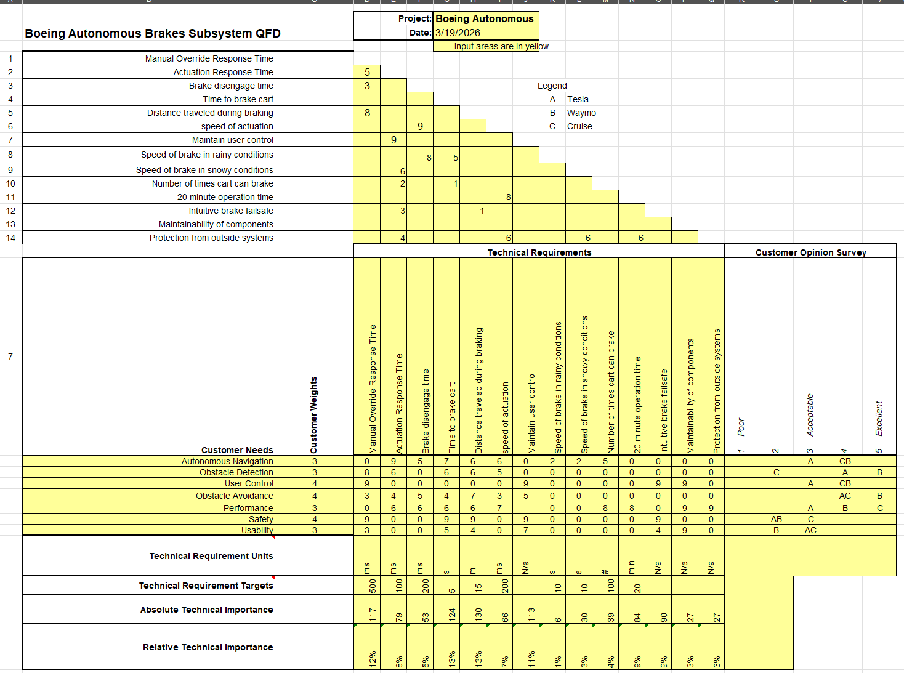

Steering
The QFD for steering displays the customer needs and weights that were derived from a list of functional and nonfunctional requirements given by the clients. For the customer needs, the steering sub team will be focused on autonomous navigation, obstacle detection/avoidance, user control, safety, and usability. The customers’ needs were compared with the three companies of our choice for benchmarking, Tesla, Waymo, and Cruise. The technical requirements are Manual Override Response Time, Actuation Response Time, Failsafe Response Time, Time to achieve angle, Time to start turn, Rate of steering, Maximum Turning Radius, Steering Radius Left, Steering Radius Right, Max Rotation Range, and Cycles to failure. As depicted in Table #11 below, Manual Override Response Time was determined to be the most important technical requirement based on the weighed customer needs.
Table #11: Steering Subassembly QFD
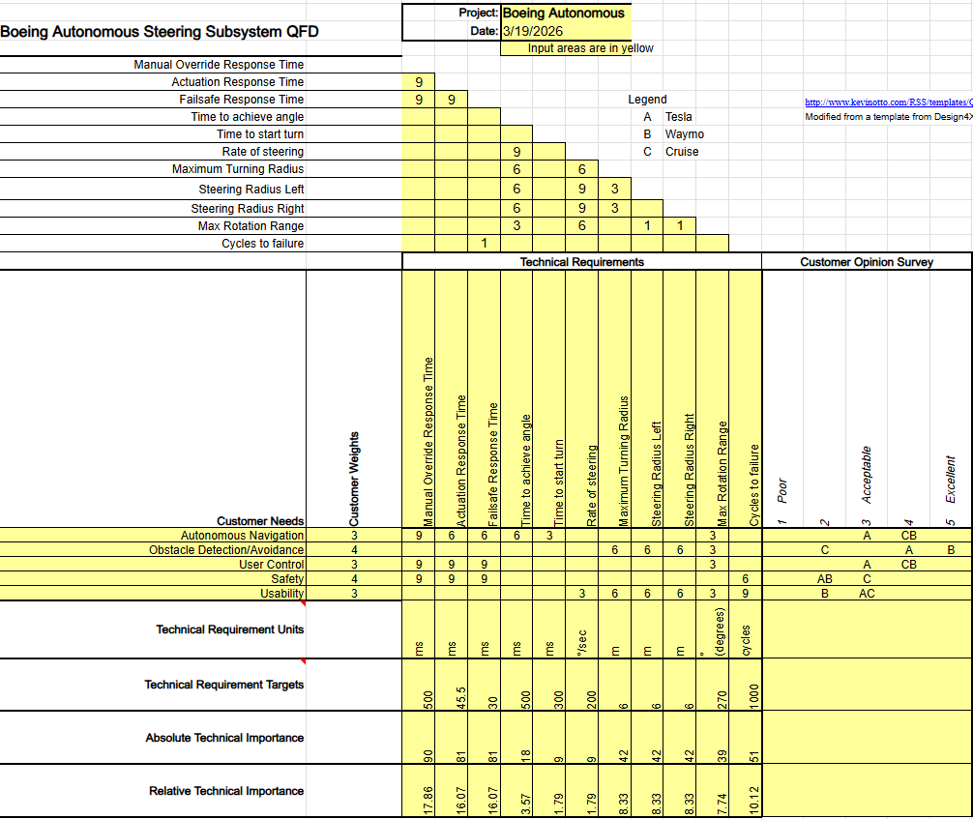
Throttle
The following table, Table #12, displays the QFD for the throttle subassembly and the related engineering and customer requirements. The engineering requirements include the speed range of the go-kart, the spring force range on the throttle lever, and the response times for the manual override, actuation, and failsafe mechanism. These requirements also include the throttle cable’s velocity, the RPM of the spool on the stepper motor, and the required force to pull the cable between the spool and lever. Moreover, the customer requirements are the same for brakes and steering, which include autonomous navigation, user control, state monitoring, performance, safety, and usability. The customer opinion survey includes competitors in autonomous driving such as Tesla, Waymo, and Cruise, to evaluate and compare the current market.
Table #12: Throttle Subassembly QFD
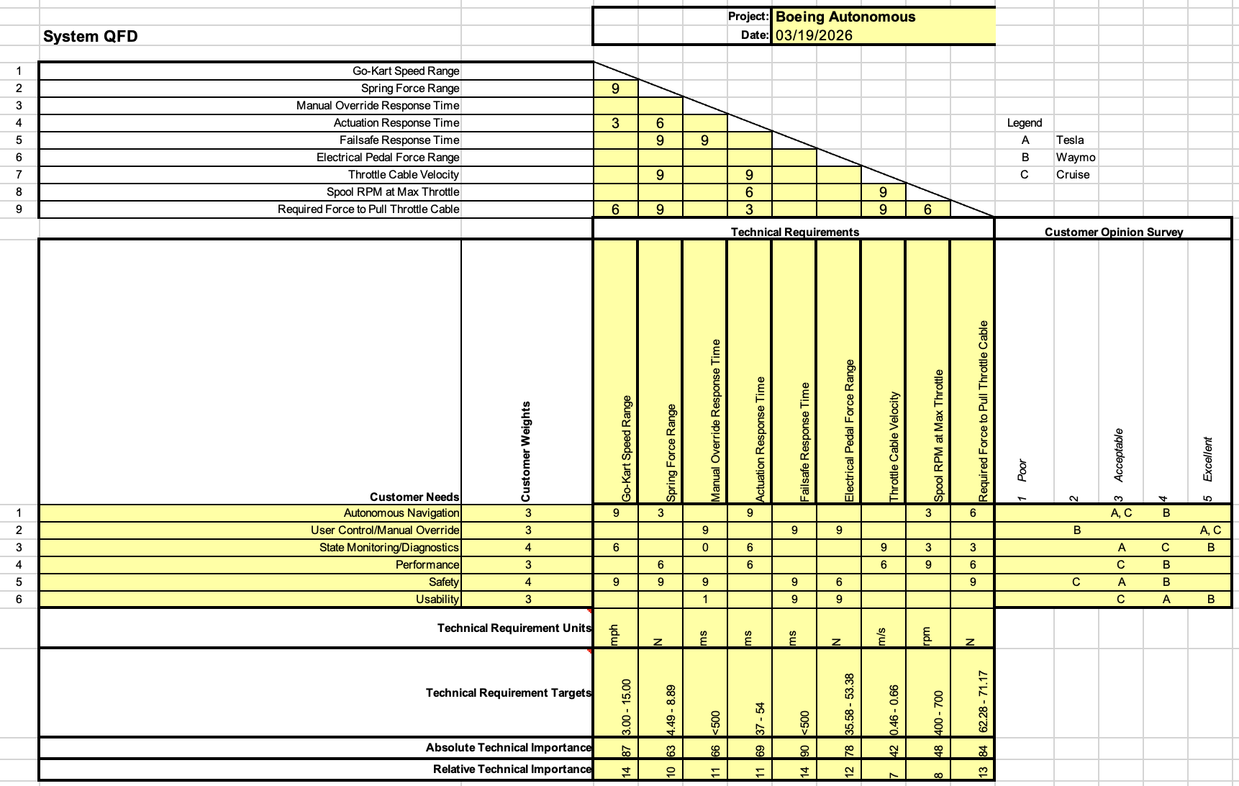
Copyright © 2005 Kevin Otto
Please freely distribute and modify, but properly reference and maintain this contact information in the sheet.
www.robuststrategy.com
kevin_n_otto@yahoo.com
http://www.kevinotto.com/RSS/templates/QFD Template.xls
Modified from a template from Design4X Inc.

The engineering requirements work in tandem with the needs listed by the Boeing clients. The response time for actuation and the go-kart speed are related to the autonomous navigation requirement. The manual override and failsafe response times are directed towards the safety and user control requirements. The spool and throttle cable measurements are aimed towards the safety and performance requirements to make sure that the mechanism offers enough support and strength to fully actuate. The electric pedal force range is designated for the state monitoring diagnostics, as well as safety in case the stepper fails. The pedal also offers an electrical backup for the user to continue to control the throttle during operation. The full document of the QFD is attached as a separate file within this submission.

Conclusion
The finalized testing plan aims to outline each subsystem of the autonomous go-kart and its associated methods of experimentation required to verify each design requirement. The brakes subsystem will use a combination of brake caliper test and mainline experiments to demonstrate the actuation of the braking mechanism and the failsafe to ensure that the brakes are always engaged. The steering subsystem will incorporate wheel rotation, dynamics, and timing tests to observe the steering wheel during autonomous navigation and how diagnostics will be tested in case of any emergency. The throttle mechanism will use a series of speed, response time, and stress tests to guarantee that each component is integrated successfully and that there is no interference between the stepper motor and electrical pedal. Each subsystem is intended to be integrated with one another, in which these tests will define any individual errors before fully integrating all three systems. This plan also ensures that every angle of each subsystem and its mechanism is exhausted to fully demonstrate that all components work and there are no errors during operation.

References
[1] “Shigley’s Mechanical Engineering Design.” Available: https://dl.icdst.org/pdfs/files3/ad7608c18e740b0e402c025fa3187de8.pdf

