Formula SAE – FBA Final Report

Gustavo Ruiz – Chassis Team Lead, CAD Engineer
Brandon Guzman – Test Engineer, Engine box design, Firewall
Alexandra Brister – Cockpit Engineer, Pedal Box Engineer
Ryan Meger – Rear Suspension Box, Chassis Analysis, Front Wing Engineer
Carson Kent – Aerodynamic Engineer

Fall 2024-Spring 2025

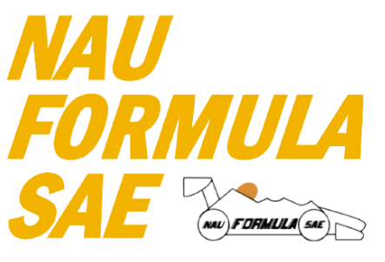
Project Sponsor: Northern Arizona University
Faculty Advisor: David Willy

DISCLAIMER
This report was prepared by students as part of a university course requirement. While considerable effort has been put into the project, it is not the work of licensed engineers and has not undergone the extensive verification that is common in the profession. The information, data, conclusions, and content of this report should not be relied on or utilized without thorough, independent testing and verification. University faculty members may have been associated with this project as advisors, sponsors, or course instructors, but as such they are not responsible for the accuracy of results or conclusions.

EXECUTIVE SUMMARY
The Formula SAE chassis sub-team is tasked with the design and construction of the chassis for a Formula SAE style race car, with focuses on structural integrity, safety, integration, and overall performance. The chassis serves as the backbone of the car, supporting suspension, aerodynamics, powertrain, driver and everything in between. The team’s primary objective is to create a lightweight, yet stiff frame that is compliant with the Formula SAE Rule Book, all while designing the cockpit to be comfortable, and pickup points and other aspects of the car to be widely adjustable, all while performing at a high level.
The chassis chosen for NAU’s Formula SAE car was a steel space frame, mainly due to its adjustability when designing, but also cost. Primarily constructed from 4130 chromoly steel tubing, this material was used for its high yield strength, ease of fabrication and fantastic weldability. The design of the frame was influenced strongly by the rules in the Formula SAE rule book, such as triangulation of the steel tubes, roll cage parameters, and side impact structure (SIS) design requirements.
The second semester of this year was a pivotal point for the team. Shifting focus from the frame, to integrating the aero package and the other sub teams to it. This provided the team with a plethora of engineering challenges that were not anticipated. Most of which were based on the manufacturing of the aero package. Considerations were made from the rule book and research on what other FSAE teams have done. Being a first-year aero team, we had to learn as much as we could about design, manufacturing and integration. Our goal is to create an aero package that is rule-compliant, and simple but effective. Creating a noticeable amount of downforce, while keeping drag to a minimum. The integration of the suspension and powertrain was also a focus this semester. Extensive communication and teamwork between the teams made it possible to overcome manufacturing challenges. Having minimal access to the machine shop resources, we maximized our time at the shop as much as possible.
There have been many successes as the second semester comes to an end. Creating the aero package being the most exciting. Being a first-year team, it was interesting to work with new manufacturing techniques and materials. The carbon fiber nose cone mold was the first of its kind at NAU, that returned amazing results. The airfoils and seats have also been manufactured, leaving the endplates and side panels to be finished. Due to our carbon fiber manufacturer running out of carbon, we have been left in a limbo situation. Waiting for a response from Nova Kinetics to see if they will sponsor us with more carbon or allow us to purchase some. It would be amazing to get the aero package finished before the competition, but we understand that this is something out of our control. We will push as hard as we can to get it finished. We are excited to have a car that will be able to compete against others in Michigan this May, having made ergonomic and aerodynamic changes to the car. Making it hopefully a high-level contender.

TABLE OF CONTENTS
Contents
DISCLAIMER 1
EXECUTIVE SUMMARY 2
TABLE OF CONTENTS 3
1. BACKGROUND 4
1.1 Project Description 5
1.2 Deliverables: 5
1.2.1. Course deliverables: 6
1.2.2. Client and competition specific deliverables: 6
1.2.3. Main Constraints for chassis: 6
1.3 Success Metrics 6
2. REQUIREMENTS 7
2.1 Customer Requirements (CRs) 8
2.2 Engineering Requirements (ERs) 9
2.3 House of Quality (HoQ) 13
3. Research Within Your Design Space 14
3.1 Benchmarking 15
3.1.1. Benchmarking – Side Impact Structure 15
3.1.2. Benchmarking – Front, rear and main hoop concepts (Brandon Guzman) 18
3.1.3. Front Wing – Ryan Meger 21
3.1.4. Rear Wing – Ryan Meger 21
3.1.5. Nose Cone – Ryan Meger 21
3.2 Literature Review 22
3.2.1. Alexandra Brister – Seat Belt/ Seat/ Mounting System 22
3.2.2. Ryan Meger – Torsional Stiffness 24
3.2.3. Gustavo Ruiz – Chassis Frame Design 24
3.2.4. Brandon Guzman Benchmarking/Bending/Firewall(b) 25
3.2.5. Carson Kent Aerodynamic Design 27
3.3 Mathematical Modeling 27
3.3.1. Seatbelt Stress/ Safety for 6-point and Seat Mounts– Alexandra Brister 28
3.3.2. Finite Element Analysis (FEA) of the Chassis – Ryan Meger 29
3.3.2.1.1. Torsional Analysis 29
3.3.2.1.2. Front and Side Impact Analysis 30
3.3.2.1.3. Bending mathematical modeling – Brandon Guzman 30
3.3.2.2. Preliminary Aerodynamics Mathematical Modeling – Carson Kent 33
4. Design Concepts 34
4.1 Functional Decomposition 35
4.2 Process Diagram (Gustavo Ruiz) 36
4.3 Concept Generation 37
4.3.1. Chassis Generation Ryan Meger & Gustavo Ruiz 37
4.3.2. Seat Belt Systems – Alexandra Brister 38
4.3.3. Nose Cone Designs – Ryan Meger 39
4.4 Selection Criteria 40
4.4.1. Chassis Selection Criteria – Gustavo Ruiz 40
4.4.2. Seatbelt Selection – Alexandra Brister 41
4.4.3. Front Wing Selection Criteria 42
4.4.4. Rear Wing Selection Criteria 42
4.4.5. Firewall Selection Criteria 42
4.5 Concept Selection 42
4.5.1. Concept Selection for Chassis Design (Ryan Meger) 43
4.5.2. Seatbelt Selection – Alexandra Brister 43
4.5.3. Front Wing Concept Selection 44
4.5.4. Rear Wing Concept Selection 44
4.5.5. Firewall Concept Selection – Brandon Guzman: 45
5. Project Management 45
5.1 Schedule 46
5.2 Budget 46
5.3 Bill of Materials (BoM) For FSAE Frame-Body-Aero 47
5.3.1. Frame and Jig 47
5.3.2. Seat 47
5.3.3. Firewall 48
5.3.4. Nose Cone 48
5.3.5. Front Wing 48
5.3.6. Rear Wing 49
5.3.7. Safety Equipment 49
6. Design Validation and Initial Prototyping 49
6.1 Failure Modes and Effects Analysis (FMEA) 50
6.1.1. Frame – Ryan Meger 50
6.1.2. Aerodynamics – Ryan Meger 51
6.1.3. Overview – Ryan Meger 52
6.2 Initial Prototyping 52
6.2.1. Alexandra Brister – Seat Prototype 52
6.2.2. Ryan Meger – PVC Prototype 52
6.2.3. Gustavo Ruiz – Tube Templates for Notching Prototype 54
6.2.4. Gustavo Ruiz – JIG Design Prototype 56
6.2.5. Gustavo Ruiz – Front Bulkhead Prototype 58
6.2.6. Gustavo Ruiz – Frame Cut list Prototype 59
6.2.7. Brandon Guzman – Firewall Prototype: 60
6.2.8. Carson Kent – Front Wing and Nose Cone Prototype 61
6.3 Other Engineering Calculations 63
6.3.1. Brandon Guzman – Thermal resistive network of Firewall: 63
6.4 Future Testing Potential 65
7. Final Hardware 66
7.1 Final Physical Design 67
7.2 Nose Cone 67
7.3 Front Wing 68
7.4 Rear Wing 70
7.5 Seat 70
7.6 Firewall 71
8. Final Testing 72
8.1 Top Level Testing Summary Table 73
8.2 Detailed Testing Plan 73
8.2.1. Test 1 – Egress 73
8.2.2. Test 2 – Cockpit Thermal Test 74
8.2.3. Test 3 – Harness Position Test 76
8.2.4. Test 4 – Head Restraint Force Analysis 77
8.2.5. Test 5 – Design Requirement Testing 77
8.2.6. Test 6 – Disassembly Test 79
8.3 Specification Sheet 80
9. Future Work 82
10. Conclusion 83
11. References 83
11.1 Alexandra Brister 84
11.2 Ryan Meger 84
11.3 Brandon Guzman 85
11.4 Gustavo Ruiz 86
11.5 Carson Kent 87
12. APPENDICES 88
12.1 Appendix A: FSAE Rules 88
12.2 Appendix B: House of Quality 88
12.3 Appendix C: FMEA Chassis 89
12.4 Appendix D: FMEA Aerodynamics 90

BACKGROUND
The first chapter will be used to introduce the goals and requirements of the Formula SAE capstone project. This includes the requirements given by the Formula SAE rulebook, and team goals. The NAU department of Mechanical Engineering is setting ambitious yet tangible goals and objectives as a second-year team to create a standard for future Formula SAE teams.

Project Description
The Formula SAE project described by SAE International is “The Formula SAE competitions challenge teams of university undergraduate and graduate students to conceive, design, fabricate, develop and compete with small, formula style vehicles. The competition is an engineering education competition that requires performance demonstration of vehicles in a series of events, both off track and on track against the clock. Each competition gives teams the chance to demonstrate their creativity and engineering skills in comparison to teams from other universities around the world.” As a second-year team, we are striving to exceed last year’s performance and fix any issues that arose during design, manufacturing and testing. Building a base for future teams to be successful.
As described above by SAE International, the project gives students the opportunity to put all their engineering knowledge gained into practice. Allowing students to expand their connections with other students, faculty, and potential employers. It also connects the teachings from past engineering courses to develop an engineering design process that will end with a successful capstone project. With the nature of the Formula SAE project, hands on skills in the machine shop will also be developed. Creating and refining real-world knowledge on manufacturing.
The chassis team’s total budget for the Formula 2025 car project is $6,058.24. To date, $1,747.99 has been spent on all the tubing, jig materials, and the PVC prototype, leaving $4,310.25 for future expenses. We plan to secure a sponsorship from Nova Kinetics, which will cover the cost of our first aerodynamic component, the front nose cone, which will help reduce the overall project expenses. Our primary fundraising efforts are focused on obtaining donations from individuals to support the team, while also exploring potential sponsorships to further offset expenses.
To give an update on the second semester, the team has been working extensively with Nova Kinetics. Manufacturing the nose cone, seat, and airfoils with their help. The frame-body-aero team also secured sponsorship from Mother Road Brewery in Flagstaff. Giving us the opportunity to showcase the car to the community and showcase the car.
Having such a large project to manage, it has given the team priceless skills and professional growth. Working in the machine shop manufacturing on the lathe and mills, writing extensive reports has given the team hands-on experience before entering the workforce. It has been a test of our will and teamwork to get this project finished, working long hours with full course loads to get this project finished. We are excited to compete in the FSAE competition this up coming May.

Deliverables:

Course deliverables:
The project scope for this course is to design and manufacture a new FSAE chassis for the 2025 racing season. The sub-team has been given the task of iterating on the 2024 FSAE chassis design which was also the first year NAU competed in this competition. Main goals include:
- Conform to all FSAE chassis rules
- Improve on the previous year senior designs
- Manufacture components for final design
- Document manufacturing process for future senior designs.
In addition to these major goals, the chassis design plays a large role in impacting the other systems and sub-team designs. To achieve the most efficient design, the team aims to be as flexible as possible to consider the needs of each subsystem for the car.

Client and competition specific deliverables:
The client and competition specific deliverables for this project were determined after a thorough review of the rules and research in each iteration of the chassis design. These deliverables can be summed into a brief list of constraints that will reinforce decisions with chassis designs and iterations.

Main Constraints for chassis:
- Tubing specifications: Tubing requirements are based on application are defined in section F.3.2 of the 2025 FSAE Rules. This involves thickness and tube diameter.
- Roll Hoop dimensions: The main and front hoop design are to comply with rules in sections F.5.6—F.5.9. Which defines clearance for safety based on the 95th percentile male as well as protection in case of rollover.
- Cockpit: Cockpit dimensions must comply with section T.1. this is a requirement for the competition. The driver must be able to safely and quickly exit the vehicle through the Egress test which is defined in section IN.5 which is also a requirement for the competition. Both sections can be found in the 2025 FSAE Rule Book.
- Driver Template Position: Bottom 200 mm circle on seat bottom where the distance between the center of this circle and the rearmost face of the pedals is no less than 915 mm. The driver template is important to ensure that rules and regulations are met while applying our customer requirements.
All of these sections will be linked in Appendix A at the end of this report, any other constraints or competition specific deliverables will be defined in section 2.1 and 2.2 regarding Customer and Engineering requirements.

Success Metrics
The success metrics for the Formula SAE project will be measured by categories as laid out by the SAE Design Judging Score Card. The four categories are based of the car’s design, build, refinement/validation, and understanding. Having an innovate design that push the limits of the rule book and performance of the vehicle is an interest point the judges will be investigating. As a second team year, we are focusing on completing all dynamic events and static tests while having a safe car and performing at a high level.
Success of the project means completing all dynamic events and static tests, while passing inspection done by the judges at the SAE International this coming May. The dynamic tests are performance tests on the car, which include acceleration, skid pad, autocross, efficiency, and endurance events. The Static tests include a leak test, and a knowledge test of the car and the design choices. The primary goal of the project is to have a car that goes to competition, passes technical inspection, and competes in all dynamic events at a higher level than last year. As last year’s car didn’t complete all the events, we want to make a name for NAU’s mechanical engineering school as a high-level competitor.

REQUIREMENTS
When building an FSAE car the most important requirements would be to build a high performance, durable racecar that can compete against the rest of the field. Along with this there are numerous underlying requirements which help us succeed in building a successful design. There are several sections which these requirements are divided into including general regulations, administrative regulations, chassis and structural, technical aspects, and driver equipment. All of the regulations and requirements will be discussed in the section following.

Customer Requirements (CRs)
The customer requirements for the chassis were taken from the rules specified in the Formula SAE rulebook for 2024 and improvements from last year’s car. These requirements are specifications and functions that the chassis must perform to pass the technical inspection. The customer requirements are as follows.
The cockpit of last year’s car was cramped, not allowing the driver to use the car to its full extent. Changing the design of the cockpit to make it larger is a priority in our chassis design this year.
The primary structure must meet the specified requirements for each section of the chassis. The rules split the tubing sizes into size A, B, and C, with the specified dimensions for each size. Tube sizes must meet the standards for each section of the chassis, laid out in the FSAE rulebook.
Another improvement the team would like to achieve on this year’s design is a removeable firewall. The fire wall is in proximity to the powertrain system so having it be removeable will allow for maintenance and adjustability of the engine to be efficient and effective.
Aerodynamics attached to the car have also been considered for this year’s car. Having aero will give the car more of a fighting chance against the other school we are competing with. The body of the car and other aero attachments must seamlessly integrate on the chassis. Making it easy to remove and assemble.
The pedal box is required to fit three pedals. Making sure the area for the pedal box is large enough to house the new pedal box design.
Reduce Rear Suspension Z-axis size?
The car must use a 5-, 6-, or 7-point harness and meet one of the following: SFI Specification 16.1, SFI Specification 16.5, or FIA Specification 8853/2016. Also, the lap belt must pass around the pelvic area below the anterior superior Iliac Spines.
The front bulkhead must be securely integrated into the frame. This creates a protection bubble around the driver’s legs in between the front hoop and front bulkhead area.
The fuel tank is a potential safety hazard for the driver. Having it shielded from side and rear impacts is paramount to the safety of the driver.
To meet rule book requirements regarding aero, the front aero must be no more than 700mm forward of the front tire. The aero in the back must be no more than 250mm rearward of the rear tire.
The SIS is required to connect the front and main hoops, creating a stiff design and give the driver a bubble of protection.
The cockpit must accommodate the driver template, designed by FSAE. This gives the cockpit is the correct dimensions to accommodate a driver up to the size of a 95th percentile male.
Meeting deliverables is important for the success of the car, so prioritizing the ease of manufacturing the chassis is important to the team.

Engineering Requirements (ERs)
Vehicle Configuration
The engineering requirements along with the customer requirements are derived directly from the FSAE rulebook. The requirements listed below are the technical requirements that we must accomplish to not only build a high performing car but more importantly to be able to compete. The engineering requirements are listed below in categories.
Since the vehicle must be open wheeled, the top 180 degrees of the wheels/tires must be unobstructed when viewed from above and from the side of the wheels. (see figure 1)
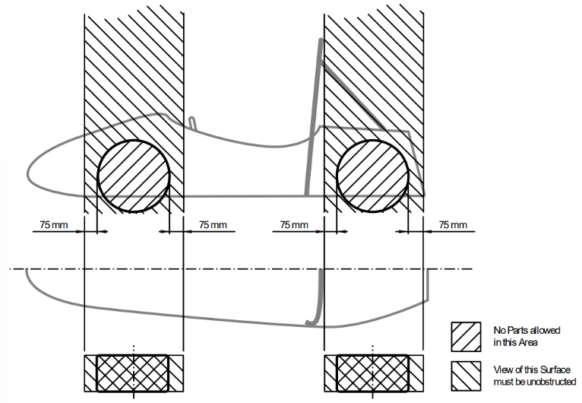
Figure 1: Open Wheel Requirements
The vehicle must have a minimum wheelbase of 1525 mm, and the track and center of gravity must combine to provide sufficient rollover stability.
The smaller track of the vehicle must be no less than 75% of the larger track.
Ground Clearance
Ground clearance must be sufficient to prevent any portion of the vehicle except the tires from touching the ground during dynamic events.
The distance to the ground below the Lower Side Impact Structure at its lowest point must be 90 mm or less. The distance to the ground should be 75 mm or less. There must also be an opening for measuring the ride height at that point without removing aerodynamic devices.
Intentional or excessive ground contact of any portion of the vehicle other than the tires will forfeit a run or event.
Driver
The vehicle must be able to accommodate drivers of sizes ranging from 5th percentile female to 95th percentile male.
The driver's head and hands must not contact the ground in any rollover attitude.
The driver must have sufficient visibility to the front and sides of the vehicle.
In a normal seating position, the driver must have a minimum field of vision of 100 degrees to the left and right sides.
Chassis
The fabricated structural assembly that supports all functional vehicle systems. This assembly may be a single fabricated structure, multiple fabricated structures or a combination of composite and welded structures.
The minimum radius of any bend, measured at the tube centerline, must be three or more times the tube outside diameter.
Frame members
A minimum representative single piece of uncut, continuous tubing.
Monocoque
A type of chassis where loads are supported by external panels.
Main hoop
A roll bar located alongside or immediately aft of the driver’s torso.
Front hoop
A roll bar located above the driver’s legs, in proximity to the steering wheel.
Roll hoop
Referring to the front hoop and the main hoop.
Roll hoop bracing supports
The structure from the lower end of the roll hoop bracing back to the roll hoop(s).
Front bulkhead
A planar structure that provides protection for the driver’s feet.
Impact Attenuator
A deformable, energy absorbing device located forward of the front bulkhead.
Primary Structure
The combination of these components:
- Front bulkhead and front bulkhead support
- Front hoop, main hoop, roll hoop braces and supports
- Side impact structure
- Any frame members, guides, or supports that transfer load from the driver restraint system
Primary structure envelope
A volume enclosed by multiple tangent planes, each of which follows the exact outline of the primary structure frame members.
Major Structure
The portion of the chassis that lies inside the primary structure envelope, excluding the main hoop bracing and the portion of the main hoop above a horizontal plane located at the top of the upper side impact member or top of the side impact zone.
Rollover protection envelope
The primary structure plus a plane from the top of the main hoop to the top of the front hoop, plus a plane from the top of the main hoop to the rearmost triangulated structural tube, or monocoque equivalent.
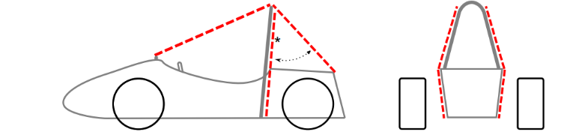
Figure 2: Rollover Protection Envelope
Tire surface envelope
The volume enclosed by tangent lines between the main hoop and the outside edge of each of the four tires.
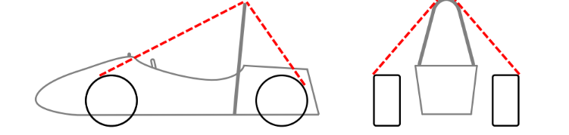
Figure 3: Tire Surface Envelope
Component envelope
The area that is inside a plane from the top of the main hoop to the top of the front bulkhead, plus a plane from the top of the main hoop to the rearmost triangulated structural tube, or monocoque equivalent.
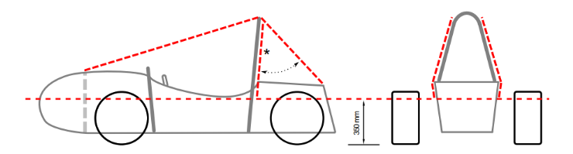
Figure 4: Component Envelope
Buckling modulus
Equal to E*I, where E = modulus of elasticity and I = area moment of inertia about the weakest axis.
Triangulation
An arrangement of frame members where all members and segments of members between bends or nodes with structural tubes form a structure composed entirely of triangles.
- This is generally required between an upper member and a lower member; each may have multiple segments requiring a diagonal to form multiple triangles.
- This is also what is meant by “properly triangulated”
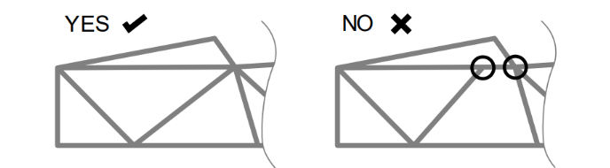
Figure 5: Triangulation Requirement

House of Quality (HoQ)
The house of quality QFD can be found in Appendix (Letter). Since our customer requirements are pulled from the rule book, the engineering requirements correlate with the customer requirements, meaning the customer requirements must be met to pass technical inspection. The engineering requirements describes how to customer requirements will be fulfilled. Due to the nature of passing technical inspection the customer requirements were all weighted with 5, the highest possible. When looking at the engineering requirements a majority of them are in regard to the main hoop. This result makes sense since the main hoop provides the highest level of protection for the driver if a roll over occurs. The chassis must meet tangible and important requirements in order to pass technical inspection, meaning all the customer and engineering requirements must be met to pass. Having a ranking system of importance regarding the chassis is unnecessary. To be repetitive and assertive in this statement, all requirements must be met.
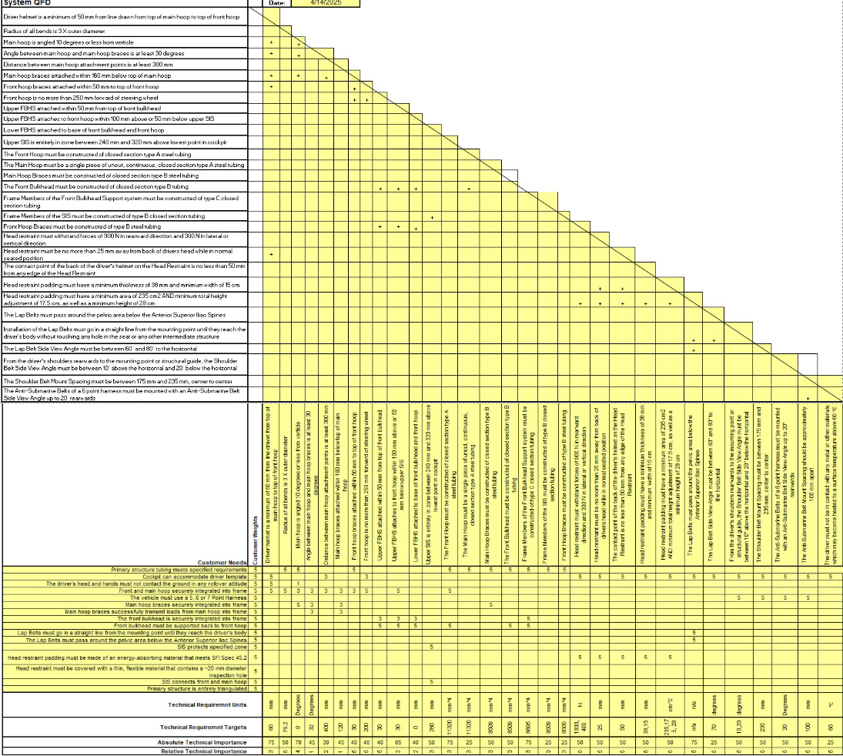
Figure 6: Frame-Body-Aero QFD

Research Within Your Design Space

Benchmarking

Benchmarking – Side Impact Structure
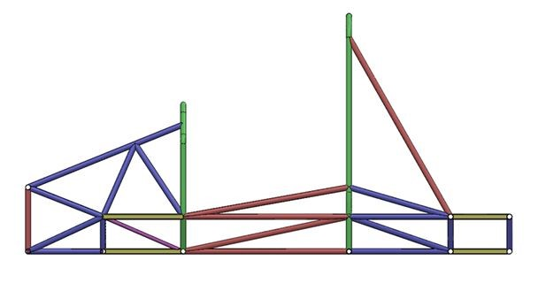
Figure 7: University of Arkansas V.1
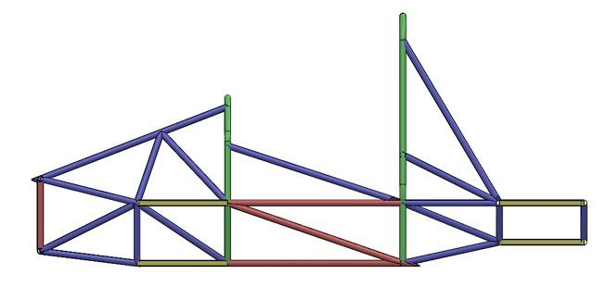
Figure 8: University of Arkansas V.2
Conducting research on universities Formula teams, University of Arkansas had an extensive review of seven different iterations. The first iteration had SIS tubes running backwards up towards the main hoop, providing support for the main hoop. It did leave a large amount of area towards the front hoop that could be dangerous in a collision. Iteration 2 added more SIS structure to deal with that concern and increased torsional rigidity by 58%. Farther down the iterations, iteration 6, they reduced the size of the top SIS tube, to reduce weight. Their final iteration surpassed their goal of 1750 ft-lb/deg(2372.7 Nm/deg) by 13ft-lb/deg.

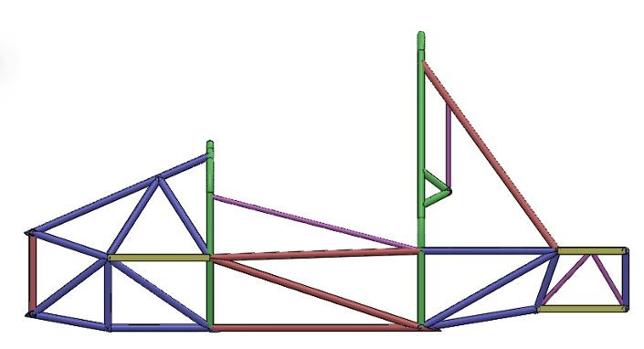
Figure 9: University of Arkansas V.3

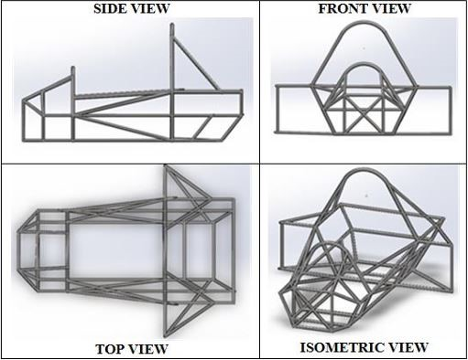
Figure 10: University of Bhopal Chassis Design
The next source is from the University of Bhopal, India. Their frame design took an unorthodox approach by adding structural side pods. This increased torsional rigidity and protection from side impacts. The structural side pods were highly effective at protecting the driver in their analysis but added a large amount of weight to the chassis.

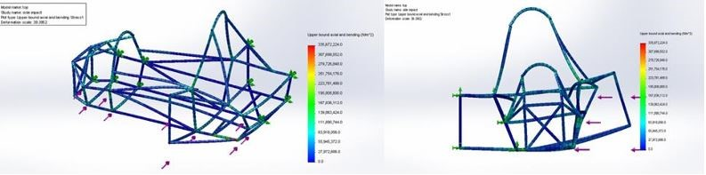
Figure 11: University of Bhopal SIS Analysis

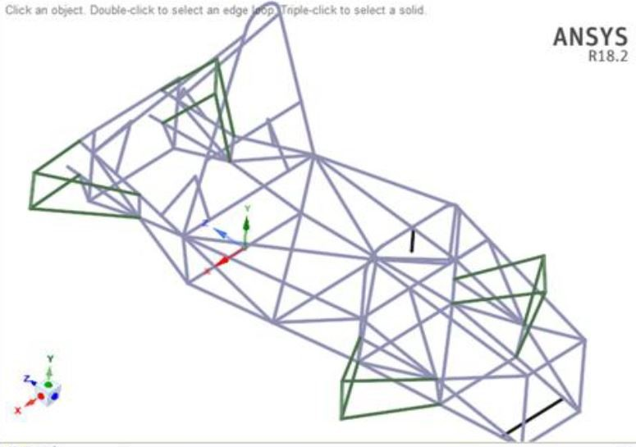
Figure 12: University of Charotar Chassis Design
The last source is from the University of Charotar. Choosing a highly triangulated and complex SIS design. Resulting in a max displacement of 11.7mm. This design results in protecting the driver, but at the cost of more weight and complexity. Other designs have shown that complexity isn’t always the right decision.

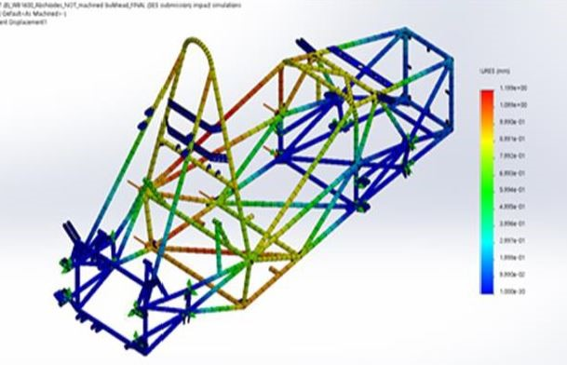
Figure 13: University of Charotar SIS Analysis

Benchmarking – Front, rear and main hoop concepts (Brandon Guzman)
While conducting research and benchmarking with other Universities formula teams State of the art (SOTA) designs, the team was able to narrow down our own design concepts to the one that best meets the present and other sub team deliverables. A few goals from the chassis specific sub team are regarding larger front hoops, more room in cockpit/pedal box, and proper triangulation. In addition, NAU’s previous FSAE team from the 2024 competition did not get the opportunity to include an aerodynamics aspect to their vehicle design, this year it is one of our sub teams goals to also create a design that could incorporate this feature to allow for more downforce and less drag on the vehicle. In this section of the report, a brief description of 3 SOTA chassis designs from other universities followed by the team’s final selected design that will later be used in section 4.4 as the datum for the Pugh chart regarding concept selection.
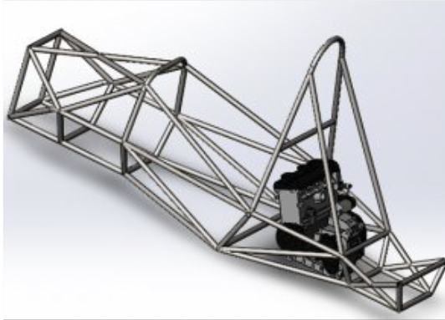
Figure 14: San Deigo State Chassis
In Figure 14 above, this is the chassis design from San Diego state during the 2010 FSAE competition. Although an older design it still performed admirably enough to be show cased at SolidWorks world. This is due to its robust design from being properly triangulated, the large front hoop with extra pedal box room, and cockpit space Which is why this design was selected for one of SOTA designs to benchmark the teams designs with.

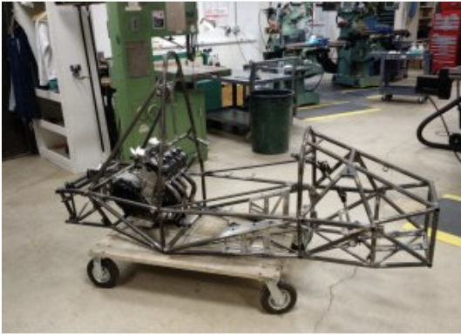
Figure 15: University of Delaware Chassis Design
This figure above showcases the university of Delawares chassis design from the 2017 FSAE competition. Their design includes a very large cockpit and front hoop, giving the driver lots of space. It is more of a stalky design but because they were a top performing school it is interesting to compare a variety of designs to see what does well and what doesn’t which is why this design was selected as a SOTA design.
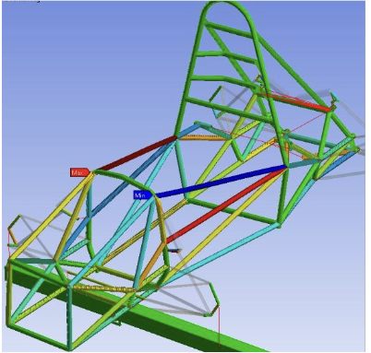
Figure 16: Purdue University chassis design
In figure 16 above, this was Purdue university’s chassis design from the 2020 FSAE competition. This chassis design scored 2nd place in the knowledge event competition of the entire event, and was the best design score a team has scored in the University’s history of competing in this competition. It is important to note this design also has a large front hoop and lots of space in the cockpit. For those reasons, this design was selected as the last SOTA design to be benchmarked with the team’s designs.

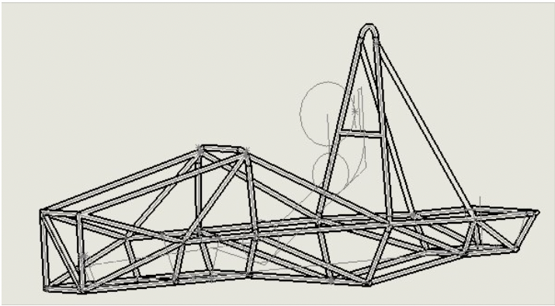
Figure 17: Final design for FSAE 2025 Car
Lastly, Figure 17 is a picture of the final selected CAD design for the 2025 car. In this final design, the team increased the height of the front hoop, made the rear suspension box smaller, and increased the width of the cockpit. The front hoop size was one of the most notable changes for the design, this was done for safely in case of the event of a roll over and to implement more aerodynamic designs to the car. It is also important to note that the other designs chosen as the teams SOTA designs also incorporate a large front hoop. More description as to why this design was selected will be further described in section 4.3, section 4.3 and section 4.4 further down in this design report.

Front Wing – Ryan Meger
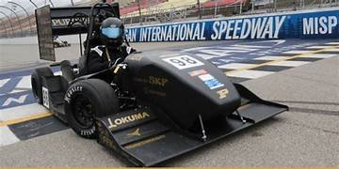
Figure 18: Purdue FSAE Car
The front wing was a tricky aerodynamic device to incorporate onto the car. Due to the size of the nose cone it left little room to be creative with the design. The image above, Purdue university’s car, is what we take inspiration from. We have limited knowledge of the manufacturing techniques used to create such a wing, but we did what we could from images and articles found online. Having at least a two-stage front wing would be paramount to create a sort of downforce for the car. This would also add to the simplicity of the design, not having a multistage airfoil.

Rear Wing – Ryan Meger
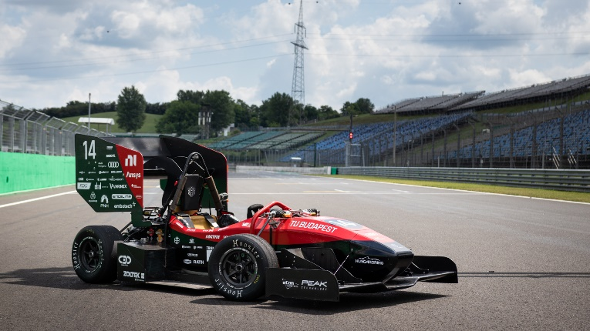
Figure 19: BME Formula Racing Team
This is the BME formula racing team in 2020. The mounting system and overall size of the rear wing was taken into consideration for our final design. They incorporated a goose neck design that connects to the main hoop of the car, giving it a rigid design. The top airfoil AOA is angled very aggressively, so we took this design choice into our final design.

Nose Cone – Ryan Meger
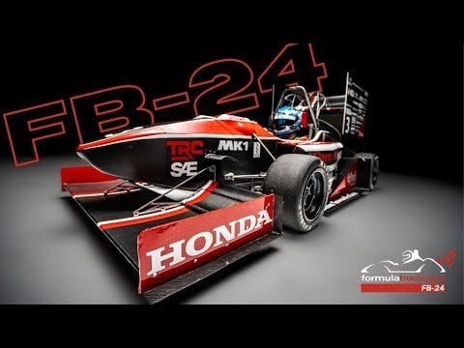
Figure 20: Ohio State FSAE Car
The image above is from one of the highest performing FSAE teams in the country, Ohio state. We have no prior knowledge of how to design a nose cone for a formula car, so this was used to guide us. The team wants the nose cone to go over the dash, so it has to be tall enough to do so. This team did just that. They also keep the front of the cone very pointy, slicing the air as the car moves forward. We copied this design and can be seen in our final design.

Literature Review

Alexandra Brister – Seat Belt/ Seat/ Mounting System
The following resources provide a foundation for benchmarking, analyzing, and designing the systems within the cockpit. These collectively address force dynamics, safety standards, and crash simulations.
[1a] Bruno Muss. "Crash test numerical analysis of a Formula SAE vehicle," YouTube, 1/17/2018. https://www.youtube.com/watch?v=c8k9Idy5kwk
This video shows an impact simulation of a Formula SAE vehicle using LS-Dyna software. It shows a visual and computational insight into the safety systems and how they behave during a crash. It relates to the project because it allows for the team to observe how the seat belt systems behave under a simulated crash; this offers data for comparison with theoretical models which helps validates the design choices for the seat belt stress analysis.
[2a] C. D. Carter, C. B. Sherman, and R. D. Matthews, “Design of a Formula SAE race car: Vehicle Dynamics and Performance,” SAE Technical Paper Series, Feb. 1982. doi:10.4271/821092 Aerodynamics
This discusses the dynamics of the vehicle and the aspects of performance for a Formula SAE standard. This discusses how the forces are transmitted through the vehicle; it is important to understand how the seat belt system reacts during impacts or maneuvers of the vehicle. This paper shows how to apply Newton’s laws in real world examples, it provides case studies show how to optimize the performance of seat belt systems with different conditions.
[3a] C. Itu, A. Toderita, L.-V. Melnic, and S. Vlase, “Effects of seat belts and shock absorbers on the safety of racing car drivers,” Mathematics, vol. 10, no. 19, p. 3593, Oct. 2022. doi:10.3390/math10193593
This paper explains how the driver's safety is impacted by the seat belt systems in various scenarios. This is useful for the mathematical modeling for calculating the stress of the seat belt system under impact conditions and use this information to assess the safety and design for the application.
[4a] The, Dynamics: Force and Newton’s Laws of Motion. 2019 (Chapter 4).
This chapter covers Newton’s Second Law of Motion, it focuses on the relationship between acceleration, force, and mass. Using the Newton laws to analyze the forces acting on the seat belt systems during impact. This creates a foundation for calculating the crash forces to understand the dynamics that act on the driver during an impact.
[5a] K. Baszczyński and M. Jachowicz, “The Effect of the Use of Full Body Harnesses on Their Protective Properties,” International Journal of Occupational Safety and Ergonomics, vol. 15, no. 4, pp. 435–446, Jan. 2009, doi: https://doi.org/10.1080/10803548.2009.11076823.
This provides insight into understanding the long-term effectiveness of racing harness systems, it expresses the importance of periodic maintenance for the protective features. It aids in considering the durability and the shelf life of the seat belt product, this ensures that it remains effective over time, specifically in racing environments.
[6a] R. G. Budynas, J. K. Nisbett, and J. E. Shigley, Shigley’s mechanical engineering design. New York, NY: McGraw-Hill Education, 2020. Chapter 3
This provides information for a foundation on the behaviors of materials under stress and how the forces are distributed across the system. It discusses the force distribution in a 6-point harness system, this explains how the lap, submarine, and shoulder belts share the forces from impact. This forms a basis for understanding stress analysis on the seat belt systems. This ensures uniform force distribution across the system to increase safety.
[7a] “SAE standards for Mobility Knowledge and Solutions,” SAE International, https://www.sae.org/standards?utm_source=google&utm_medium=ppc&utm_campaign=LVL_SAE_SCH_GSE_NTN_GPM_B2C_Standards&utm_content=Standards&utm_term=B2C&utm_device=c&utm_keymatch=p&utm_adposition=&gad_source=1&gclid=CjwKCAjw0aS3BhA3EiwAKaD2ZSgsuuN9rfyeBQE_uWePei2JlxfRiqc2r97IeRPudAJ_66PtXDuT6xoC7T4QAvD_BwE (accessed Sep. 17, 2024).
This website outlines the standards for vehicle safety and efficiency. This provides essential information on the safety requirements specific to the seat belt harness. This further benchmarks for safety for the system.
[8a] B. Herbstreit, “Seat & Firewall Design for Cornell Racing FSAE,” Dec. 2017. Available: https://www.ergofoundation.org/images/Bailey_Herbstreit_%20Seat_and_Firewall.pdf
This document discusses the design for the seat systems which has insigight into the integration of seat belts, this provides optimal driver protection
[9a] H. Bergstrand, “F-SAE Race Car Seat Design -A user-centred concept development project.” Accessed: Nov. 27, 2024. [Online]. Available: https://hampusbergstrand.com/wp-content/uploads/2017/02/F-SAE_race_car_seat_design_Hampus_Bergstrand_2015_Newcastle.pdf
This document focuses on the seat design being ergonomic and have optimal safety features which would enhance the seat belt system integration.
[10a] M. Scheitlin and T. Bräunl, “Renewable Energy Vehicle Project: Pedal Box Design for Formula SAE,” 2011. Available: https://robotics.ee.uwa.edu.au/theses/2011-REV-3-PedalBox-Scheitlin.pdf
This details the pedal box design, which is relevant to the mounting system in the cockpit .

Ryan Meger – Torsional Stiffness
For my portion of the literature review, I researched how the chassis will react to torsional forces when cornering. I first looked at a well-known vehicle dynamics textbook, Race Car Vehicle Dynamics Milliken Milliken [1r]. This familiarized me with chassis stiffness, impact on handling and the dynamics associated, optimization, and driver feedback. Next, I needed to know the required equations and calculations to find the torsional rigidity, which was found using a combination of Analysis of Torsional Stiffness of the Frame of a Formula Student Vehicle [2r] and Formula SAE Chassis System [3r]. Both sources helped me develop method to analyze a chassis for its torsional rigidity. To test torsional rigidity, SolidWorks’ simulation tool was chosen for its available resources and ability to test different designs efficiently. I learned how to use the simulation tool by watching SolidWorks Simulation By Mahtabalam [4r] and SolidWorks FSAE & Formula Student Tutorials [5r]. The simulation tool is only as good as how you know how to use it. Studying on how to use the simulation tool was paramount to having correct results. Sources: ANALYSIS OF FSAE CHASSIS [6r], MEEG 402-010 Chassis Design Report [7r], and Modeling of a chassis for an SAE formula car [8r] for a larger selection of frame types to compare to each other for our team’s chassis design. To further my knowledge and understanding of a Failure Mode and Effect Analysis (FMEA) I read Understanding FMEA Calculations[9]. It goes over all the calculations regarding a FMEA analysis and their importance. It explains what the RPN value is and their results. Next I wanted to apply it to our SAE Formula capstone. Watching a video called DFMEA explained[10] it goes over the important functions and subfunctions of a SAE Formula car and important failure points to address in the analysis.

Gustavo Ruiz – Chassis Frame Design
[1g] "Design and Analysis of FSAE Chassis for Safe Conditions" (Paper)
Helpful design parameters and calculations to run our design through, as well as finding vertical center of gravity methods.

[2g] "FEA Analysis of FSAE Chassis" (Paper)
Main goal highlighted were to decrease weight and increase torsional rigidity, helpful ANSYS simulation of stresses and torsion.

[3g] "The Science of Vehicle Dynamics", Chapter 3 "Vehicle Model for Handling" (Book)
Great explanation on aerodynamics in a Formula car, and goes more in depth on front and rear vertical forces

[4g] "Fundamentals of Aerodynamics", Chapter 19 "Turbulent Boundary Layers" (Book)
Helpful way to create turbulent modeling and find characteristics of a turbulent flow.

[5g] "Renewable Energy Vehicle Project: Pedal Box Design for Formula SAE" (Paper)
Future Work ideas from pedal box are to decrease weight and use an angle-mounted cylinder to decrease pedal box length, like our goal.

[6g] "Formula SAE Rules 2025", F- Chassis and Structural (Standard)

[7g] M. L. Mohamad et al., “Design and static structural analysis of a race car chassis for Formula Society of Automotive Engineers (FSAE) event,” Journal of Physics: Conference Series, vol. 908, p. 012042, Oct. 2017. doi:10.1088/1742-6596/908/1/012042

Main design constraints and regulations that are frame needs to abide by. Helpful templates to ensure ergonomics of vehicle and as well as its functionality.

Brandon Guzman Benchmarking/Bending/Firewall(b)
[1b] M. Planchard, “San Diego state university formula SAE team showcased at Solidworks World,” SOLIDWORKS Education Blog, https://blogs.solidworks.com/teacher/2014/01/san-diego-state-university-formula-sae-team-showcased-at-solidworks-world.html
Source 1b is a blog from SolidWorks showcasing the sand Diego state chassis that was very helpful for benchmarking designs for the chassis. This aided in the selection process of our own designs.

[2b] C. Dodd, N. Geneva, P. Geneva, and C. Morris, Dr. Steven Timmins , rep., 2017
Source 2b is the final report from the university of Delaware on their chassis design for the 2017 competition. This source was full of a lot of insight on designing and modeling the chassis as well as bending and welding it together.

[3b] “Purdue Formula SAE scores 2nd place; Best Design Score in their history,” Mechanical Engineering - Purdue University, https://engineering.purdue.edu/ME/News/2021/purdue-formula-sae-scores-2nd-place-best-presentation-score-in-their-history-
This source is from Purdue university showcasing their best design score in their history at the competition, this document was full of helpful insight and was also a main source for benchmarking.

[4b] William F Milliken and Douglas L Milliken. Race car vehicle dynamics. Vol. 400. Society of Automotive Engineers Warrendale, 1995
Source 4b is a book the whole team is utilizing for the design process of the chassis, this book is full of useful equations regarding analysis of acceleration weight transfer, stiffness, and force impact.
[5b] Martin Meywerk. Vehicle Dynamics. John Wiley & Sons, 2015
This is another useful book full equations for weight transfer and forces on the vehicle.
[6b] “The construction Process: Pipe and Tube bending,” https://www.herl.pitt.edu/indiachair/indiachairsh/cl_bend.html#:~:text=Rule%20for%2090%20degree%20and%20180%20degree%20Bends&text=180%20degree%20bends%3A%20Multiply%20the,length%20of%20the%20curved%20section.
Source 6b is a website that is dedicated to tube bending, this will be utilized during the beginning manufacturing processes of the car to ensure tube will not need to be remade.
[7b] “Mastering small tube bends,” YouTube, https://youtu.be/MymUqxuCKv4?si=pWnrkCMSN0BtZO4K
Source 7b is a YouTube video that goes over pipe bending basics, this is another source that will be useful for the manufacturing process of the final chassis design.
[8b] “TFS: Tube Bending Basics 1 - What You Need to Know,” YouTube, https://youtu.be/3n_lf2RHIPs?si=NaGZuH7i3eOT0MqW
This last source is another YouTube video that goes over roll cage designs, as well as how to effectively bend using centerline radius of tubes. This will also be useful during the manufacturing process of the cars design.

[9b] ennologic, Ed., “Emissivity table for infrared thermometer readings,” Emissivity Table for Infrared Thermometer Readings, https://ennologic.com/wp-content/uploads/2018/07/Ultimate-Emissivity-Table.pdf (accessed Nov. 21, 2024).

Source 9b is an emissivity table that was utilized during the theoretical analysis of the firewall, this table contained emissivity values for standard and reflective materials. This will also be useful during the final mathematical analysis of the firewall.

[10b] F. Wang, L. Cheng, Q. Zhang, and L. Zhang, “Effects of heat treatment and coatings on the infrared emissivity properties of carbon fibers: Journal of Materials Research,” Cambridge Core, https://www.cambridge.org/core/journals/journal-of-materials-research/article/abs/effects-of-heat-treatment-and-coatings-on-the-infrared-emissivity-properties-of-carbon-fibers/B82F9713F9E2FD2417F7E1AA7EAFEFB3 (accessed Nov. 20, 2024).

This source was used specifically for finding the heat transfer rate between the exhaust and seat, the teams plan is to have the seat constructed of coated carbon fiber. This source has values of the emissivity of coated carbon fiber and aided in the mathematical analysis.

[11b] T. L. Bergan and A. S. Lavine, “13.3.4, Two-Surface Enclosures in Series and Radiation Shields,” in Fundamentals of Heat and Mass transfer, 8th ed, John Wiley and sons, 2019, pp. 808–811
This section of the heat transfer book aided in constructing the Thermal resistive network for the firewall. The equations used involved the heat transfer rate between two surfaces and a radiation shield between them which is what the reflective aluminum firewall will act as.
[12b] [1] S. International, “Formula SAE Rules 2025,” 2025 formula SAE rules V.1 , https://www.fsaeonline.com/cdsweb/app/NewsItem.aspx?NewsItemID=379e4a8a-80a2-4a74-87c2-6f2de4212270 (accessed Nov. 21, 2024).
This final source is the rulebook for the FSAE competition and gives parameters on how the firewall should be constructed as well as what temperature the components the diver touches should not exceed. This will be utilized for mathematical analysis for the final design of the firewall.

Carson Kent Aerodynamic Design
1] S. Gupta and K. Saxena, "Aerodynamics Analysis of a Formula SAE Car," in Proceedings of the 13th International Conference on Heat Transfer, Fluid Mechanics and Thermodynamics, Portoroz, Slovenia, July 2017

[2] T. C. Schuetz, Aerodynamics of Road Vehicles, 5th ed. Warrendale, PA, USA: SAE International, 2015

[3] S. Hetawal, M. Gophane, A. B. K., and Y. S. Mukkamala, "Aerodynamic Study of Formula SAE Car," Procedia Engineering, vol. 97, pp. 1198–1207, 2014, doi: 10.1016/j.proeng.2014.12.398

[4] J. Divahar, "NACA 4 Digit Airfoil Generator," MATLAB Central File Exchange, 2009. [Online]. Available: https://www.mathworks.com/matlabcentral/fileexchange/19915-naca-4-digit-airfoil-generator. [Accessed: Dec. 16, 2024]

[5] L. J. Clancy, Introduction to Aircraft Airfoil Aerodynamics. London, U.K.: Pitman, 1975.

[6] MIT Department of Mechanical Engineering, "2.972 How an Airfoil Works," Massachusetts Institute of Technology, Cambridge, MA. [Online]. Available: https://web.mit.edu/2.972/www/reports/airfoil/airfoil.html. [Accessed: Apr. 16, 2025].

[7] G. D. McBain, Theory of Lift: Introductory Computational Aerodynamics in MATLAB/Octave. Chichester, U.K.: Wiley, 2012

[8] A. M. O. Smith, "High-Lift Aerodynamics," Journal of Aircraft, vol. 12, no. 6, pp. 501–530, 1975, doi: 10.2514/3.59830.

[9] M. Gaunaa, N. N. Sørensen, and C. Bak, "Thick Airfoils and High Lift," in Research in Aeroelasticity EFP-2007-II, T. Buhl, Ed., Roskilde, Denmark: Risø National Laboratory for Sustainable Energy, 2009, pp. 103–114.

[10] J. Li and Z. N. Wu, "Unsteady Lift for the Wagner Problem in the Presence of Additional Leading and Trailing Edge Vortices," Journal of Fluid Mechanics, vol. 765, pp. 1–17, 2015, doi: 10.1017/jfm.2014.691.

Mathematical Modeling

Seatbelt Stress/ Safety for 6-point and Seat Mounts– Alexandra Brister
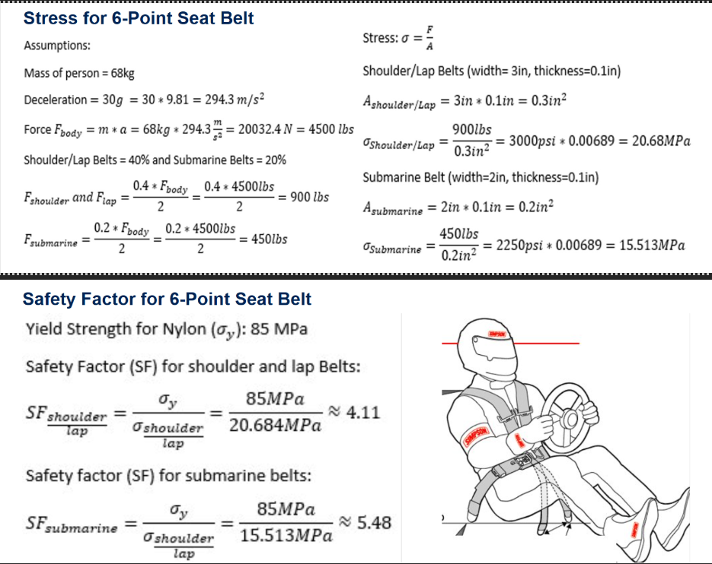
Figure 21: Stress and FOS for 6-Point Seat Belt
The mathematical modeling analyzes the stress and safety factor of a 6-point seat belt system. The analysis starts with basic assumptions, this includes a person's mass, deceleration of 30g, which shows 30 times that gravitational acceleration. The total force acting on the body is calculated based on the parameters which is about 20034N or about 4500lbs. This force is then distributed between the different straps of the seat belt system. The shoulder and the lap belts bear 40% of the total force and the submarine belts bear about 20% of the total force. Using these forces calculated for each belt, the stress can be determined by the force divided by the cross-sectional area of the belt. The cross-sectional areas of the shoulder and lap belts is 0.3in² the calculated stress is about 20.68MPa. For the submarine belts the cross-sectional area is 0.2 in² the stress is about 15.51 MPa. The factor of safety (SF) for the 6-point seat belt is determined using the yield strength of Nylon (85 MPa). The safety factor is calculated by dividing the yield strength of the belt by the stress of the belt. The safety factor (SF) for the shoulder/lap is about 4.11 which means that the material is over four times stronger than the stress applied to the belts. For the submarine belts the safety factor is about 5.48 which shows a great margin of safety. These calculations show that the 6-point belt system is within the safe limits, indicating that it will not fail under high impact forces.

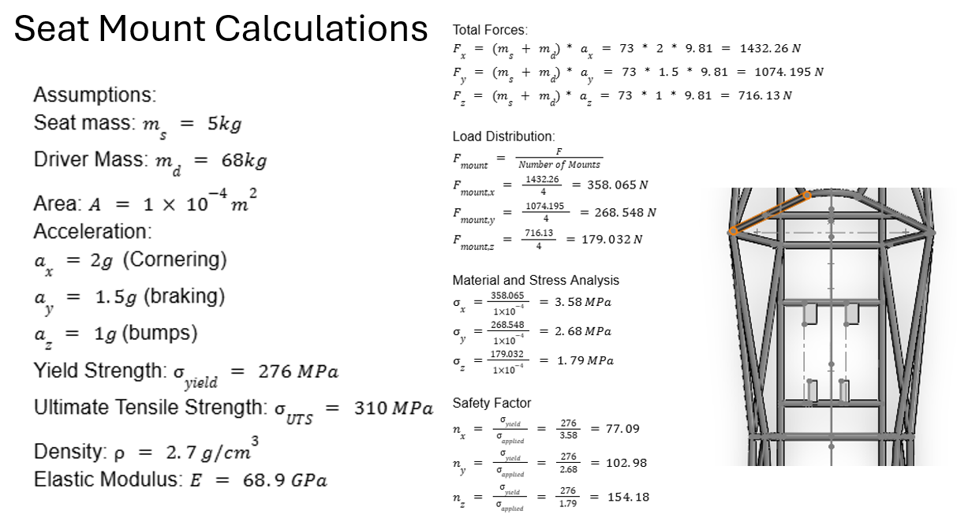
Figure 22: Stress and FOS for Seat Mounts
This analysis does the calculations for the seat mounts. There are several assumptions that were needed to determine the forces and safety factor, the resulting total forces of 1432.26N, 1074.195 N, and 716.13 N. These forces are evenly distributed among the four mounts, which gives each of the mount forces of 358.065N, 268.548 N, and 179.032 N. The resulting safety of factors are high which indicates that the mounts are over-engineered and robust.

Finite Element Analysis (FEA) of the Chassis – Ryan Meger

Torsional Analysis
Torsional stiffness of a race car is important for a race car because it improves handling, weight transfer, suspension optimization, and consistent aerodynamics performance. Making this analysis have a meaningful impact on the performance of the car. An ideal stiffness the team has chosen is high, at 2400 Nm/deg. The equations below explain how I tested and calculated the theoretical torsional stiffness.
$C_{T}=\frac{T}{α}$ [1]
The variable T is the applied Torque in Nm. This value is calculated using equations [3] and [4]. Alpha is the angular deflection in degrees using equation [2], and $C_{T}$ is the torsional stiffness in Nm/deg.
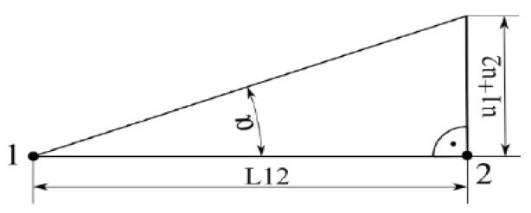
Figure 23: Deformation Triangle
$α=\arctan\left(\frac{u_{1}+u_{2}}{L12}\right)$ [2]$⁡$
$F_{lateral}=m × a_{lateral}$ [3]
$T_{applied}= \frac{F_{lat}}{\# of points}$ [4]
The part of the frame that will be analyzed for displacement is the front hoop, where a most of the torsional forces will be acting upon when driving. The figure below gives a representation of how a real-life experiment would gather displacement data, instead it will be conducted in solid works using the displacement plot in SolidWorks simulation tool. The mass of the car was estimated to be 250kg and a lateral acceleration of 2 Gs. Displaced along 4 points on the front suspension box, giving an applied force of 1103N.
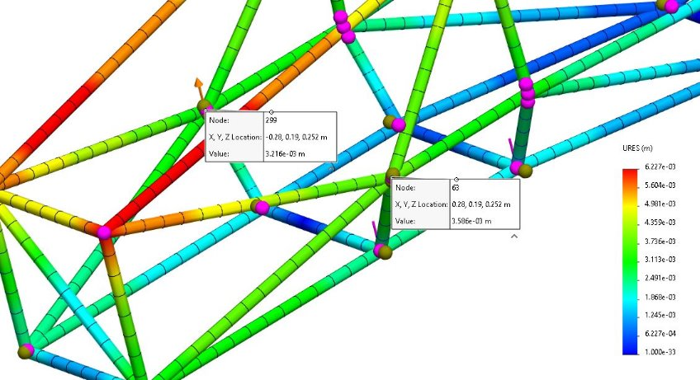
Using the max displacement on the front hoop, at 3.586x10-3 meters, a theoretical Torsional rigidity of 1932.7 Nm/deg. This does not meet our goal of 2400 Nm/deg but is high enough to be competitive.
Figure 19: Displacement Plot
Figure 24: Displacement Plot

Front and Side Impact Analysis
The forces in the next two analyses were calculated using the following equations:
$p=mass ×velocity$ [5]
$F= \frac{p}{time} [N]$ [6]
The mass is 250kg and velocity was estimated to be 70 mph. The impact time was set at 0.25 seconds. Resulting in a force of 31,300 N.

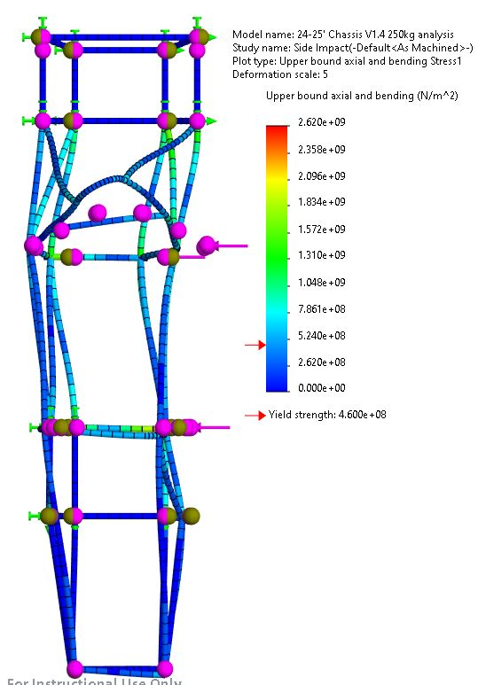
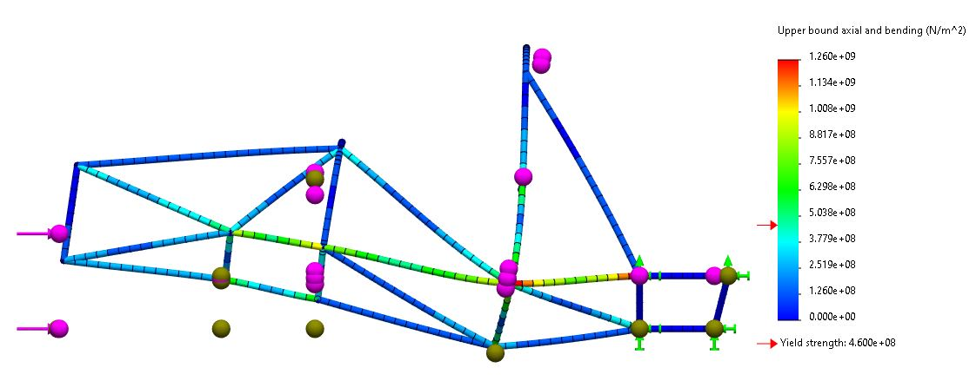
Figure 25: Side View of Front Impact Stress Plot
Figure 26: Top view of SIS Impact Stress Plot
Figure 20: Top View of SIS Impact Stress Plot

Bending mathematical modeling – Brandon Guzman
This section of this report will cover the bending calculations and analysis for the beginning manufacturing process of the front and main hoops for the final designs. The calculations used are simple but will aid in ensuring the lengths of bending won’t be to short and too long. Accuracy here is important because of material cost and time, mistakes could cost money and take away time meant to be spent on other parts of this project. The figure below is the drawing of the front hoop, and the angles used for the calculations described further below.
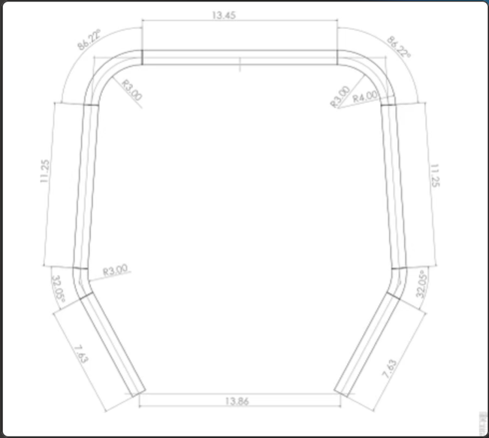
Figure 27: Drawing of front hoop
The calculations used were found from a website about tube bending [6b], which utilizes a bending constant that allows for users to find the total length of the tube using simple calculations. The constant is equal to 0.01745.
$Length=r ×angle × const$ [7]
Equation 7 will be utilized for both angled parts of the front hoop drawing. The first angle is 32.05 degrees which is a smaller section and using equation 7 the length was found to be around 1.7 inches but was rounded up to 2 inches to be safe during manufacturing. The length of the bigger angle which was around 85.76 degrees was found to be around 4.5 inches but was rounded up to 5 to be safe. The reason these angles were increased so much was to make sure even if the team uses too much tube, we can still cut off excess to be safe. After these calculations were done the total length of tube was calculated to be around 68 inches in total for the front hoop. The figures below show the manufacturing process for the front hoop and main hoop, which follows the same process described above.

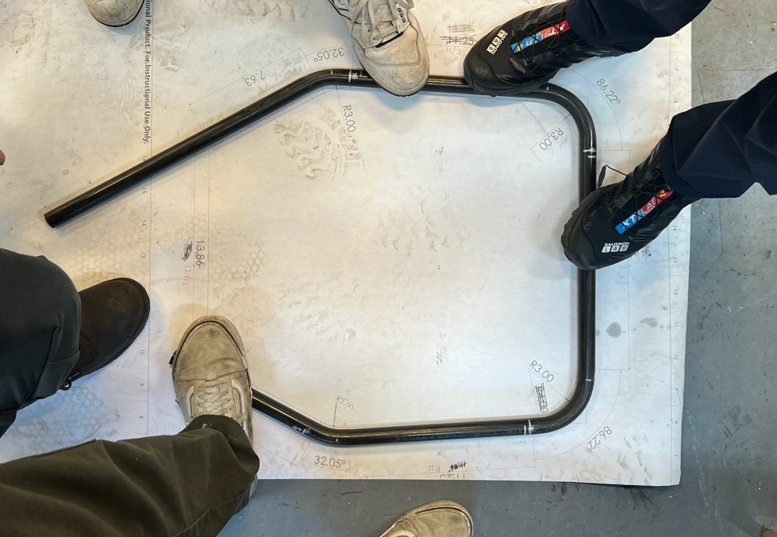
Figure 28: Front hoop over drawing
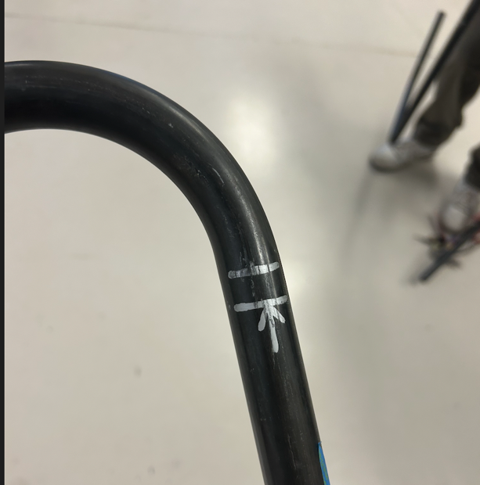
Figure 29: Offset of bending chuck
It is important to also note that every bending chuck has an offset from when the true bend starts, figure 24 demonstrates the offset by showing where the bend starts from the marks made. The offset is around a half an inch, so wherever there was a bend, the team measured half an inch from the marking and placed an arrow in front of it, the arrow represents how far the tube will be placed in the chuck. This was not added to the calculations but was used during the manufacturing process. The same process was followed for the main hoop, which is shown in figure 25 below.
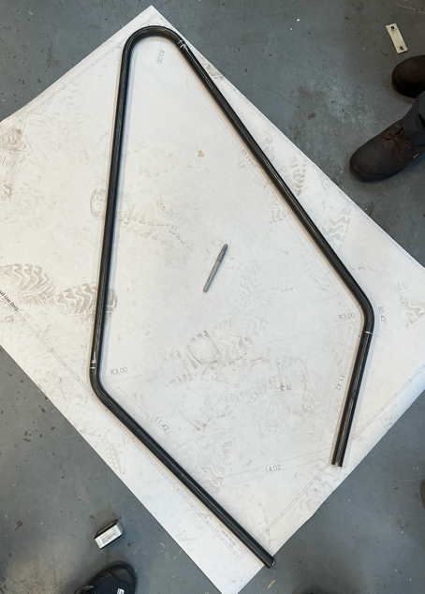
Figure 30: Main hoop over drawing

Preliminary Aerodynamics Mathematical Modeling – Carson Kent
Aerodynamic calculations were performed on the chosen airfoil geometry using the Vortex Panel Method, to find coefficient of lift and drag. Results prove there are high pressure zones at the front of the airfoil which produce the lift and drag when in fluid flow. Negative lift values show the amount of downforce and after tests at –30 degrees for angle of attach, there is a lift coefficient of around –3 which proves these airfoils will be capable of producing significant downforce.
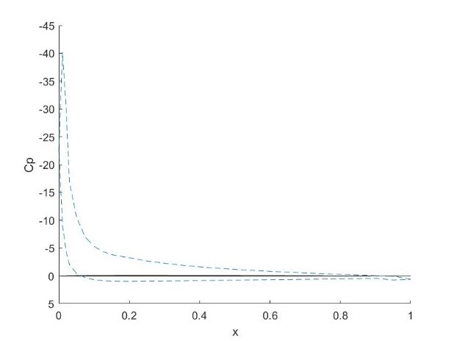
Figure 31: Pressure plot for –30 degrees angle of attack
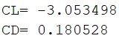
Figure 32: Lift and drag for –30 degrees angle of attack

In conclusion, there were no additions to mathematical modeling from the first semester. The second semester was dedicated to manufacturing and assembling the car. This included the firewall, front wing, rear wing, and seat.

Design Concepts

Functional Decomposition
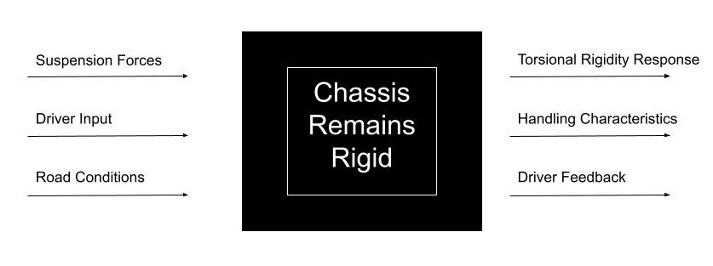
Figure 33: Chassis Black Box Model
The main concept that the chassis must accomplish while driving, is to be stiff under any loads it receives. Inputs on the chassis are from the suspension, driver, and road. All of which test the chassis’ ability to resist torsional forces.

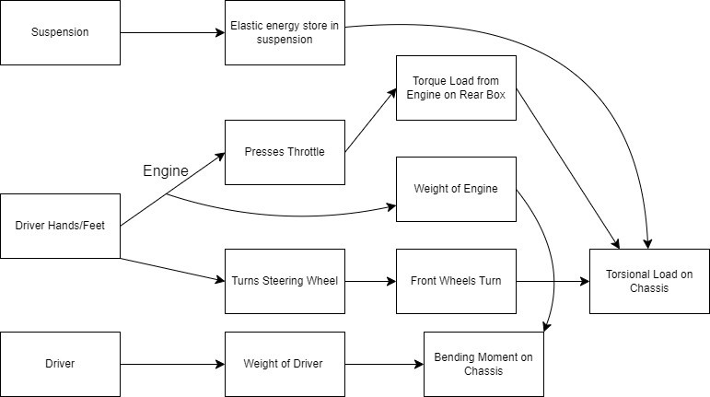
Figure 34: Functional Decomposition for Chassis
Next is the functional model for the chassis. It’s end goal is the same as the black box, which is that chassis remains rigid. This model dives deeper into the interactions with the chassis and the associated outputs and system behavior.

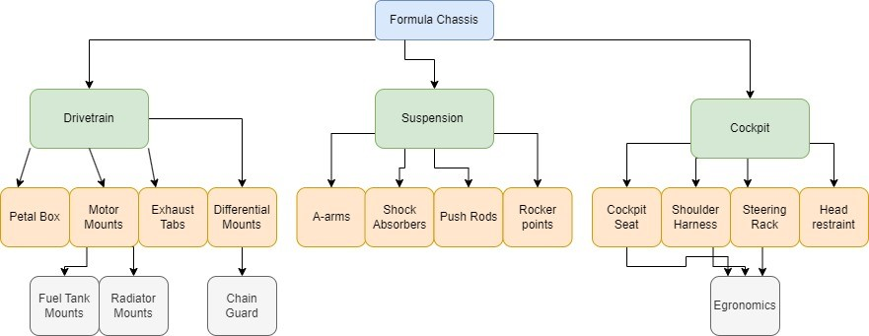
Figure 35: Physical Decomposition for Chassis
The physical decomposition consists of all the components that are connected to the chassis. All need to be considered in order for the sub-teams to successfully integrate their designs onto the chassis. Keeping track of all the components helps with organization and not forgetting what is needed.

Process Diagram (Gustavo Ruiz)
The process of finalizing the seat design is critical to the success of the FSAE chassis and its related subsystems. The seat design establishes the location of the driver’s seat by finalizing the seat mounts and brackets, locking in its position within the chassis. This step provides a foundation for subsequent design elements, such as the exhaust and fuel tank. Once the seat position is finalized, the head restraint, which extends rearward of the main hoop, can be designed. The head restraint is essential for driver safety during impacts and serves as a spatial reference for the next step in the process.
With the seat and head restraint positions determined, the firewall can then be designed to fit snugly behind these components. The firewall serves to shield the cockpit from engine heat, enhancing driver safety while maximizing the available space in the engine box. This positioning ensures that the firewall aligns closely with the seat and head restraint, allowing for optimal use of chassis interior space. Finally, once the firewall’s design is finalized, the drivetrain team can proceed with designing, or at least adjusting the size, of the fuel tank and exhaust system based on the available space.
This process diagram is important because it ensures that each subsystem is addressed in a logical order, minimizing rework and ensuring compatibility. The process diagram will help the team stay on track with the project and meet necessary safety and performance requirements. As seen below in Figure 31, the process diagram shows the flow of these steps. The chassis team aims to complete this design process before the end of the semester.

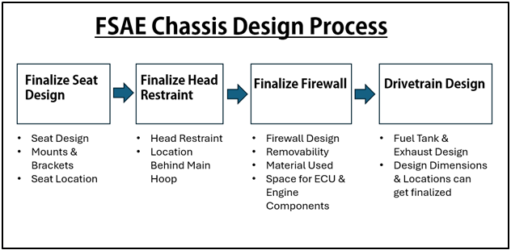
Figure 36: Design Process Diagram

Concept Generation

Chassis Generation Ryan Meger & Gustavo Ruiz
Table 1: Frame Design Concept Generation
Criterion | Design 1 (Final)  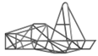 | Design 2  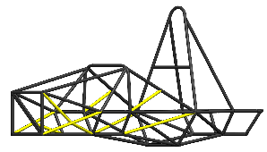 | Design 3  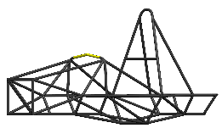 | Design 4  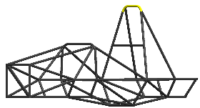
Torsional Rigidity | 4 | 5 | 4 | 4
Cost | 4 | 2 | 4 | 4
Weight (lbs.) | 4 | 1 | 3 | 4
Manufacturability | 4 | 2 | 3 | 3
Safety | 4 | 5 | 4 | 4
Total | 20 | 15 | 18 | 19

The concept generation for the chassis was kept simplistic to encourage specialized designs for the specific sections of the chassis design. The first design is our final design, having the third best torsional rigidity, which can be referenced in Table 4. It also is the second lightest, meaning it is cheaper and will perform better than the heavier frames. Design 2 wanted to incorporate more triangulation to increase torsional rigidity. It did by 15%, but at the cost of increases the weight by almost 12%. The weight increase did not justify the increased stiffness of the chassis, since our designs is stiff enough to be competitive. Design 3 aimed to change the design of the front hoop, allowing for more cockpit gauges and leg room to be possible. It did however make the front hoop more complex to manufacture and increased it weight. The last design aimed to making the main hoop less dramatic in its top bend. This would allow for better integration with attachments for aerodynamics. The bend would consist of two smaller bends, to make a flatter top surface to attach the aerodynamics to. Its design is great but would make manufacturing difficult and might not even be used if we don’t implement large rear wing.

Seat Belt Systems – Alexandra Brister
Table 2: Seat-Belt Systems Concept Generation
Criterion  Scale 1 to 5 | Design 1: 5-point  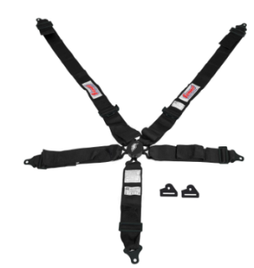 | Design 2: 6-point  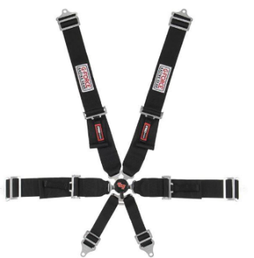 | Design 3: 7-point  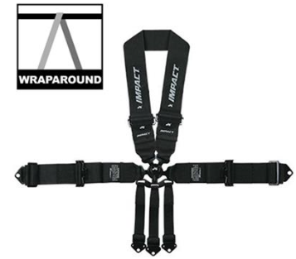
Cost:  1 being the most expensive  5 being affordable | 5  This is the most expensive option | 4  This option is expensive however it is more affordable than Design 1 | 1  This is the cheapest option however it would not be able to endure the stresses
Force Distribution:  1 very poor force distribution, with significant pressure on small areas  5 Force distribution across the body, minimizing the pressure points | 3  This option is a 5 point seat belt system and would have poor force distribution on all belts. This would add pressures on the driver | 4  This option would enough for the stresses and forces it will endure. It will evenly distributing the stress and forces | 5  This design would over-engineered design and unnecessary for the forces and stresses hat it would endure.
Comfort:  1 Uncomfortable, causes pain and discomfort  5 Very Comfortable, can wear belt for long periods | 2  With the 5-point seat belt it puts pressure or could cause pain for the driver in some areas | 4  This would be the most comfortable because the forces are evenly disturbed on all the belts | 3  This system would be uncomfortable because of the amount of belts can cause discomfit and interfere with the driver
Durability:  1 very low durability, wears out quickly  5 the system is built to withstand wear and tear | 4 | 5 | 5
Safety:  1 Poor protection, high risk during impacts  5 Excellent protection, low risk during impacts | 3 | 5 | 5
Total: | 17 | 22 | 19

Based on the concept generation table, the 6-point seat belt system is the best choice, it offers balance of comfort, cost, and safety. While the 7-point seat belt systems would provide better protection, the cost is extremely high and due to the complexity, it ranks lower than the 6-point system.

Nose Cone Designs – Ryan Meger
Table 3: Nose Cone Designs
Criterion  Scale 1-5 | Design 1:  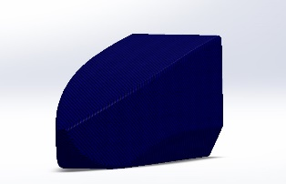 | Design 2:  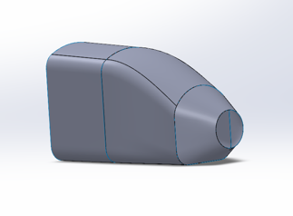 | Design 3:  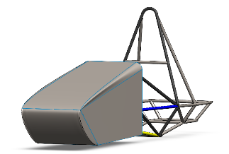
Driver Visibility | 3 | 5 | 3
Performance | 4 | 3 | 3
Removability | 5 | 3 | 5
Applicability | 4 | 3 | 4
Total: | 16 | 14 | 15

The first design is used a combination of both design two and three CAD techniques. It was difficult to have the nose cone huge the frame in design three. Using the techniques from design two, the final design was made possible. The winning design is also compliant with the FSAE rule book. Stating the front end of the nose cone can not be smaller than 38mm radius. It is also sleek improving aerodynamics and covers the suspension allowing for high applicability towards integrating with the rest of the chassis. The removability was the highest due to recent adjustments. The nose cone has been cut to have a hood, which was sourced from design three having a large sleek top.

Selection Criteria

Chassis Selection Criteria – Gustavo Ruiz
The selection of the final chassis frame design was based on five primary engineering criteria: torsional rigidity, cost, weight, manufacturability, and safety. Each criterion is rooted in the engineering requirements of the chassis and can be quantified through calculations and well-established specifications.
Torsional rigidity is a critical parameter for the chassis frame as it directly affects the vehicle’s handling and overall structural stability under dynamic loading conditions. The torsional rigidity of each frame design was found by using SolidWorks Simulation for stress and torsional rigidity. A summary of the torsional stiffness values for the evaluated designs is presented in Table 4.
Table 4: Design Torsional Rigidity
Design Option | Torsional Stiffness (Nm/°)
Design 1 | 2009.25
Design 2 | 2321.7
Design 3 | 2091.05
Design 4 | 1948.27

The cost analysis focused solely on the material cost. For the materials, we obtained quotes from Industrial Metal Supply and Online Metals for the steel tubing used in the designs. The manufacturing cost was estimated based on the complexity of the frame constructing, including the number of welds, joints, structural members with respective cuts, and specialized process required such as tube bending. Based on the frame design concept generation showed earlier in table 1 our final design which is design 1, design 3, and design 4 have a really similar amount if each sized tube; 17 feet of Size A tube at $8.85 per foot totaling to $150.45, 37 feet of Size B tube at $9.80 per foot totaling to $363.00, and 46 feet of Size C tube at $10.11 per foot totaling to $465.06. Our design 2 received the lowest score for cost due to more structural members, where it has 8 feet more of size B tubing and 5 feet more of size C tubing, totaling to a total of around $125.00 more, and we also need to consider purchasing for safety stock in case of any mistakes or variability in usage.
The weight of the chassis is a key factor in the overall performance of the vehicle, particularly in terms of acceleration, braking, and fuel efficiency. The total mass of each chassis design was found from SolidWorks “Mass Properties” tool, after setting the frame material to AISI 4130 steel annealed at 865°C. The lighter the frame, the better the vehicle performance would be, as long as the design still met safety requirements. Table 5 below shows the weight for each design.
Table 5: Design Total Weight
Design Option | Weight (lbs.)
Design 1 | 62.72
Design 2 | 69.97
Design 3 | 63.01
Design 4 | 62.67

Manufacturability was evaluated based on the complexity of the design and the ease with which it could be fabricated using available tools and processes. This including assessing the number of welds, the complexity and amount of tube notching and tube bends. Designs that required more complex jig setups and specialized tube bending were deemed less favorable. Design 2 had more structural support members so that meant more difficult to reach welds, and more tube notching so it received the lowest score. Designs 3 and 4 had one to two more bends so the bending of the those would require more time in the machine shop compared to design 1, which only had seven total bends.
Safety is a paramount and was evaluated based on the ability of each design to protect the driver in the event of the crash, our reengineering requirements are all from the FSAE rulebook. This includes compliance with FSAE safety rules and regulations, as well as the frame’s overall structural integrity. Stress analysis simulations were performed to assess the energy absorption capabilities and determine the likelihood of failure under front and side impact conditions.

Seatbelt Selection – Alexandra Brister
In evaluating potential seat belt systems, a selection criteria framework was established to assess each design based on five critical categories: Cost, Force Distribution, Comfort, Durability, and Safety. Each category was rated on a scale from 1 to 5, with 1 representing the least favorable outcome (e.g., most expensive, least comfortable, poor protection) and 5 representing the most favorable (e.g., most affordable, most comfortable, best protection).
Cost assesses the affordability of each design, crucial for large-scale implementation.
Force Distribution evaluates how well the system spreads impact forces across the body to minimize injury.
Comfort considers user experience, particularly during prolonged use.
Durability measures the design’s ability to withstand wear and tear over time.
Safety focuses on the system’s ability to protect the occupant during a collision.

Table 6: Seatbelt Selection
Criterion | Design 1: 5-Point | Design 2: 6-point | Design3: 7-point
Cost | 5 | 4 | 1
Forces Distribution | 3 | 5 | 5
Comfort | 2 | 4 | 3
Durability | 4 | 5 | 5
Safety | 3 | 5 | 5
Total | 17 | 22 | 19
Each criterion was weighted equally, and the total scores were calculated by summing the ratings across all categories. This systematic approach ensures that the selected concept performs well not just in protection, but also in usability and cost-effectiveness.

Front Wing Selection Criteria
There will be four criteria for the front wing. The first being aerodynamic performance, structural integrity, rule compliance, and manufacturability. Aerodynamic performance will be based off drag and lift coefficients that ran through a MATLAB code developed by a teammate. Structural integrity refers to a rule in the FSAE rule book. Rule T.7.1.3 says, all aerodynamic devices must be rigid and have no excess deflection. Regulatory compliance will ensure the wing follows all rules. The main rule being that it must be within the aerodynamic envelope of the car, and that the edges have to be within a specific radii of greater than 5mm horizontally and 3mm vertically.

Rear Wing Selection Criteria
There will also be four main criteria for the rear wing: aerodynamic performance, structural integrity, rule compliance, and manufacturability. Aerodynamic performance will focus on maximizing the lift-to-drag ratio, evaluated using MATLAB simulations and CFD outputs to ensure the wing contributes to overall downforce with minimal drag penalties. Structural integrity will be assessed according to FSAE Rule T.7.1.3, requiring that all aerodynamic devices, including the rear wing, remain rigid under load with no significant deflection. Rule compliance will verify that the rear wing remains within the allowed aerodynamic envelope and does not exceed height or width limitations outlined in the FSAE rulebook. Additionally, the rear wing must meet the same edge radius requirements as the front wing, with all exposed edges having radii greater than 5 mm horizontally and 3 mm vertically. Manufacturability will ensure that the rear wing can be produced using the team’s available tools and materials, while also being easy to assemble and repair as needed throughout the season.

Firewall Selection Criteria
There are five criteria for the firewall, but all are focused mainly around making the firewall removable which is the main criteria for these designs. The first criteria are resistance to radiation heat transfer which is done through polishing aluminum to reflect heat coming off the exhaust, Information regarding why this was done, and the emissivity and reflectivity of the aluminum can be found in section 6.3.1. The other criteria consist of Complexity, Manufacturability, and Ergonomics. To be rule compliant and to ensure this design doesn’t affect other sub teams components of the vehicle these five criteria were selected to base the final design off. It is also important to note that these criteria were also selected based on section T.1.8 from the FSAE 2025 rule book regarding the firewall.

Concept Selection

Concept Selection for Chassis Design (Ryan Meger)
Table 7: Concept Selection for Chassis Design
 | Weight (1-5) | Design 1(datum) | Design 2 | Design 3 | Design 4
Torsional Rigidity | 4 | + | ++ | 0 | 0
Cost | 3 | + | - | + | 0
Weight | 4 | + | - | 0 | 0
Manufacturability | 4 | 0 | - | - | 0
Safety | 5 | 0 | + | - | +
Total |  | +3 | 0 | -1 | +1

Selection and design of the frame was completed over the summer of 2024. Consideration of different designs can be seen above. Slight changes were made to each design to keep simplicity to a maximum. Going with complex designs can cause roadblocks that a second-year team is not prepared to handle. The idea with these changes was to see if they improve rigidity, cost, weight, safety and manufacturing. Design one is the datum. Created in SolidWorks over the summer, it follows a similar design to last year. This year we have wanted the car more ergonomic for the driver. Making the cockpit wider and moving the front hoop forward and upward. Design two aimed at making the frame more rigid, improving the handling of the vehicle under dynamic conditions. This came at a cost of weight, adding 12 percent. Since the addition of an aerodynamics kit, saving weight has been a priority of the team, making design two not applicable this year. The third design incorporates a high bend in the front hoop. Giving more room in cockpit for the dash, steering rack, and driver. This bend would require more equipment which would have to be taken out of the budget, and more time to bend it in the machine shop. Due to this, the more simplistic design of the datum is more realistic. The fourth design is like the third, making more bends. The bend in design four add more room inside the cockpit, aiding our design choice of making the car more ergonomic. As said in the last design, the extra bends would take more time to manufacture and add complexity. For these reasons design one is the chosen chassis design we will be using for this year’s car.

Seatbelt Selection – Alexandra Brister
Three seat belt designs were analyzed using the defined selection criteria: a 5-point system (Design 1), a 6-point system (Design 2), and a 7-point system (Design 3).
Design 1 (5-point) scored 17. While it is durable and relatively safe, it is the most expensive and scores poorly on comfort and force distribution, making it less desirable overall.
Design 2 (6-point) scored the highest with a total of 22. It offers a balanced combination of affordability, excellent force distribution, high comfort, maximum durability, and top-tier safety. It was deemed the most practical and effective design.
Design 3 (7-point) received a score of 19. Despite being the safest and most affordable option, its over-engineered structure is unnecessary for the intended forces and can lead to discomfort, negatively affecting user experience.
Based on this assessment, Design 2: 6-point seat belt system was selected as the optimal concept. It meets all essential performance and usability requirements while maintaining a cost-effective approach, making it the best choice for implementation.

Front Wing Concept Selection
Table 8: Front Wing Concept Selection
Criteria | Weight(1-5) | Design 1  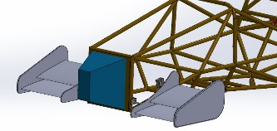 | Design2  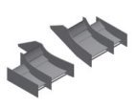 | Design 3  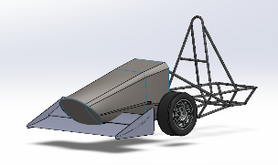
Aerodynamics | 4 | - | ++ | 0
Rigidity | 4 | + | - | -
Rule Compliance | 5 | + | + | +
Complexity | 3 | + | - | 0
Total |  | +3 | +1 | 0
The Pugh chart shows the chosen design is the first one. In MATLAB the second design showed the most negative aerodynamic lift, putting the most downforce to the ground. This design would be great to use, but it is out of our ability and budget to create such a wing. The third design is very simple, not giving it much aerodynamic ability. The integration to the frame would also be difficult, not allowing solid support to the frame by interfering with the nose cone. Making rigidity a problem, which is reflected in the chart. The first design takes inspiration from the third design, being two airfoils design which a level of complexity the team was ready to tackle. It was also a complaint with the rule book and was easily integrated into the frame. Having two rods extend from welded mounts on the frame. Although it did not align up to the aerodynamic capabilities of the other two designs, the team felt it was the best fit all around. Giving the aero team the ability to create such a design with the knowledge and tools we have available to us.

Rear Wing Concept Selection

Firewall Concept Selection – Brandon Guzman:
Table 9: Firewall Concept Selection
Criteria | Weight (1-5) | Design 1:  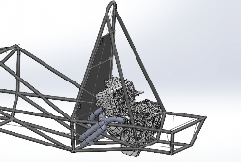 | Design 2:  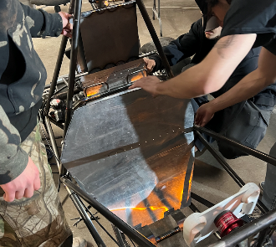 | Design 3:  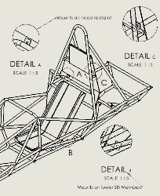
Prevents radiation heat transfer | 3 | + | + | +
Complexity | 2 | + | - | +
Removable | 4 | - | ++ | +
Manufacturability | 3 | + | + | +
Ergonomic: | 2 | - | - | -
Total: |  | +3 | +4 | +4

Defined in the Pugh chart above is the concept selection table for the final design of the firewall which is depicted as design two. It is important to note that this final design was tied with design three but was still selected because of several factors. Additionally, every single one of these designs will utilize reflective aluminum to prevent most of the heat radiating off of the exhaust from reaching the cockpit. As far as the final selected design goes, this was chosen because all together is one piece compared to design three which would've been two pieces and much harder to place into the frame with all other components accounted for, which was discovered during the manufacturing process. Which basically makes design two an upgrade of design three that additionally meets the team's goal of making the firewall Removable. Design one was used as a frame of reference and was the first iteration of the firewall using CAD.

Project Management

Schedule
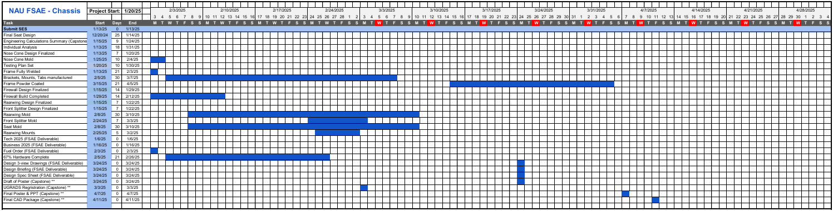
Figure 37: Schedule for Frame-Body-Aero

Budget
Table 10: Chassi Budget
Chassis Budget
Category | Units | $/Unit | Total
Frame
Size A Tubing | 18.02 | $28.75 | $518.08
Size B Tubing | 36.1 | $7.10 | $256.31
Size C Tubing | 40.4 | $11.33 | $457.73
Size D Square Tubing | 1 | $45.60 | $45.60
Front Bulkhead Sheet | 1 | $56.36 | $56.36
Prototype
PVC 1in Pipe | 10 | $8.48 | $84.80
Duct Tape | 2 | $8.98 | $17.96
Jigging
Material |  | $336.40 | $336.40
Welding
Tig Rods ER70S-D2 | 1 | $50.00 | $50.00
Argon | 1 | $65.00 | $65.00
Safety Equipments
Impact Attenuator | 1 | $210.00 | $210.00
Harness | 1 | $260.00 | $260.00
Tabs & Fasteners | 1 | $200.00 | $200.00
Head Restraint | 1 | $100.00 | $100.00
Seat | 1 | $350.00 | $350.00
Floor Closeout | 1 | $100.00 | $100.00
Firewall | 1 | $150.00 | $150.00
Aero
Body Panels | 1 | $300.00 | $300.00
Aero Molds | 1 | $2,000.00 | $2,000.00
Front Nose Cone | 1 | $500.00 | $500.00
 |  | Total | $6,058.24

Bill of Materials (BoM) For FSAE Frame-Body-Aero

Frame and Jig
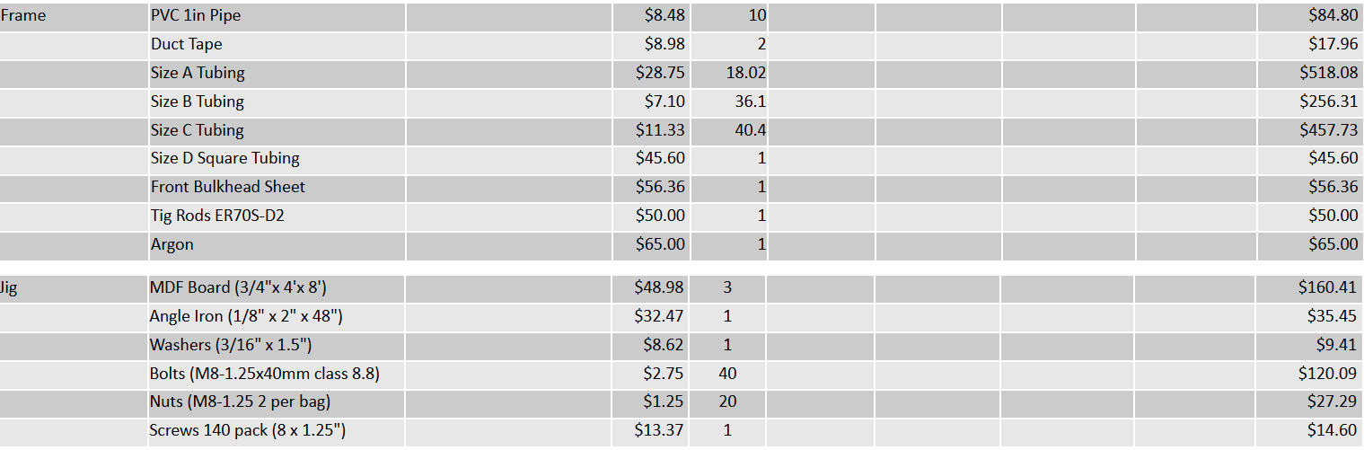
Figure 38: Frame and Jig BOM

Seat
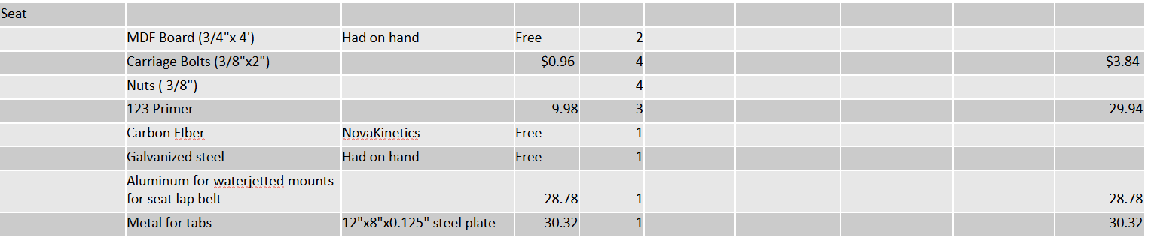
Figure 39: Seat BOM

Firewall
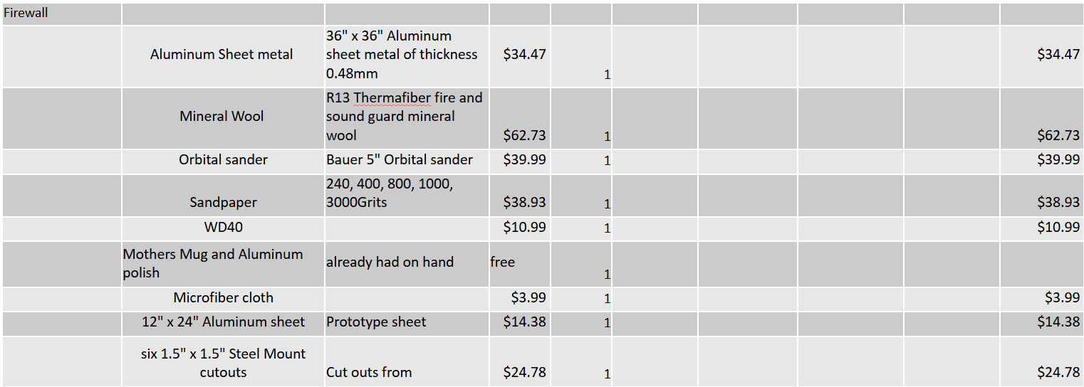
Figure 40: Firewall BOM

Nose Cone
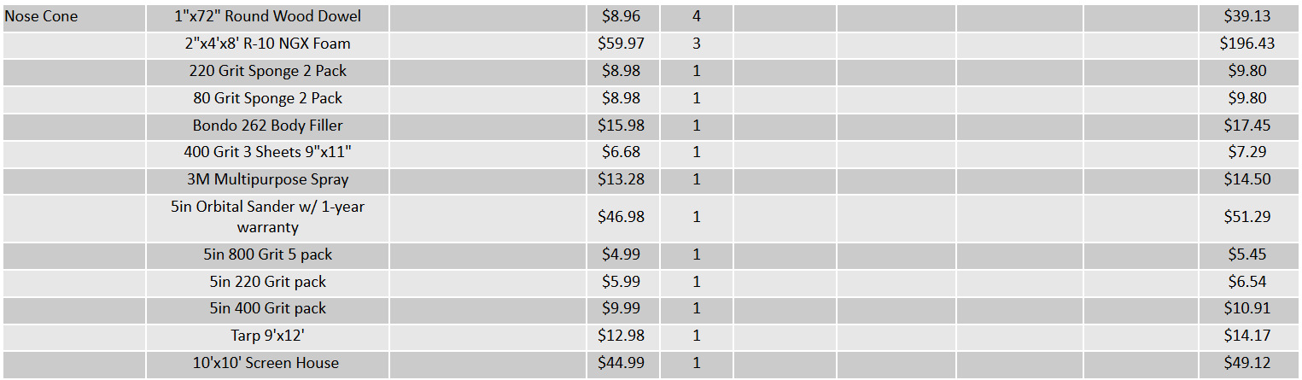
Figure 41: Nose Cone BOM

Front Wing
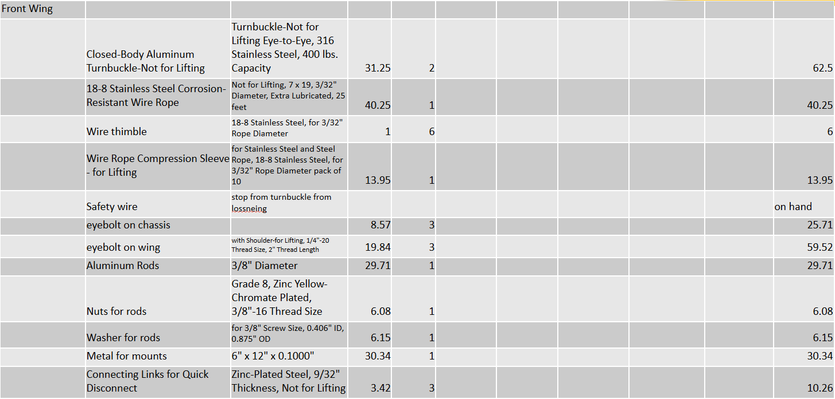
Figure 42: Front Wing BOM

Rear Wing
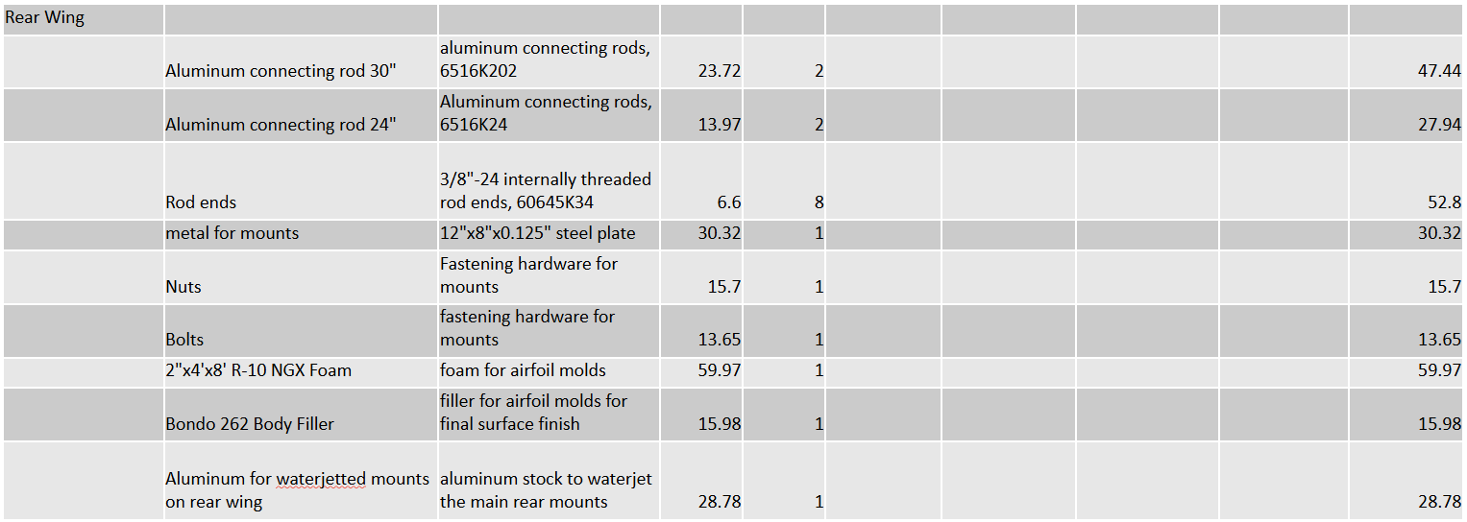
Figure 43: Rear Wing BOM

Safety Equipment
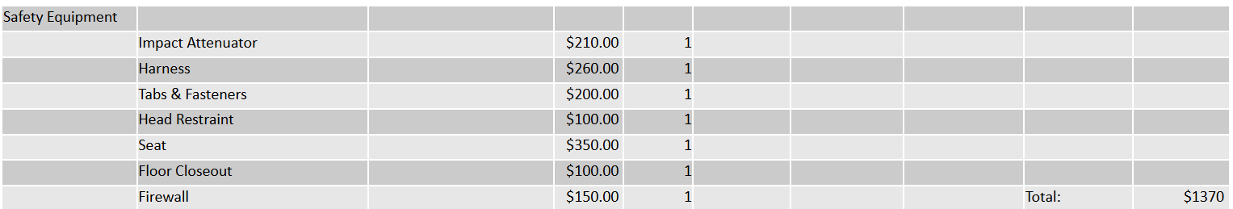
Figure 44: Safety Equipment BOM

Design Validation and Initial Prototyping

Failure Modes and Effects Analysis (FMEA)

Frame – Ryan Meger
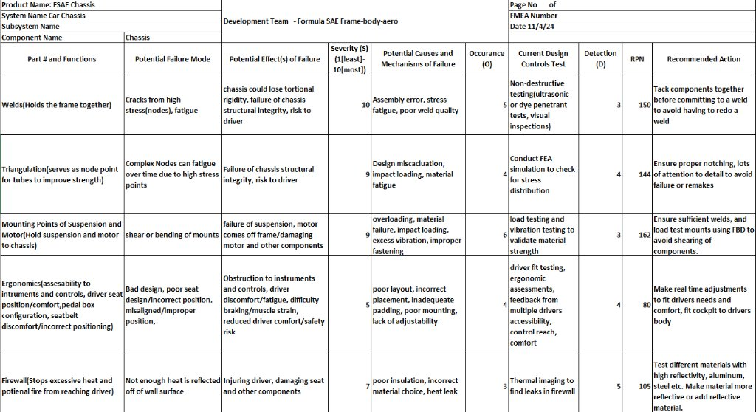
Figure 45: Chassis FMEA
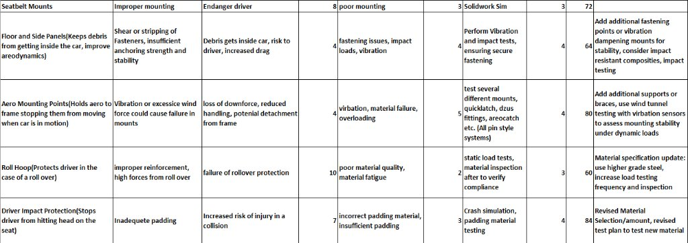
Figure 46: Chassi FMEA cont.
Performing an FMEA on the chassis is important to ensure no catastrophic failures arise during testing or racing. To name a few critical potential failure points would be the weld, mounting points, firewall failure, ergonomics failure, and aerodynamic mounting points, and triangulation failures. To mitigate these design failures analyses on each system were done. For the weld, ultrasonic tests can be performed that don’t impact the integrity of the welds. Mounting point failures can be mitigated using simulation software like SolidWorks and Ansys. Load testing can also be conducted to find the max load the mounting points can withstand. Firewall failure has a high RPN value and is important to mitigate. Through thermal camera testing and calculations to find the temperature on the back of the cockpit seat will be essential in ensuring the firewall doesn’t degrade or fail over time. Using flame retardant materials are also a nice layer of safety that should be included. An ergonomics failure would include driver discomfort and inaccessibility to the controls. A mitigation tactic will have a wide range of adjustability regarding pedal and seat position to accommodate multiple drivers. An aerodynamic mounting point failure would happen under aerodynamic load or heavy vibration. A mitigation avenue the team has been considering is using ample vibration damping and conducting FEA analysis on mounting brackets. Lastly, the triangulation points will be mitigated with FEA cycle simulations on the chassis and regular maintenance checks to ensure the stress points have not shown damage.
Our team has prioritized critical safety features to investigate before looking at less important potential failure points. We concluded that the welds, triangulation points and mounting points are the most important, where consequences of failure are the most severe. The risk trade-offs for the welds that testing would increase cost and time, but improved safety outweighs a catastrophic failure of the chassis. For the triangulation points, adding in addition reinforcement would raise the weight of the chassis. However, it would enhance safety and rigidity of the chassis. Mounting points would be designed for a long service life, by increasing the design complexity or robustness. This would take more time to design but would reduce the likelihood of failure.

Aerodynamics – Ryan Meger
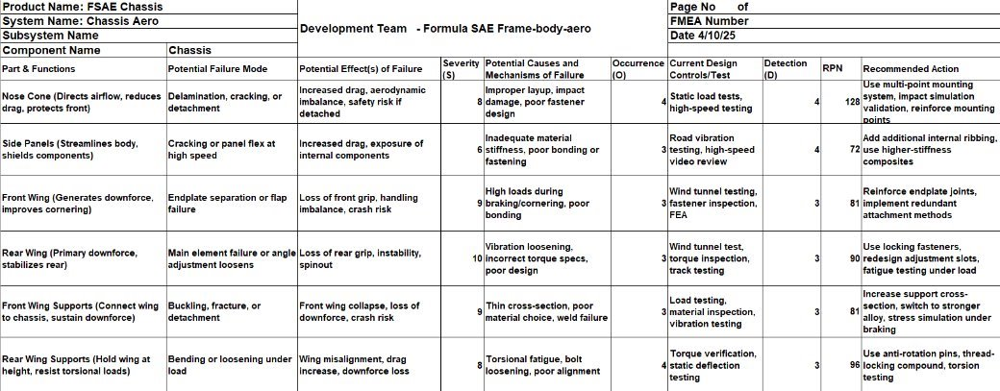
Figure 47: Aerodynamics FMEA
The aerodynamic package for this year consists of a front wing, nose cone, rear wing, side panels and their mounting systems. The nose cone is the largest piece of the package, encountering the most amount of air. Leaving it at risk of delamination or detachment from the car. The causes of this could be the amount of air it encounters or poor fastener design. A failure from the nose cone could cause increased drag and risk of being a safety hazard. To test this
The side panels are not a high-risk part of the assembly. The only forces they will encounter is the air current and the forces of the car driving. Potential failure mode could be cracking or panel flexing at high speeds. This would cause increased drag and exposure of internal components. A cause of these failure modes could be inadequate material stiffness or poor fastener design.

Overview – Ryan Meger
The FMEA charts are crucial in the design and testing of the race car. Having an idea of weak points or potential failure points can give the team specific areas to review during the manufacturing and testing. There is a person driving the car, so having an outline like this will minimize the potential of injury. The charts organize and make the information easier to read, making the review process easier. Having any of the systems fail during the race could result in the car not placing in the competition or being disqualified. Having an overbuilt system will minimize or eliminate these failure points, which is what we have designed the car to be. However, prototyping these system to ensure they check off our list of requirements is just as important to figure out unforeseen issue.

Initial Prototyping

Alexandra Brister – Seat Prototype
This is a virtual prototype which shows the design of the seat for the vehicle. This design shows the ergonomic contours and the lightweight material for the driver's comfort while driving. There are slots for the seat belt system to connect through, there are also holes to connect the seat-to-seat mounts. This prototype prioritizes functionality, comfort, and safety.
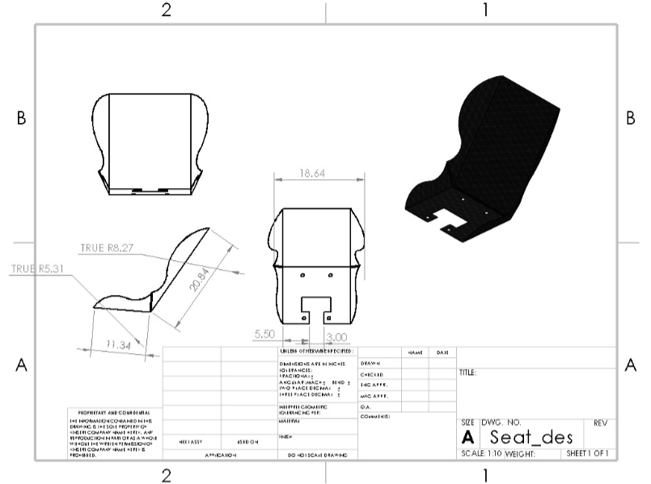
Figure 48: Initial Seat Design

Ryan Meger – PVC Prototype
The PVC prototype was a 1 to 1 scale PVC and duct tape model of the chassis. Having this type of prototype will serve to test improvement of ergonomics and ensuring the SAE Formula cockpit templates fit into our chassis. To improve ergonomics compared to last year’s design, the front hoop was moved 3 inches back and 3 inches up. This would provide easier access to the steering wheel and instruments, while also providing more leg room for the driver. Given the car must adhere to the rulebook, two templates are required to fit inside the cockpit and front hoop area. The team must check the templates fit to pass technical inspection.
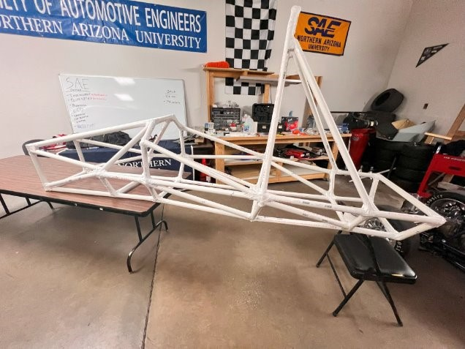
Figure 49: PVC Prototype
Once we were done with the prototype, the cockpit area visually looked bigger. We all sat inside the prototype, and all say improvements in elbow room and leg room near the front hoop. Next, we cut out the templates to the require dimensions and found both fit comfortably inside the prototype. Images below show the template compliance. The new design of the chassis informed the team the chassis design improved over last year ergonomics and would pass the technical inspection.
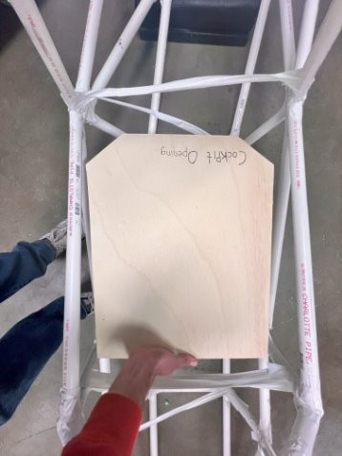
Figure 50: Cockpit Opening Template
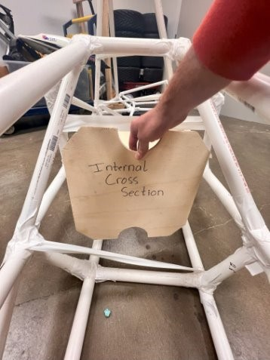
Figure 51: Internal Cross Section Template

Gustavo Ruiz – Tube Templates for Notching Prototype
The team developed a prototype process for creating tube notching templates to improve the efficiency and accuracy of building the chassis for the FSAE car. Although it required extra time to design and apply the templates to each tube, this approach ensured precise cuts and an organized manufacturing process.
Using SolidWorks, I isolated individual frame members from the chassis design, as shown in Figure 36, where a tube in the frame is highlighted and made into its own part. I then added a thin line to the front profile of each tube and used an extruded cut to represent the notch. The Sheet Metal flattening tool was used to create flat templates that could wrap around the tubes. These templates were turned into drawings, as seen in Figure 37, where the tube is shown in the flattened sheet metal feature.
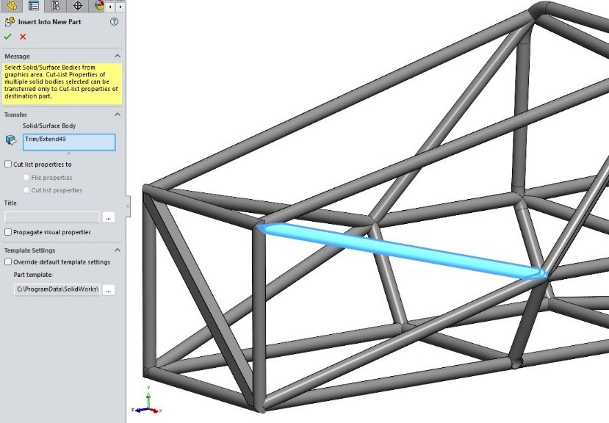
Figure 52: Insert Into New Part Feature on SolidWorks
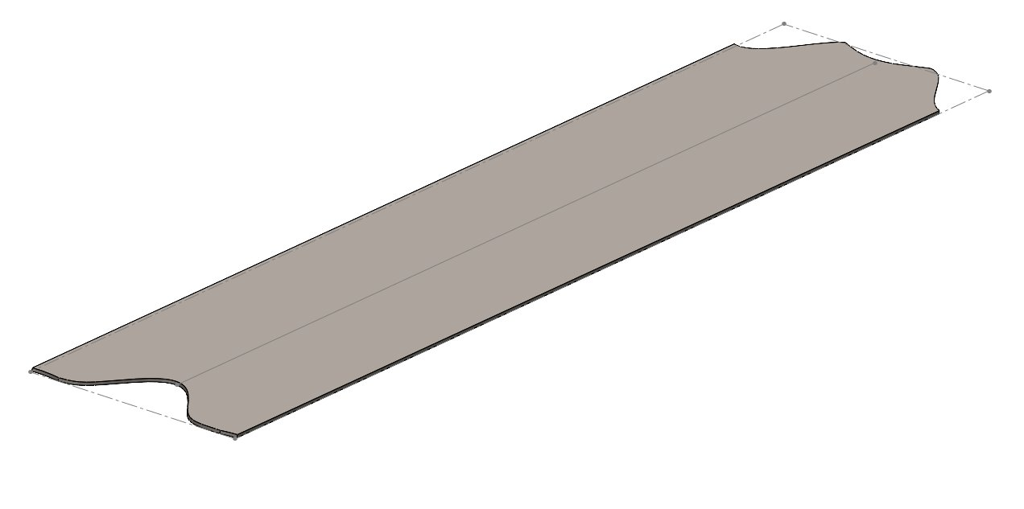
Figure 53: Flattened Tube for Template
Initially, the templates didn't match the tube's circumference because the K-factor was set to 0.5 instead of 1. After adjusting the K-factor, the templates matched the calculated circumference of a 1-inch tube (3.14 inches). I also used SolidWorks’ Trim and Extend tool to modify the tube ends based on how they connected at nodes.
The process involved cutting the tubes to length, marking centerlines for alignment, and wrapping the templates around them. As shown in Figure 54, the tube template is taped onto the tube with a centerline for reference. The templates were traced with markers to create durable guidelines for notching. The completed tubes were then checked for fitment in the jig, which the welder confirmed was accurate.
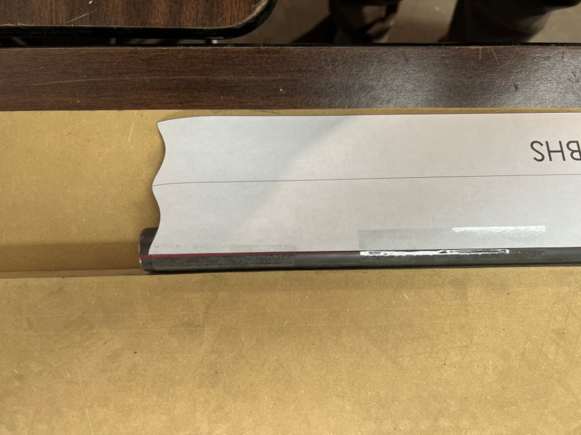
Figure 54: Tube Template Applied to Tube

Gustavo Ruiz – JIG Design Prototype
The chassis jig was designed to hold the frame at specific angles for welding or tacking. The jig included eight planes made of MDF boards, which were strategically placed between sections with angled tubes to ensure proper alignment and accessibility for welding. Each section plane was spaced to accommodate the tubes while leaving room for the welder to work, although some parts were tight. As the welding progressed, certain MDF sections were removed to allow access to different areas.
To create the jig, I used SolidWorks to design the section planes, ensuring they were properly spaced between the front bulkhead, front hoop, and front suspension box. The challenge with angled tubes was that they intersected the planes as ellipses, not perfect circles. To address this, I used the "Convert Entities" tool to create accurate intersections for the tube shapes. I then designed cutout templates for each section, ensuring they were wide enough to fit the tubes snugly but not obstruct their path. Figure 39 shows the first MDF cutout sketch for the first section and first plane.
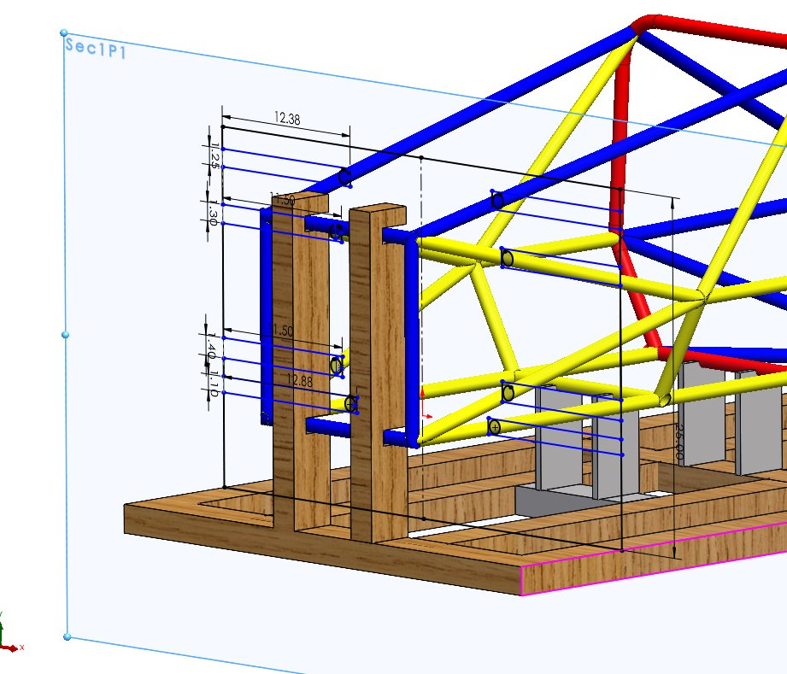
Figure 55: 1st MDF Sketch on 1st Plane of 1st Section
During the process, adjustments were made to the cutouts to prevent interference with the tubes, especially as the MDF boards were ¾ inch thick. The final design was mirrored to maintain symmetry, and the CAD files were used to cut the MDF boards to size. Additionally, modifications were planned for the front bulkhead area to accommodate the anti-intrusion plate support. Figure 40 provides a side view of the tube entering the MDF board to ensure the tube does not intersect with the thickness of the MDF.
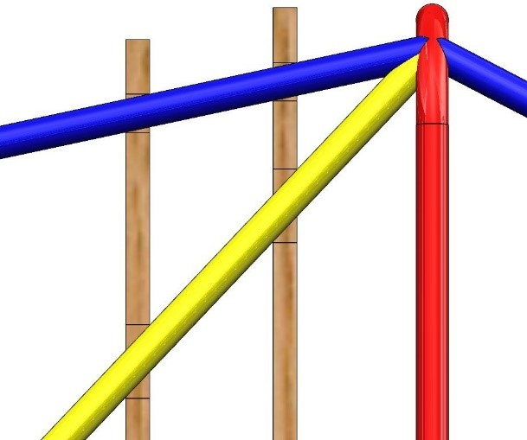
Figure 56: Side View of MDF Board w/ Respect to Tube
The completed jig design provided the necessary structural foundation for accurately welding the chassis components together. Figure 57 displays the completed jig with the frame, featuring transparent MDF boards for better viewing.
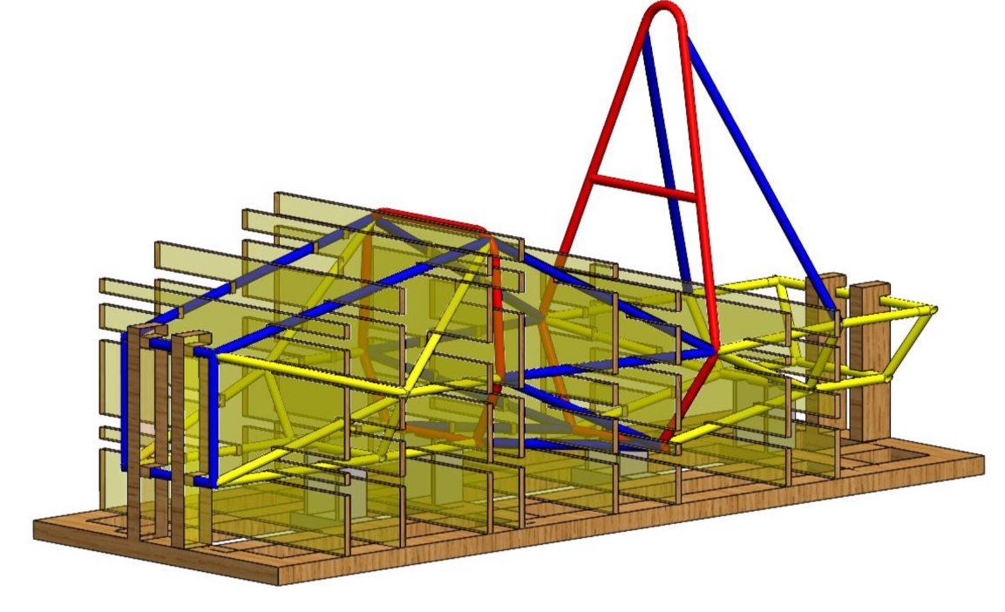
Figure 57: JIG Design

Gustavo Ruiz – Front Bulkhead Prototype
The front bulkhead is a critical part of the car’s frame, designed to protect the driver's feet. It is made from size B tubing, with 45° angle cuts on all four sides instead of bending the tubes, as bending was difficult to control. A chop saw was used to make these cuts. The bulkhead also includes a size D square tube running diagonally for the anti-intrusion plate support. To ensure accurate cuts, we created a template for the square tube instead of eyeballing it. Figure 42 shows the cutout template for the anti-intrusion plate applied to the square tube.
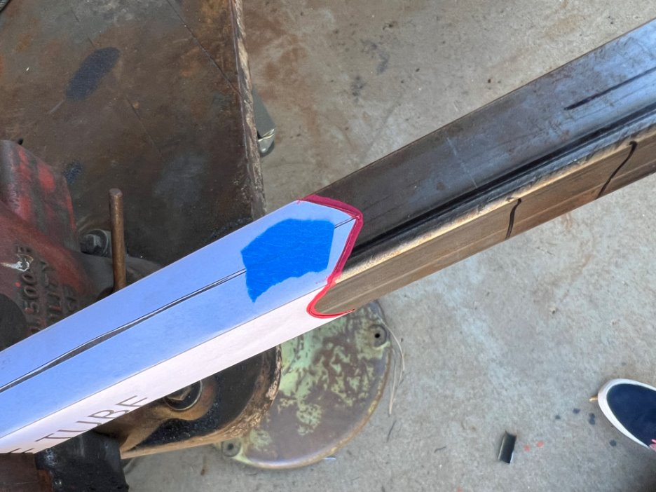
Figure 58: Anti-Intrusion Plate Support Cutout Applied
During the fitting process, we had to grind the inner corners of the bulkhead members to reduce gaps and make welding easier. Once the fit was correct, we tacked the pieces together and then welded them fully, establishing a solid reference for the front hoop and other parts of the frame. We also learned that using a template for the 45° cuts would have provided more accuracy and saved time compared to relying on the chop saw alone. Figure 59 shows the completed welded front bulkhead.
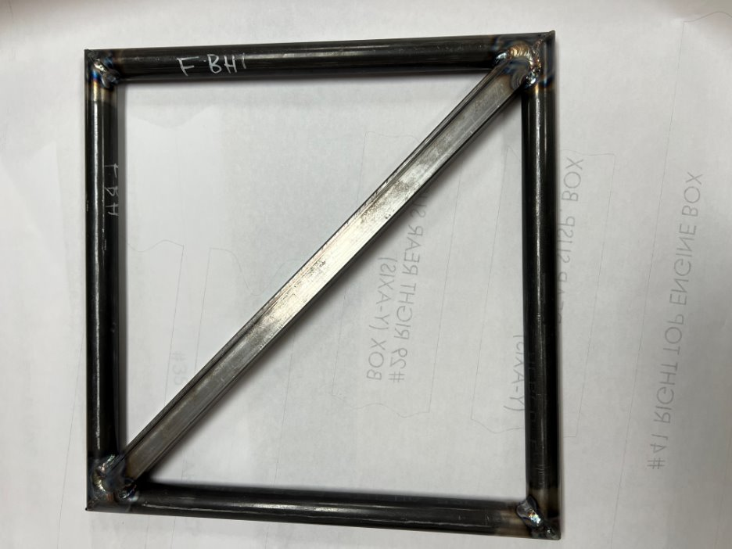
Figure 59: Front Bulkhead

Gustavo Ruiz – Frame Cut list Prototype
The frame with the cut list prototype helped us ensure the efficient and accurate fabrication of the chassis with minimal errors in cutting, assembly, and welding. By using the frame cut list along with a balloon diagram, we organized a material inventory that outlined how much tubing of each size was needed, as well as what had been used or cut. This allowed us to determine the exact length to cut each tube, such as item number 10, the left lower side impact structure, which needed to be 26.7 inches long. Having this precise information also helped us plan tube notching by giving us extra length for adjustments.
The cut list also streamlined our tube preparation process. By organizing the cuts in sequence from front to back, we could plan which parts needed notching first and ensure no misalignment of the tubes. Additionally, the frame cut list was crucial for designing the jig, as it helped define tube positions and ensured accurate dimensions to avoid interference with the MDF board. This approach minimized trial and error and accelerated the chassis assembly process, especially in preparing the front components. Figure 44 will show the frame with a balloon diagram aligned with the cut list for further clarity.
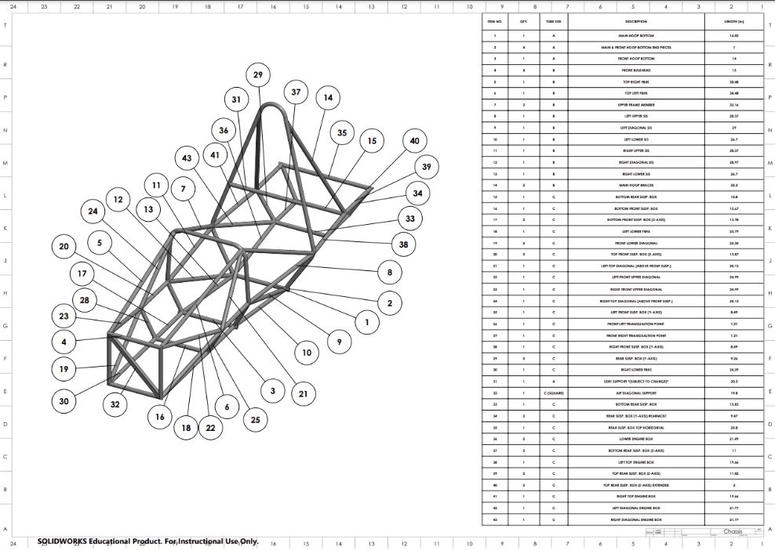
Figure 60: Frame w/ Cut List

Brandon Guzman – Firewall Prototype:
Defined below is the first iterations of the firewall design for the 2025 car. It is important to note that this design is subject to change as the placement of many components has not been finalized. The goal is to design a firewall that can prevent any component the driver touches from exceeding 60°C
[12b], the mathematical analysis for the radiation emitted from the exhaust will be defined in section 6.3. The firewall will be constructed of aluminum sheet metal that has been polished to reflect radiation heat transfer from the exhaust behind the driver seat, this material was selected because polished aluminum reflects 85-90% of radiation heat. Prototyping firewall designs will allow for a theoretical thermal resistive network to be created for the aluminum sheet acting as a radiation shield.
Using SolidWorks assembly, the first iterations of these prototypes were brought to life for visual simplicity. Included in the figure below is the firewall design fitted onto the chassis using Dzus fasteners, these fitting will allow the firewall to be removable and were selected because of their strong resistance to vibration.
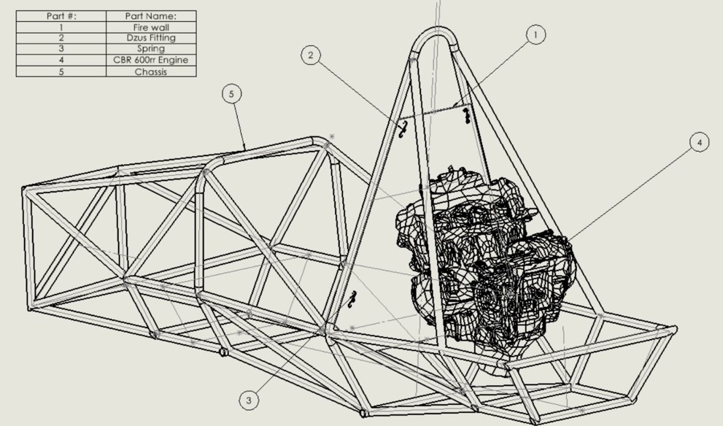
Figure 61: First iteration of firewall design
The iteration in Figure 61 is the first prototype created before the drivetrain sub-team had finalized the positioning of the exhaust. The next figure below is a more up to date version of the firewall design, this version was modified based on the final placement of more components. However, the tangible final design will be done by hand a little differently to ensure it is removable and 1 piece all together.
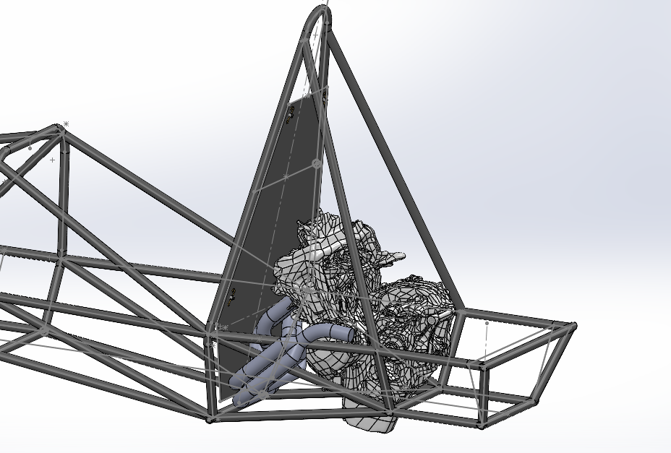
Figure 62: Final Firewall Iteration

Carson Kent – Front Wing and Nose Cone Prototype
In the images below, are the first iterations of the nose cone and front wing assembly for the car. The goal of this prototype is to create something that can be tested and iterated upon before coming to the final design. These initial designs were created in SolidWorks, and they are designed to be tested in Ansys Fluent in the near future. With this CAD model we will be able to create mounts for the separate pieces and also run aerodynamic analysis to find the amount of downforce these parts create.
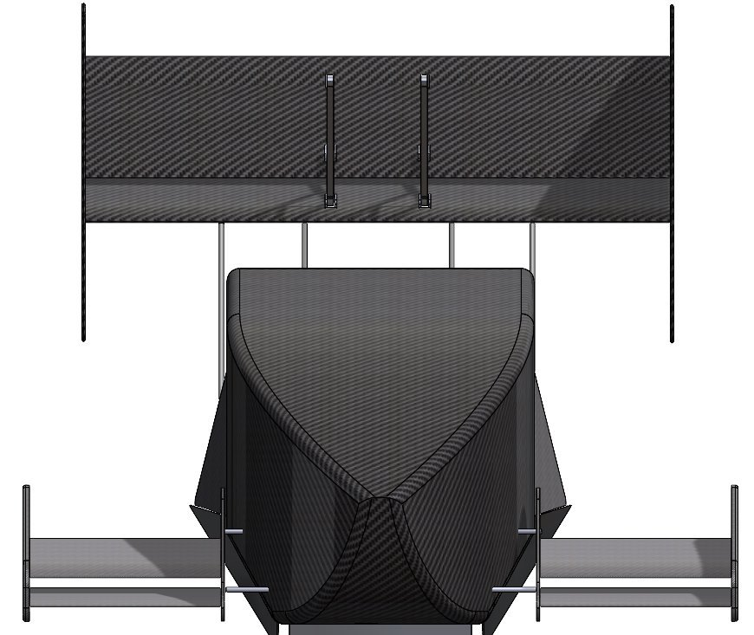
Figure 63: Current Aero Design
In Figure 63 the current full assembly of the aero components is displayed. Working with the suspension team I was able to get the exact location of the wheels and the suspension geometry. However, the suspension components were removed due to ease of input for Ansys Fluent. In the next few weeks there are plans to move forward with creating a foam mold of the nose cone to get ahead on that front. With this mold we can build our carbon fiber nose cone with the help of Nova Kinetics.
One aspect of the design that I may work to change is the very front portion of the nose cone because I believe it can be more aerodynamically efficient than it is at this point. Creating the front of the nose cone was mostly dependent on my ability to close that off, however now I think I can create a more efficient design.
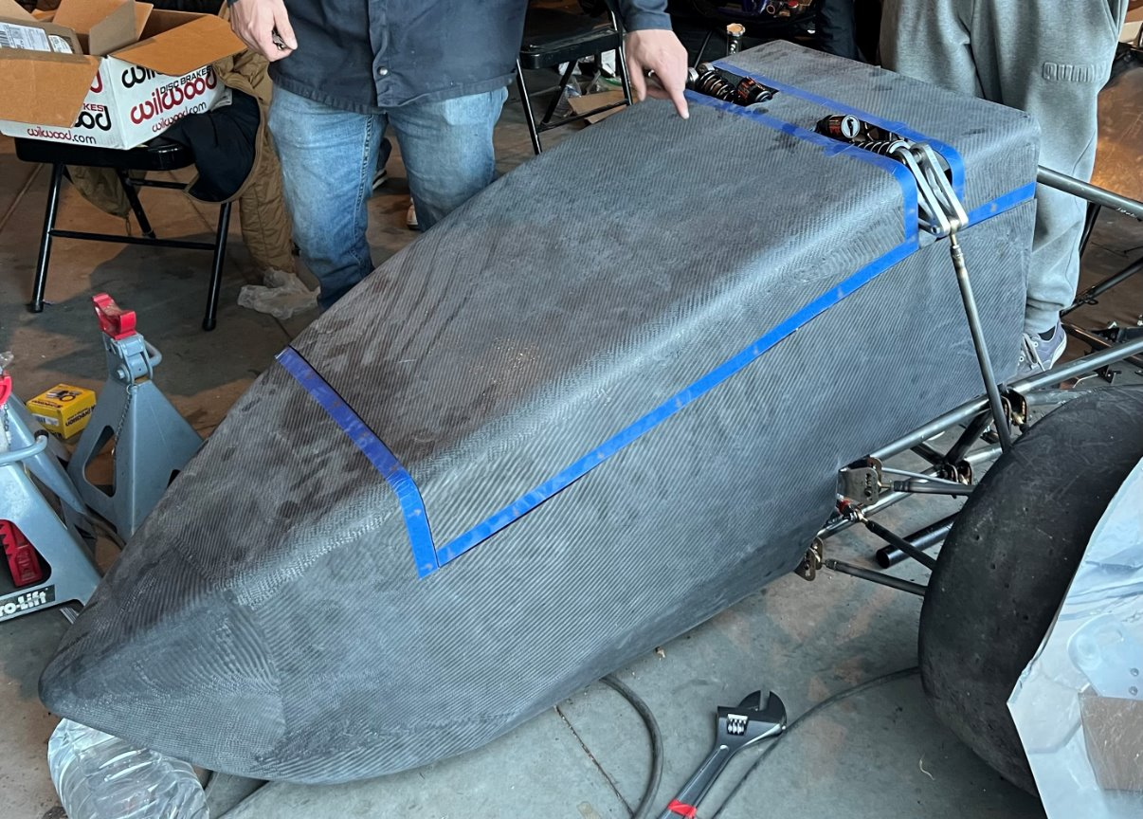
Figure 64: Front Nose Cone Current Design – Isolated
With this isolated nose cone, I will be able to create cross sectional drawings that we can print 1 to 1 on the plotter. With these drawings we will be able to perfectly cut a larger block of foam down to exact dimensions. This foam will serve as our mold prototype, which we will use to form our nose cone.

Other Engineering Calculations

Brandon Guzman – Thermal resistive network of Firewall:
The calculations below are for the heat transfer rate between the exhaust and driver seat as well as amount of radiation emitted from the exhaust using the Stephan Boltzmann equation.
Terms:
- $ϵ_{1}=$Emissivity of exhaust material [304 Stainless Steel] which is 0.36-0.44 [9b]
- $A_{1}=$Estimate of Surface area of exhaust facing fire wall [$m^{2}$] which is 0.0387096$m^{2}$
- $F_{1s \& 2s} =$ shape factor and is assumed to be 1, since material chosen for firewall is aluminum and polished aluminum reflects 85-90% of radiation we can Assume the shape factor to be 1 since the two surfaces are parallel to one another.
- $ϵ_{s1 \& s2}=$Emissivity of Fire wall (Polished aluminum) which is 0.05-0.10 [9b]
- $A_{s}=$Surface area of fire wall [$m^{2}]$ which is 0.4362$m^{2}$ in total, Portion facing exhaust is 0.13837$m^{2}$
- $A_{2}=$Surface area of back of seat [$m^{2}]$ which is 0.2958$m^{2}$
- $ϵ_{2}=$Emissivity of seat (Carbon Fiber) which is 0.3-0.5 [10b]
- $q=$Heat Transfer rate [W]
- $σ=Stephan Boltzman constant$ [$\frac{W}{m^{2}*K^{4}}]$ which is 5.67 x ${10}^{-8}\frac{W}{m^{2}*K^{4}}$
- $T_{1}=$Exhaust Temperature [$°K$]
- $T_{2}=$Seat Temperature [$°K$], Assumed to be ambient temperature which is 293.15 [$°K$]

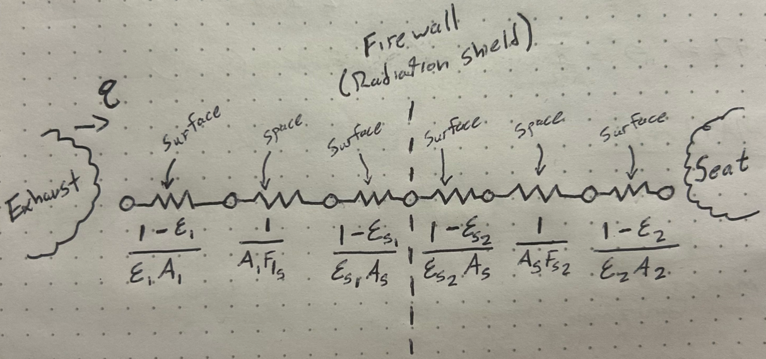
Figure 65: Theoretical Thermal Resistive network of firewall
The Equation for Heat Transfer rate for this problem is defined below, this will be used to estimate heat transfer rate between the two surfaces[11b]:

$$q= \frac{σ(T_{1}^{4}-T_{2}^{4})}{\frac{1-ϵ_{1}}{ϵ_{1}A_{1}}+ \frac{1}{A_{1}F_{s1}}+\frac{1-ϵ_{s1}}{ϵ_{s1}A_{s}}+\frac{1-ϵ_{s2}}{ϵ_{s2}A_{s}}+\frac{1}{A_{s}F_{s2}}+\frac{1-ϵ_{2}}{ϵ_{2}A_{2}}} (1)$$

$$q_{moving}= \frac{(5.67×{10}^{-8}\frac{W}{m^{2}*K^{4}})({810.93}^{4}-{293.15}^{4})°K}{\frac{1-0.4}{0.4(0.03871m^{2})}+ \frac{1}{(0.03871m^{2})(1)}+\frac{1-0.07}{0.07(0.4362m^{2})}+\frac{1-0.10}{0.10(0.4362m^{2})}+\frac{1}{0.4362m^{2}(1)}+\frac{1-0.4}{0.4(0.2958m^{2})}}$$

$q_{moving}=$195.88 [W]

$$q_{Idling}= \frac{(5.67×{10}^{-8}\frac{W}{m^{2}*K^{4}})({644.26}^{4}-{293.15}^{4})°K}{\frac{1-0.4}{0.4(0.03871m^{2})}+ \frac{1}{(0.03871m^{2})(1)}+\frac{1-0.07}{0.07(0.4362m^{2})}+\frac{1-0.10}{0.10(0.4362m^{2})}+\frac{1}{0.4362m^{2}(1)}+\frac{1-0.4}{0.4(0.2958m^{2})}}$$

$$q_{Idling}=75.99 [W]$$

The Stephan Boltzmann equation will then be used to estimate radiation emitted from the exhaust:

$E= εσA_{s}T^{4}$ (2)

Absolute Temperature of exhaust while moving = 1000 $°F$ or 810.93$°K$

$$E_{Moving}=(0.4)(5.67×{10}^{-8}\frac{W}{m^{2}*{°K}^{4}})(0.4362m^{2})({810.93}^{4}°K)$$

$$E_{Moving}=4278.21[W]$$

Absolute temperature while idling = 700 $°F$ or 644.26 $°K$

$$E_{Moving}=(0.4)(5.67×{10}^{-8}\frac{W}{m^{2}*K^{4}})(0.4362m^{2})({644.26}^{4})$$

$$E_{Idling}=1704.41 [W]$$

For this theoretical analysis of the Radiation heat transfer rate between two surfaces and the radiation emitted from the exhaust while moving and idling, the results seem to be reasonable based on calculations. It is important to note that all these values are subject to change because placement of certain components and mounts have not been finalized. This analysis is meant to be a proof of concept for the thermal resistive network and therefore the temperature surrounding the seat/cockpit will not be solved until further confirmation of exhaust temperature and firewall dimensions have been adjusted to best fit other sub teams deliverables.

Future Testing Potential
The chart in the Figure below highlights significant failure points from components of the chassis design. In addition, the plans for controlled testing are listed to address these failure points.
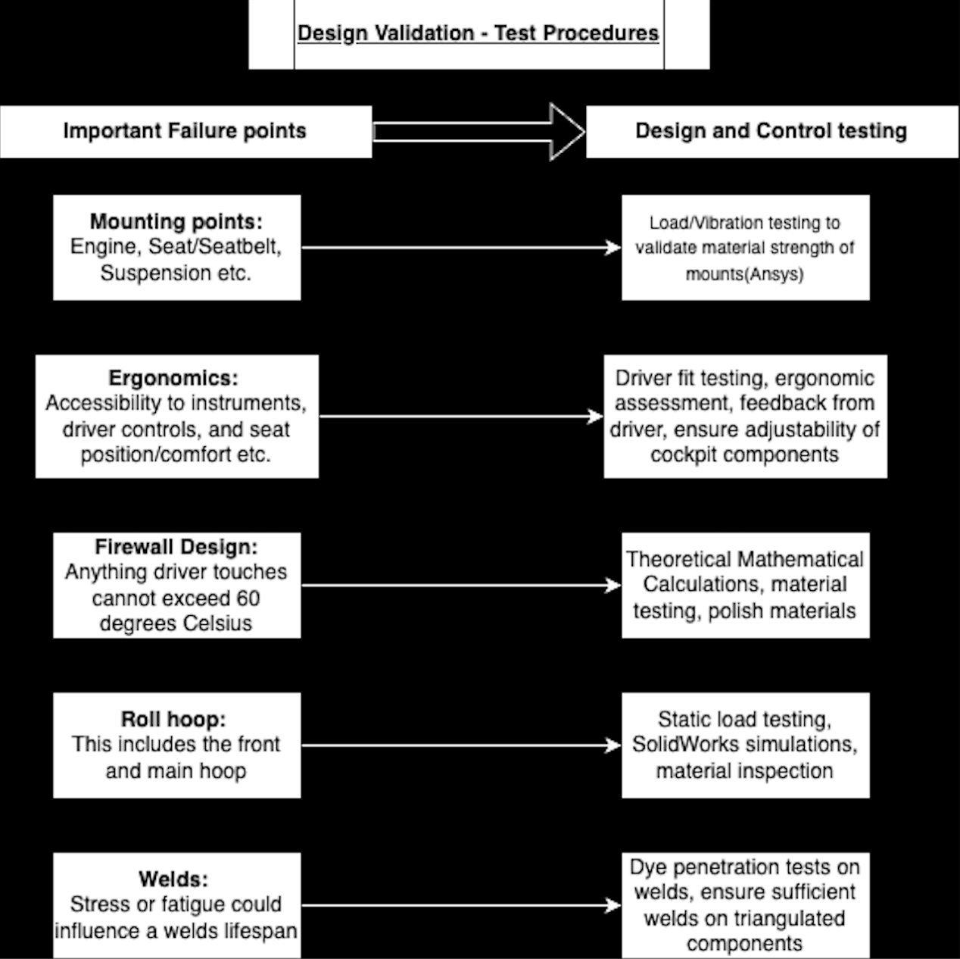
Figure 66: Testing plans

Final Hardware

Final Physical Design
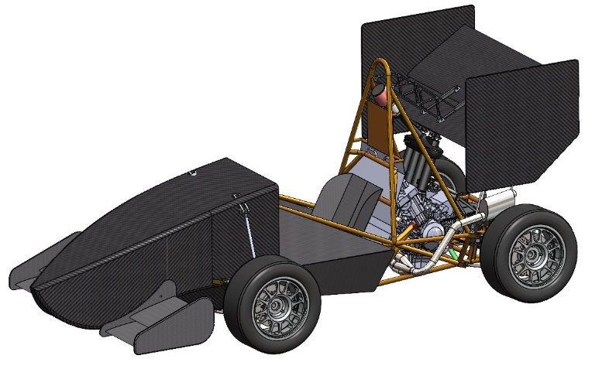
Figure 67: Final CAD
There were no significant design changes from what was described above in the concept generation and design selection portion of this report. This is the final CAD of the aero package, firewall and seat.
Small design changes were made to the seat mold and front wing. Last year’s seat mold was supposed to be changed to make it work for the angles we want. However, it was difficult to make changes to the mold, so a new mold was made. The front wing mounting hardware had to be changed to comply with the SES. There was miscommunication about the hardware needed and was forgotten about. The changes needed to the screws for the mounting hardware were made by buying new ones off Mc-Master Carr. Other challenges were with the fitment of the nose cone and floorboard. Having to make the nose cone seamlessly fit under the floorboard and have them attach to same dzus fittings. A lot of time and patience was needed to overcome that challenge.
Right now, our team is waiting for a response from Nova Kinetics. They were giving us left over carbon fiber from other projects, but it was all used via the FSAE project, Baja, and other capstone projects. We are still waiting for a response to say if they will be giving us more carbon or if we will have to buy it. This has halted our manufacturing process. Right now, the nose cone, seat, and airfoils for the wings are completed. This has left the side panels and endplates for the wings to be manufactured. CAD images of the remaining parts will be used.

Nose Cone
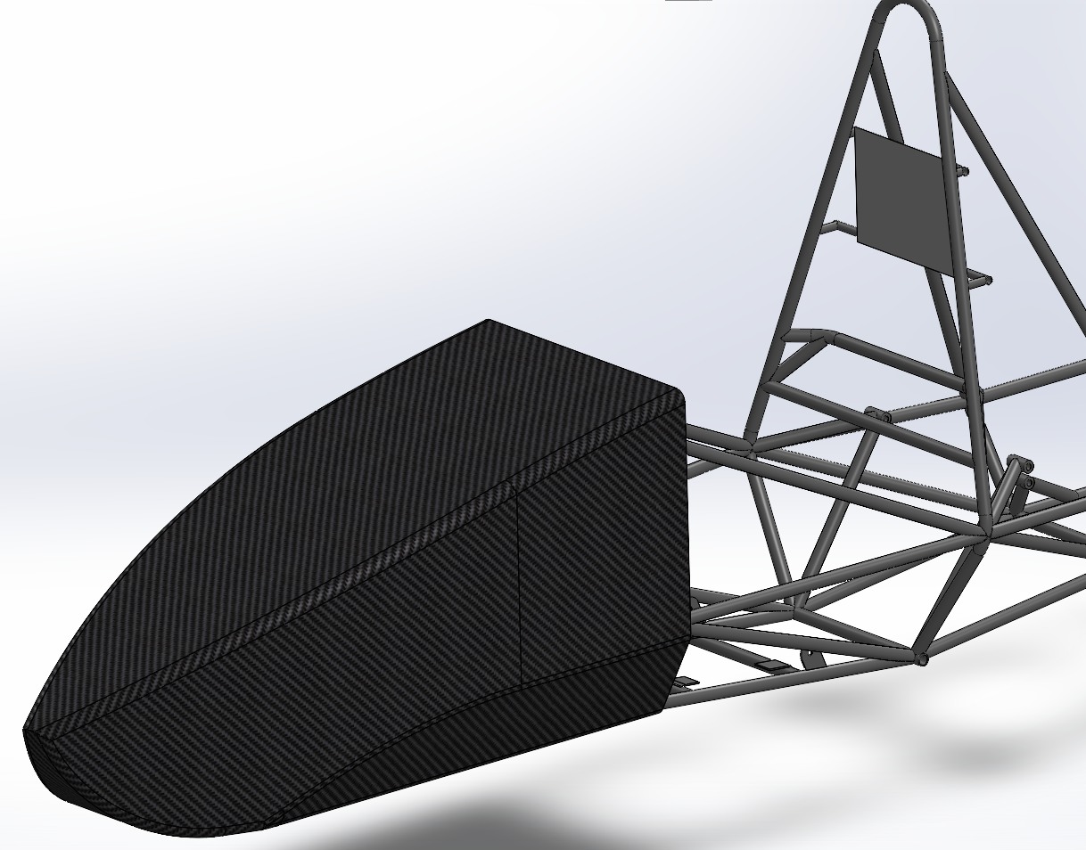
Figure 68: Nose Cone in CAD
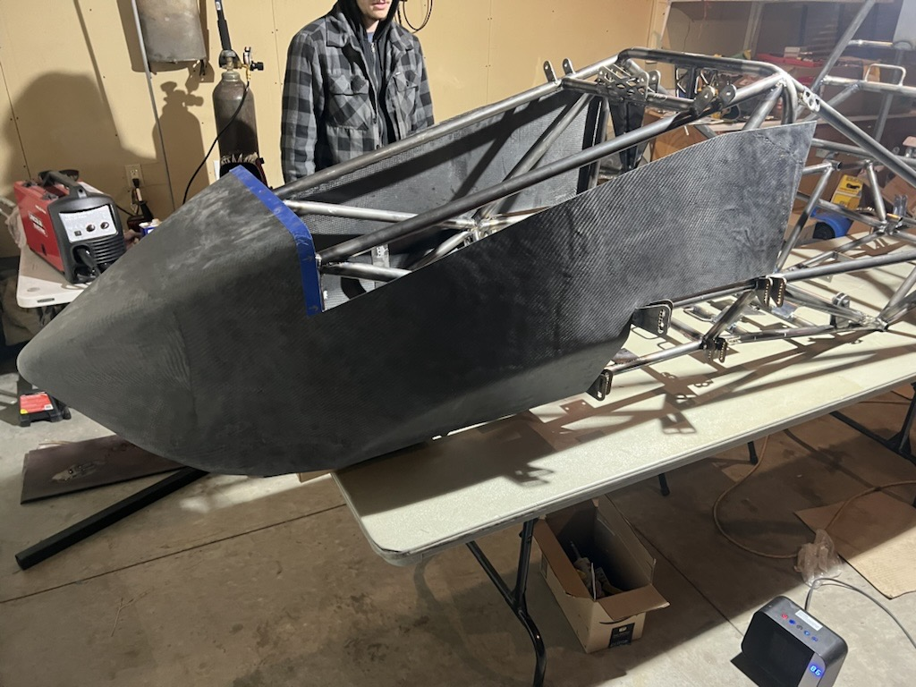
Figure 69: Nose Cone on Physical Frame
There were no significant changes to the nose cone aside from cutting certain parts to make the frame more accessible.

Front Wing

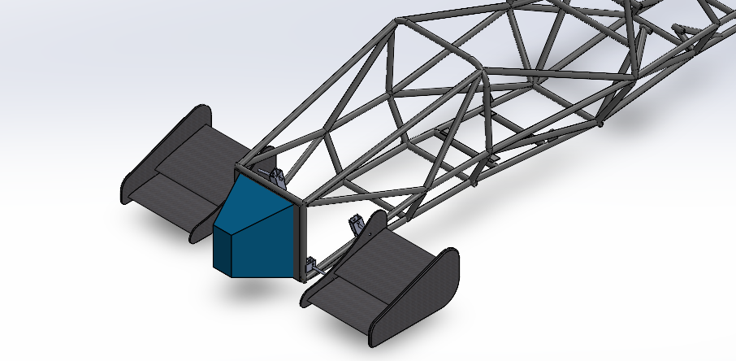
Figure 70: Front Wing in CAD

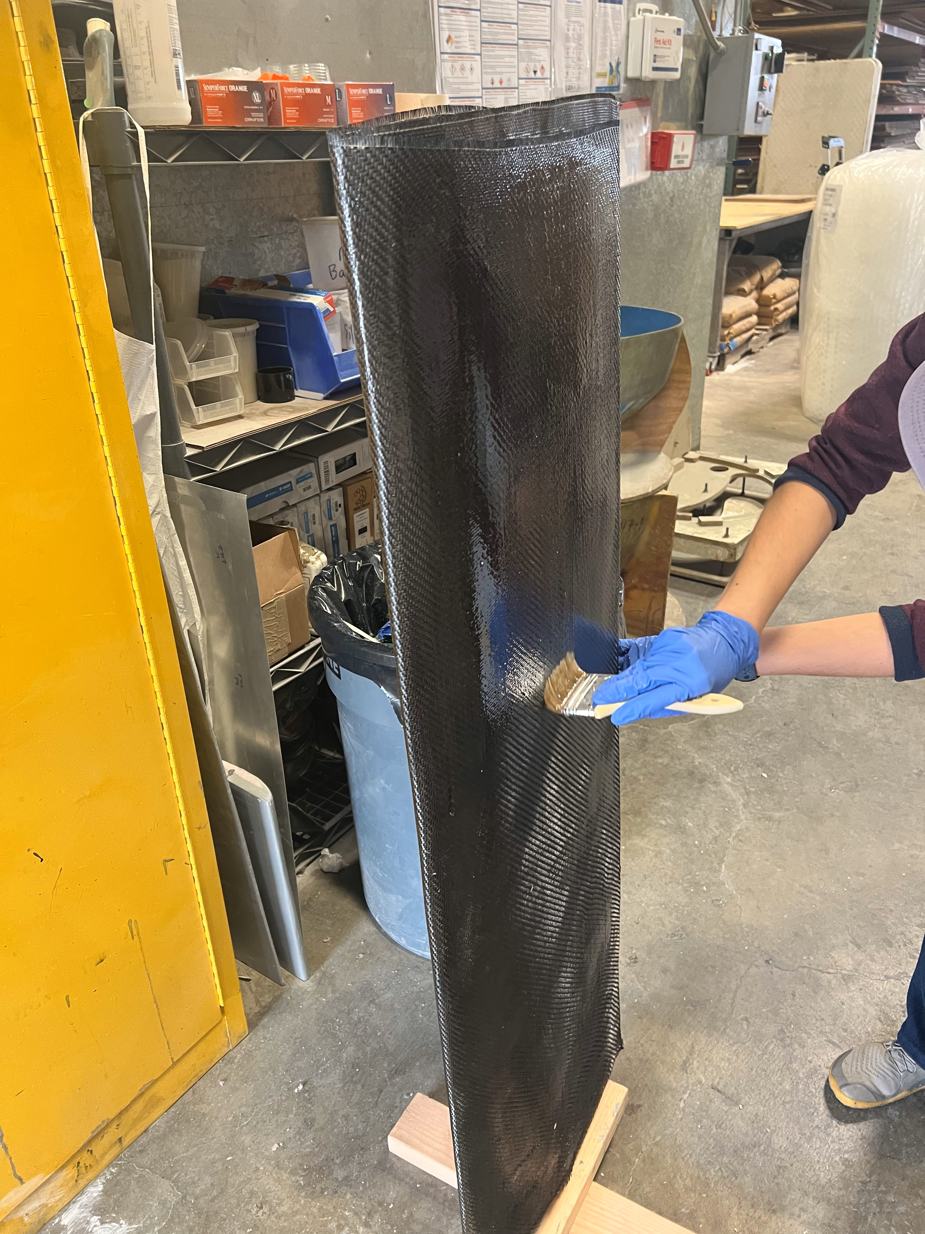
Figure 71: Wet lay up of airfoils

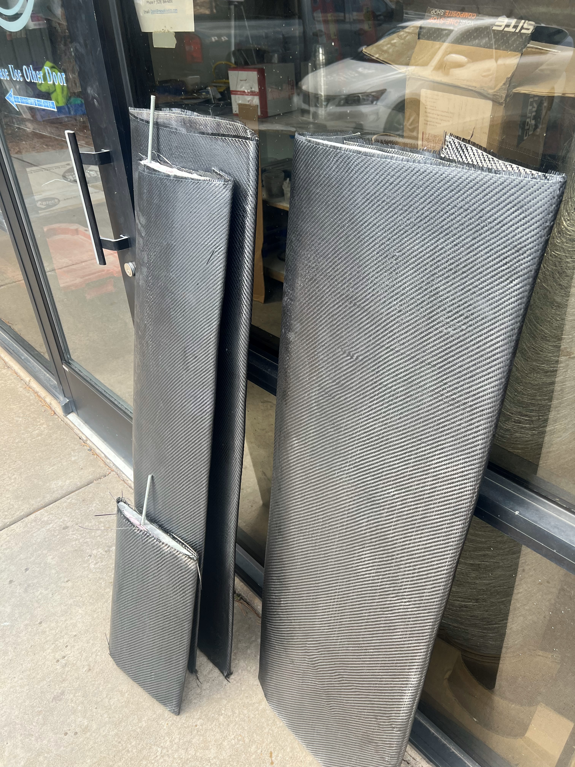
Figure 72: Finalized Airfoils

As stated, the endplates for the front wing have not been manufactured yet due to Nova Kinetics. These are the airfoils in the current form. We plan to get an answer from Nova by the end of the week (4/21).
For the overall design, the wings will be attached to two steel rods. These rods are threaded for a screw on either end, which will mount the rod to frame and wing. The screws are specific to what is needed in the SES. Allowing for the screws to shear off in case of a collision.

Rear Wing

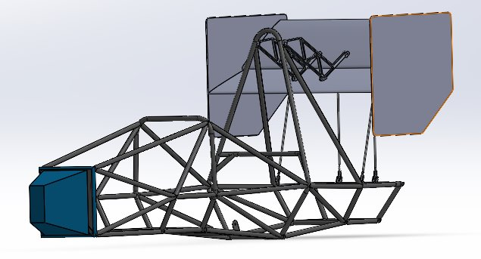
Figure 73: Rear Wing in CAD
As stated, the endplates for the rear wing have not been manufactured yet due to Nova Kinetics. The current airfoils for the rear wing can be seen in the above images.

Seat
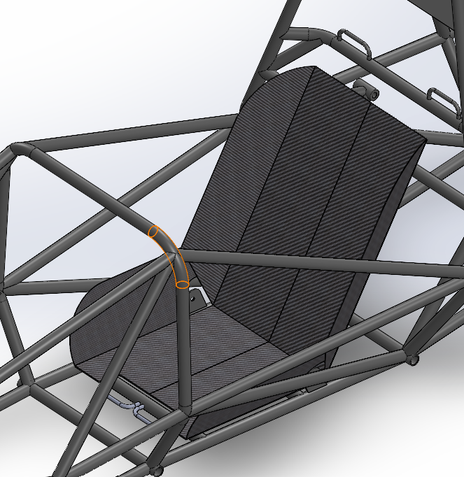
Figure 74: Seat in CAD
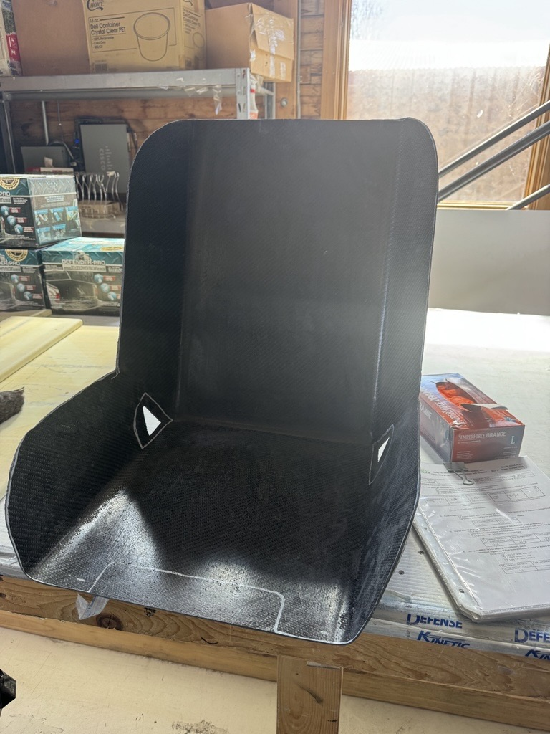
Figure 75: Seat in Physical Frame
Only a few changes were made when making the physical seat. We changed the angle of the seat so the drivers would be more comfortable. The final seat is fully cut and has been placed in the frame with its finalized position.

Firewall
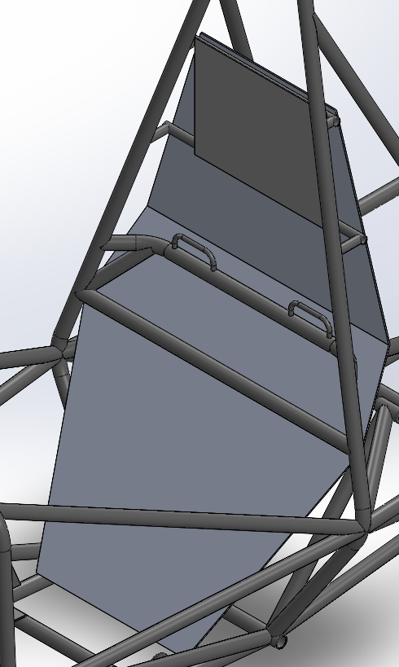
Figure 76: Firewall in CAD

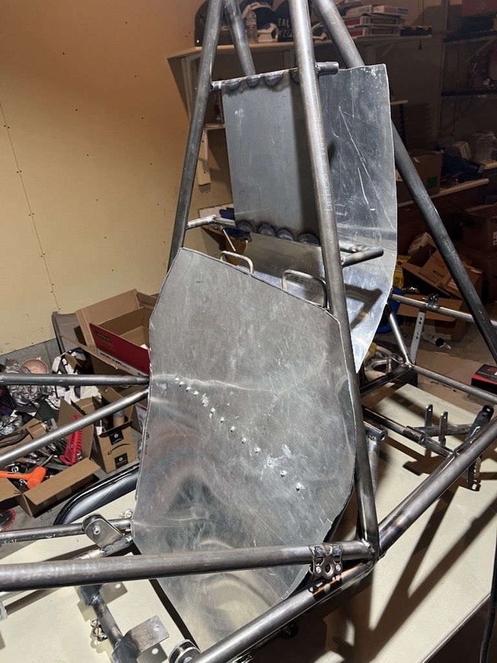
Figure 77: Firewall in Physical Frame

Final Testing

Top Level Testing Summary Table
Table 11: Top Level Testing Summary
Test/Experiment | Relevant DR’s | Testing Equipment Needed | Other Resources
Egress | CR2, CR12, CR14 | Fully Built Car, full race suit, 6-point harness, stopwatch, camera | All drivers to do the test, a good weather day
Cockpit Thermal Test | ER23, CR10, CR13 | Testing track, Laser temperature gauge, full race suit | A good weather day(comparable to what it will be like at competition)
Harness Position Test | CR7, CR8, CR2, ER13, ER14, ER15, ER16, ER17, ER18, ER19 | Angle gauge, tape measure, ruler, 6-point harness, Rulebook | All drivers
Head Restraint Force Analysis | CR11, ER13 | SolidWorks | N/A
Design Requirement Testing | CR1, CR3, CR4, CR9, ER1, ER2, ER5, ER20 | Angle gauge, tape measure, ruler | A driver
Disassembly test | CR12, CR14, ER22, | Stopwatch, camera, tooling for disassembly | Multiple team members

Detailed Testing Plan

Test 1 – Egress
Experiment summary:
In the event of an emergency the driver should be able to exit the vehicle withing five seconds, the team will ensure the cockpit is adjustable to fit every driver. Last year’s team’s cockpit was very cramped, and the vehicle couldn’t be used to its full extent, this year we will ensure there is enough room for safety and comfort. This is also a crucial test to pass tech inspection at competition.
The car must be fully built to conduct this test. A stopwatch and a camera will be used for time measurement and analysis of the procedure. The driver being tested will have to be wearing the full race gear needed to comply with FSAE rules.
Variables that will be calculated are average time, the standard deviation, and success rate of each trial.

Procedure:
To ensure we can pass tech, CR2, CR12 and CR14 must be met. The motions of exiting the vehicle must be muscle memory to pass the 5 second requirement and to be safe in case of a crash. While testing the vehicle, timed tests for exiting will be conducted. The motions will be along this procedure. Take the steering wheel of the hub, undo the harness and lap belt throwing them aside and forward. Placing the hands on the SIS uppers and pushing upward, lifting your upper body out of the seat. Followed by bending the knees and placing them on the seat, then pushing up to full extend out of the vehicle. Lastly, stepping out of the car. A stopwatch will be used for time measurement. A minimum of 5 trials will be conducted to collect data on the consistency of the driver. A will be used camera for video analysis, looking at technique and potential inefficiencies.

Results:
The desired result from this test is being below the 5 second requirement and consistency. When tested during competition there can be no slip ups, so getting it right the first time is paramount to passing inspection.
It is difficult to derive equations to come up with a theoretical result, but we can use averages from past egress tests with race cars. First, the reaction time will have to be between 0.2-0.5 seconds. Next unbuckling will be between 0.5-1.5 seconds. Lastly, exiting the vehicle will have a range of 3.0-4.0 seconds. Have a total range of 3.7-6.0 seconds.

Conclusion:
If the driver exits in under 5 seconds consistently, the driver and vehicle will be the egress test requirements. If the driver fails, design modifications will be necessary like adjusting the seat position and harness accessibility. The results from the test will determine if additional training or ergonomic adjustments are required.

Test 2 – Cockpit Thermal Test
Experiment summary:
The cockpit is an essential part of the chassis design because the driver needs to be protected while racing. An essential part of this requirement is separating the engine, fuel tank and exhaust from the driver with the use of a firewall. The FSAE 2024 Rulebook states, “The driver must not be in contact with any metal or other materials which may become heated to a surface temperature above 60 degrees Celsius.” In addition, the team will also use insulation along with the firewall to ensure maximum safety from heat and to ensure the ECU doesn’t get fried.
For this test several thermal analyses will be done with hand calculations and physical tests with the new firewall. This year’s team has worked to incorporate a reflective heat shield using a polished sheet of aluminum to protect against radiation heat transfer and mineral wool which is completely fire retardant for conduction isolation. The main question we are looking to answer is will the firewall be able to prevent any component in the cockpit from exceeding 60 degrees Celsius?
To meet ER23, CR10 AND CR13 the team will use the equation for radiation heat transfer (1) between two surfaces which is the exhaust temperature and the seat temperature while using the aluminum sheet as our heat shield. The Stephan Boltzmann equation (2) will also be used to estimate the amount of radiation being emitted off the exhaust. These equations will be used while the car is idling and moving. The equations are defined below:

$q= \frac{σ(T_{1}^{4}-T_{2}^{4})}{\frac{1-ε_{1}}{ε_{1}A_{1}}+\frac{1}{A_{1}F_{s1}}+\frac{1-ε_{s1}}{ε_{s1}A_{s}}+\frac{1-ε_{s2}}{ε_{s2}A_{s}}+\frac{1}{A_{2}F_{s2}}+\frac{1-ε_{2}}{ε_{2}A_{2}}}$ (1)

$E= εσA_{s}T^{4}$ (2)

It is important to note that the team selected polished aluminum because despite having high thermal conductivity, reflective aluminum can reflect 85-90% of radiation heat which is what we are dealing with. Reflective aluminum has an emissivity of 0.05-0.10 and the carbon fiber seat has an emissivity rate of around 0.3-0.5. In theory, these elements should be able to successfully prevent the cockpit from exceeding 140 $°F$.

Procedure:
Using the equations above the theoretical heat transfer rate and radiation emitted from the exhaust will be calculated to create a guide for how the final firewall should be manufactured. These theoretical calculations will aid when more physical tests are done, an initial testing using a heat gun was already done using a small mockup of the firewall and carbon fiber, during this test the seat material did not exceed 85 $°F$. Further testing will be done once the head restraint is welded into the frame and the exhaust is attached to the engine, the reflective aluminum will be bent in place, and we will run to engine to get a final test. If this test fails, we will add more insulation, the goal here is to protect the driver and the ECU.

Running the engine with the firewall in place will be the best way for us to ensure this design will be rule eligible, while this final test is being done, we will use a laser temperature gun to measure the cockpit and seat temperature. After this testing, we will mount the firewall and iterate on the design to ensure it is removable.

Results:
Defined below in Figure 1 is a mockup for the firewall design that we will be using, the exhaust will be the team’s biggest concern, and we are considering placing a secondary firewall over the fuel tank with leftover reflective material.
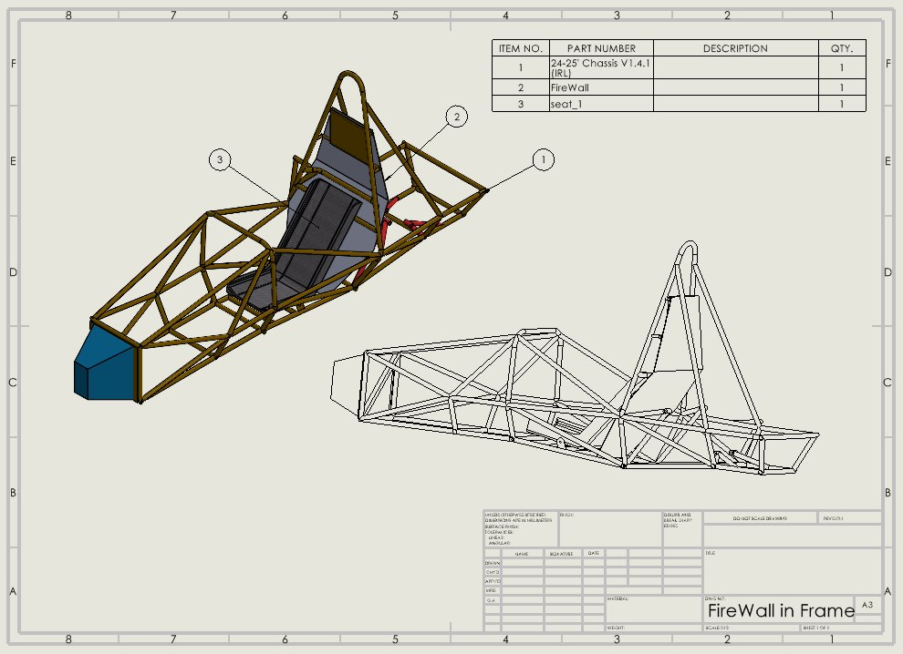
Figure 78: Firewall Mockup
The use of a reflective heat shield is something new this year’s team is incorporating into our design; in theory with the use of mineral wool and reflective aluminum we should be able to create a successful heat shield that doesn’t allow the cockpit to exceed 140$°F$.

Conclusion:
Through this testing plan and analysis, the firewall we are planning to use should be enough to keep the seat from reaching 140℉. To confirm the results from this experiment, we will measure the temperature of the cockpit while the engine is idling and running. If the experiment is done correctly, we should have a successful final design.

Test 3 – Harness Position Test
Experiment summary:
This experiment is used to verify the final position of the 6pt harness while the vehicle is in use. This test would verify and validate the engineering requirements 13 to 18, this shows the required angles that the harness is required from the side view. This can be found using the digital angle finder ruler and with the AccuMaster digital angle gauge block.

Procedure:
The pedal box is to be adjusted for each driver and the harness will need to be secured and able to fit each driver. The angles of all the belts will be measured, this includes the shoulder belts, lap belt, and the anti-submarine belt from the side view. After the initial measurements are taken and recorded, this can be used to ensure that all the measurements are within an acceptable range. The driver can then simulate driving the vehicle. After simulating the driver in the vehicle for a few minutes the position of the belts will be measured again to see if the position of the belts has changed.

Results:
In order for the vehicle to pass the technical inspection at competition, the engineering requirements 13 through 18 must be met. Which means that all the values need to be measured before and after driving, ensuring the following:
- The Lap belt angle from the side view must be between 60 and 80 degrees to the horizontal.
- The anti-submarine belts angles should be between 0 and 20 degrees toward the rear.
Conclusion:
The experiment above will need to be conducted to ensure and validate the measurements are within the requirements, then it can be finalized. Which would verify that the positioning meets all requirements outlined for the harness and ensure the safety of the driver.

Test 4 – Head Restraint Force Analysis
Experiment summary:
Most of the head restraint testing will verify that the head restraint is placed in relation to the driver's seat position. The engineering requirements ER13 to ER15 state that drivers head must be no more than 25 mm away from the head restraint and the contact point must be no less than 50 mm from any of the edges. Aside from the placement of the head restraint, it also must undergo force analysis. The requirement states that the head restraint must withstand 900 N in the rearward direction and 300 N in the vertical direction.

Procedure:
By placing the driver in the cockpit, measurements will be taken in relation to their position. Using this to verify the placement of the head restraint so that it is within the requirements. For the forces on the head restraint must undergo the team would need to use CAD simulation to simulate the forces. Due to the magnitude of these forces, the team has no way to accurately test this physically. However, this can be tested using the CAD model to see any deformations and to get the yield strength for the design of the head restraint.

Results:
A critical result must be the head restraint is positioned correctly to be within the rule specifications. For force requirements, CAD simulations will be done, showing the stress, displacement and safety factor under the applied forces. If any one of those results shows signs for potential failure, those areas will require reinforcement. The calculations will be done using SolidWorks Simulation, so no equations are required for this test.

Conclusion:
Proper placement and structural integrity of the head restraint is paramount in keeping the driver in the case of a crash or high-G scenario. Referring to the rule book and conducting simulation will ensure the vehicle is within rule specifications and that the driver will be safe.

Test 5 – Design Requirement Testing
Experiment summary:
Design requirements involve a test to pass the competition inspection. That question that needs to be answered is, “are all the measurements that are required correctly presented to meet the FSAE rules?” the engineering requirements that will tested are ER 1 through ER11 and the egress test. To test these requirements, the tools needed to test the requirements is a ruler, an angle gauge, and templates with the required measurements from the FSAE rule book. No equations are needed for this step, the templates of the required dimensions are listed below:
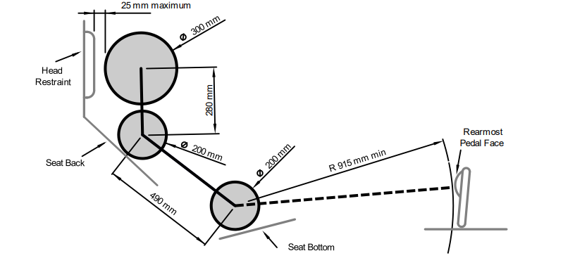
Figure 79: Driver Template
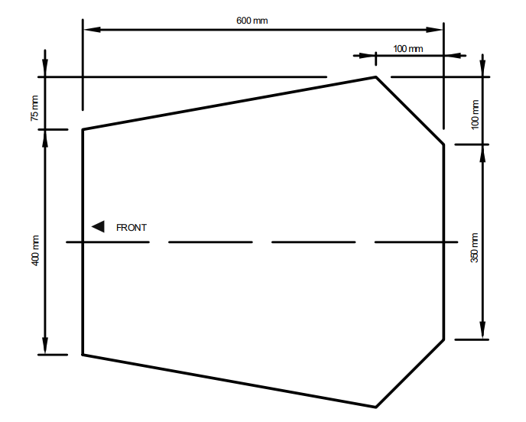
Figure 80: Cockpit Opening Testing Template
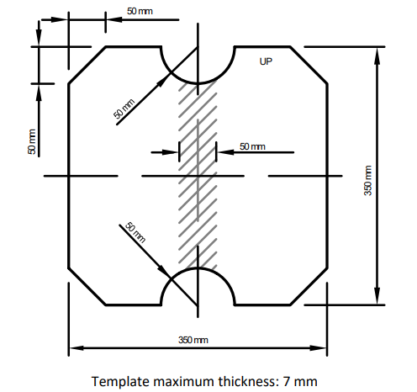
Figure 81: Cockpit Internal Cross-sectional Area Template

Procedure:
Firstly, placing the driver template from figure 2 into the CAD frame and trying different positions to ensure that it fits and doesn't exceed the reequipments will be the first test. The second test is the cockpit opening test, using the template in figure 3, lowering the template into the cockpit to ensure that the cockpit is within the required dimensions. The next test is using the template in figure 4, by inserting the cockpit internal cross sectional area template into the front hoop under the steering wheel and ensure the correct angles.

Results:
From the CAD model, the additional two tests, everything is fitting well and will be within the required measurements.

Conclusion:
This focuses on meeting the requirements necessary to pass the inspection and qualify for the race. Using the templates and measuring to ensure that it is within specs of the FSAE rules.

Test 6 – Disassembly Test
Experiment Summary:
This test focuses on the team meeting the requirements from the FSAE rules that the team disassemble the body panels and nose cone to reach the pedal box to adjust it. Another important component that the team has as removable is the firewall, which allows for access for inspection of the engine bay and the fuel system. In the engineering requirements ER22, these fasters will provide a strong connection for the body panels, nose cone, and the firewall while allowing for a quick way to dismantle and reach components required to pass tech inspection.

Procedure:
As a team we can practice take the nose cone, body panels, and any other components to reach the required components.

Results:
Minimal tool usage will be needed to efficiently disassemble the body panels and firewall. Turning screws take precious time, so using Zues fitting will help in this case. The time taken to disassemble the car will be recorded for evaluation.

Conclusion:
If the disassembly process can be performed in an acceptable timeframe, the test will be considered a success. If not further design changes and modifications will be done. Having an ergonomic car will ensure efficient disassembly to access critical components and to adjust during competition

Specification Sheet

Table 12: CR specification sheet
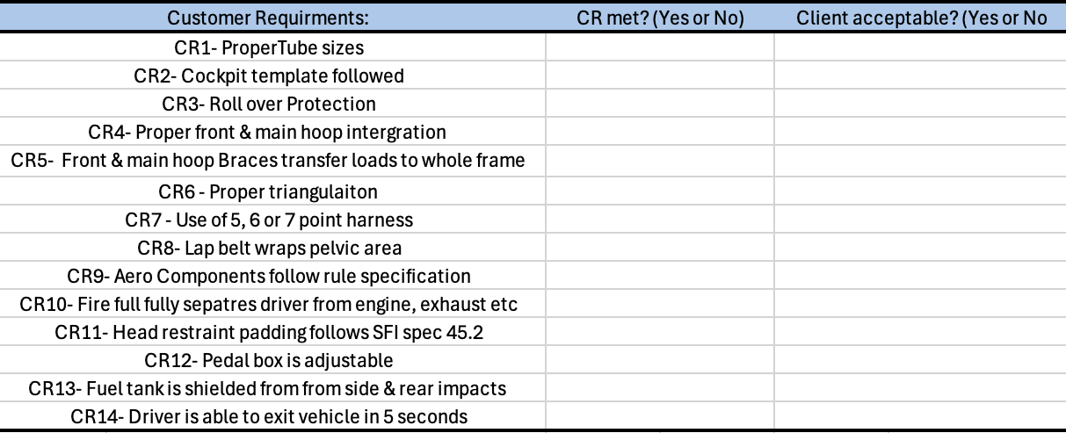

Table 13: ER Specifications and tolerances
Engineering Requirements | Target | Tolerance | CR met? (Yes or No) | Client Acceptable (Yes or No)
ER1: Driver’s helmet must be a minimum of 50 mm from the straight line drawn from the top of the Main Hoop to the top of the Front Hoop. | 60 mm | 5 mm
ER2: Drivers Helmet must also Be a minimum of 50 mm from the straight line drawn from the top of the Main Hoop to the lower end of the Main Hoop Bracing if the bracing extends rearwards. | 60 mm | 5 mm
ER3: Main hoop cannot be angled more than 10 degrees from vertical. | 9 degrees | 1 degree
ER4: Angle between main hoop and braces must be at least 30 degrees | 33-35 degrees | 2 degrees
ER5: Radius of all bends must be at least three times the outer diameter. | 3*OD | 0
ER6: Distance between main hoop and braces must be at least 380mm | more than 380 mm | 10 mm
ER7: Main hoop brace must be attached at least 160mm from the top of the main hoop. | 150-160 mm | 9 mm
ER8: Front hoop braces must be attached at least 50mm below the top of the front hoop. | 45-50 mm | 5 mm
ER9: The lower front bulkhead support must attach the base of the front bulkhead to the base of the front hoop. | ~ | ~
ER10: Upper front bulkhead member must attach within 50mm to the top of the front bulkhead. | 45-50 mm | 5 mm
ER11: Upper front bulkhead must attach no more than 100mm above or 50mm below the upper side impact structure. | 90 mm | 8 mm
ER12: The upper SIS member must Have its top edge entirely in a zone that is parallel to the ground between 265 mm and 320 mm above the lowest point of the top surface of the Lower Side Impact Member | 300 mm | plus or minus 20 mm
ER13: Head restraint must be able to withstand forces of 900N in rearward direction and 300N in vertical or lateral direction. | i.e 950 N, 350 N | 50 N
ER14: Head restraint must be no more than 25mm away from the back of driver’s head while in normal seated position. | 15 mm | 5 mm
ER15: The contact point of the back of the driver’s helmet on the head restraint is no less than 50mm. | 60 mm | Plus or minus 10 mm
ER16: The shoulder belt mount spacing must be between 175 mm and 235 mm, center to center. | 180 mm | 20 mm
ER 17: The Anti-Submarine Belt mount must be spaced 100 mm apart. | 100 mm | 0
ER18: The Anti-Submarine Belts of the 6 pt harness must be mount so that the belts are angled up 20 degrees toward to the rear. | 20 degrees | 0
ER19: The Lap Belt angle from side view must be between 60 and 80 degrees to the horizontal. | 65 degrees | 5 degrees
ER20: All aero components must be No more than 700 mm forward of the fronts of the front tires and no more than 250 mm rearward of the rear of the rear tires | i.e 650 mm, 230 mm | 20 mm
ER21: In the Rear Aerodynamic Zone must be no higher than 1200 mm above the ground and Outside of the Rear Aerodynamic Zone must be no higher than 500 mm above the ground. | i.e 1100 mm & 400 mm | 50 mm
ER22: All mounts must utilize critical fasteners that have positive locking mechanisms. | ~ | ~
ER23: All components the driver comes in contact with must not exceed 60 degrees Celsius or 140 degrees Fahrenheit. | 85 degree F | 40 degrees F

Future Work
To strengthen the FSAE program, a clear and fair team selection process should be implemented to ensure transparency and equal opportunity. Design and manufacturing efforts should begin ahead of time, ideally during the summer, to stay on schedule and improve build quality. Increasing fundraising efforts is crucial to support these goals, along with establishing a year-round club to maintain momentum and develop future team members. Upgrading the garage with better tools, including mills and a lathe, will enhance the team's technical capabilities. Appointing FSAE members as shop managers will help maintain organization and accountability in the workspace. Additionally, the team should always include 2–3 certified welders to ensure high-quality fabrication and safety standards.

Conclusion
In conclusion, the 2025 Formula SAE project at Northern Arizona University represents a significant leap forward in both design and execution for the chassis and aero teams. Through comprehensive research, iterative design, rigorous validation, and hands-on manufacturing, the team was able to overcome the many challenges that come with developing a competitive race car. Notable milestones include the successful integration of aerodynamics for the first time, a stronger and more ergonomic chassis, and the implementation of innovative manufacturing techniques such as carbon fiber molding. Although material limitations posed unexpected setbacks, the team remained resilient and committed to finishing the aero package before the competition. Most importantly, the collaboration, problem-solving, and technical skills gained throughout this capstone project have provided invaluable experience. As the team looks ahead to competition in Michigan, there is a strong sense of pride and optimism. The foundation built this year will not only push NAU’s Formula SAE team to be a contender but will also serve as a steppingstone for future teams to reach even greater heights.

References

Alexandra Brister
[1a] Bruno Muss. "Crash test numerical analysis of a Formula SAE vehicle," YouTube, 1/17/2018. https://www.youtube.com/watch?v=c8k9Idy5kwk
[2a] C. D. Carter, C. B. Sherman, and R. D. Matthews, “Design of a Formula SAE race car: Vehicle Dynamics and Performance,” SAE Technical Paper Series, Feb. 1982. doi:10.4271/821092 Aerodynamics
[3a] C. Itu, A. Toderita, L.-V. Melnic, and S. Vlase, “Effects of seat belts and shock absorbers on the safety of racing car drivers,” Mathematics, vol. 10, no. 19, p. 3593, Oct. 2022. doi:10.3390/math10193593
[4a] The, Dynamics: Force and Newton’s Laws of Motion. 2019 (Chapter 4).
[5a] K. Baszczyński and M. Jachowicz, “The Effect of the Use of Full Body Harnesses on Their Protective Properties,” International Journal of Occupational Safety and Ergonomics, vol. 15, no. 4, pp. 435–446, Jan. 2009, doi: https://doi.org/10.1080/10803548.2009.11076823.
[6a] R. G. Budynas, J. K. Nisbett, and J. E. Shigley, Shigley’s mechanical engineering design. New York, NY: McGraw-Hill Education, 2020. Chapter 3
[7a] “SAE standards for Mobility Knowledge and Solutions,” SAE International, https://www.sae.org/standards?utm_source=google&utm_medium=ppc&utm_campaign=LVL_SAE_SCH_GSE_NTN_GPM_B2C_Standards&utm_content=Standards&utm_term=B2C&utm_device=c&utm_keymatch=p&utm_adposition=&gad_source=1&gclid=CjwKCAjw0aS3BhA3EiwAKaD2ZSgsuuN9rfyeBQE_uWePei2JlxfRiqc2r97IeRPudAJ_66PtXDuT6xoC7T4QAvD_BwE (accessed Sep. 17, 2024).
[8a] B. Herbstreit, “Seat & Firewall Design for Cornell Racing FSAE,” Dec. 2017. Available: https://www.ergofoundation.org/images/Bailey_Herbstreit_%20Seat_and_Firewall.pdf
[9a] H. Bergstrand, “F-SAE Race Car Seat Design -A user-centred concept development project.” Accessed: Nov. 27, 2024. [Online]. Available: https://hampusbergstrand.com/wp-content/uploads/2017/02/F-SAE_race_car_seat_design_Hampus_Bergstrand_2015_Newcastle.pdf
[10a] M. Scheitlin and T. Bräunl, “Renewable Energy Vehicle Project: Pedal Box Design for Formula SAE,” 2011. Available: https://robotics.ee.uwa.edu.au/theses/2011-REV-3-PedalBox-Scheitlin.pdf

Ryan Meger
[1r] A. Castrillion, G. Contreras, and A. Martinez, Modeling of a chassis for an SAE formula car, http://www.irphouse.com/ijert21/ijertv14n10_10.pdf (accessed Oct. 21, 2024).
[2r] SolidWorks, “SolidWorks FSAE & Formula Student Tutorials,” YouTube, https://www.youtube.com/playlist?list=PL38088C14E31FAF31 (accessed Oct. 20, 2024).
[3r] C. Dodd, C. Morris, P. Geneva, and N. Geneva, Meeg 402-010 chassis design report 2017 FSAE SENIOR ..., https://udel.edu/~pgeneva/downloads/fsae/2017_FSAE_chassis.pdf (accessed Oct. 21, 2024).
[4r] N. Vishal and S. Aditya, Analysis of FSAE chassis - IJSER, https://www.ijser.org/researchpaper/ANALYSIS-OF-FSAE-CHASSIS.pdf (accessed Oct. 21, 2024).
[5r] CAD CAM tutorial by Mahtabalam, “Solidworks simulation,” YouTube, https://www.youtube.com/playlist?list=PLRhna5_X7uWt2LF-ZiuXFt5jrubF32C94 (accessed Oct. 20, 2024).
[6r] V. Chikkali and R. Patil, FEA analysis of FSAE chassis, https://www.ijert.org/research/fea-analysis-of-fsae-chassis-IJERTV9IS070148.pdf (accessed Oct. 21, 2024).
[7r] D. Krzikalla, J. Mesicek, J. Petru, A. Sliva, and J. Smiraus, “Analysis of torsional stiffness of the frame of a formula student vehicle,” Journal of Applied Mechanical Engineering, vol. 08, no. 01, 2019. doi:10.35248/2168-9873.19.8.315
[8r] W. F. Milliken and D. L. Milliken, Race Car Vehicle Dynamics William F. Milliken; Douglas L. Milliken. Warrendale, Pa: Society of Automotive Engineers, 1995. \
[9r] DIYguru, “DFMEA Explained | Automobile Engineering | BAJA / SUPRA / FSAE,” YouTube, https://www.youtube.com/watch?v=emH6JFqpj3w (accessed Nov. 26, 2024).
[10r] PTC, PTC help center, https://support.ptc.com/help/wrr/r12.0.0.0/en/index.html#page/wrr/GettingStartedGuide/FMEA/CalculationsFMEA.html (accessed Nov. 26, 2024).

Brandon Guzman
[1b] M. Planchard, “San Diego state university formula SAE team showcased at Solidworks World,” SOLIDWORKS Education Blog, https://blogs.solidworks.com/teacher/2014/01/san-diego-state-university-formula-sae-team-showcased-at-solidworks-world.html
[2b] C. Dodd, N. Geneva, P. Geneva, and C. Morris, Dr. Steven Timmins , rep., 2017
[3b] “Purdue Formula SAE scores 2nd place; Best Design Score in their history,” Mechanical Engineering - Purdue University, https://engineering.purdue.edu/ME/News/2021/purdue-formula-sae-scores-2nd-place-best-presentation-score-in-their-history-
[4b] William F Milliken and Douglas L Milliken. Race car vehicle dynamics. Vol. 400. Society of Automotive Engineers Warrendale, 1995
[5b] Martin Meywerk. Vehicle Dynamics. John Wiley & Sons, 2015
[6b] “The construction Process: Pipe and Tube bending,” https://www.herl.pitt.edu/indiachair/indiachairsh/cl_bend.html#:~:text=Rule%20for%2090%20degree%20and%20180%20degree%20Bends&text=180%20degree%20bends%3A%20Multiply%20the,length%20of%20the%20curved%20section.
[7b] “Mastering small tube bends,” YouTube, https://youtu.be/MymUqxuCKv4?si=pWnrkCMSN0BtZO4K
[8b] “TFS: Tube Bending Basics 1 - What You Need to Know,” YouTube, https://youtu.be/3n_lf2RHIPs?si=NaGZuH7i3eOT0MqW
[9b] ennologic, Ed., “Emissivity table for infrared thermometer readings,” Emissivity Table for Infrared Thermometer Readings, https://ennologic.com/wp-content/uploads/2018/07/Ultimate-Emissivity-Table.pdf (accessed Nov. 21, 2024).

[10b] F. Wang, L. Cheng, Q. Zhang, and L. Zhang, “Effects of heat treatment and coatings on the infrared emissivity properties of carbon fibers: Journal of Materials Research,” Cambridge Core, https://www.cambridge.org/core/journals/journal-of-materials-research/article/abs/effects-of-heat-treatment-and-coatings-on-the-infrared-emissivity-properties-of-carbon-fibers/B82F9713F9E2FD2417F7E1AA7EAFEFB3 (accessed Nov. 20, 2024).

[11b] T. L. Bergan and A. S. Lavine, “13.3.4, Two-Surface Enclosures in Series and Radiation Shields,” in Fundamentals of Heat and Mass transfer, 8th ed, John Wiley and sons, 2019, pp. 808–811

[12b] S. International, “Formula SAE Rules 2025,” 2025 formula SAE rules V.1 , https://www.fsaeonline.com/cdsweb/app/NewsItem.aspx?NewsItemID=379e4a8a-80a2-4a74-87c2-6f2de4212270 (accessed Nov. 21, 2024).

Gustavo Ruiz
[1g] "Design and Analysis of FSAE Chassis for Safe Conditions" (Paper)
Helpful design parameters and calculations to run our design through, as well as finding vertical center of gravity methods.

[2g] "FEA Analysis of FSAE Chassis" (Paper)
Main goal highlighted were to decrease weight and increase torsional rigidity, helpful ANSYS simulation of stresses and torsion.

[3g] "The Science of Vehicle Dynamics", Chapter 3 "Vehicle Model for Handling" (Book)
Great explanation on aerodynamics in a Formula car, and goes more in depth on front and rear vertical forces

[4g] "Fundamentals of Aerodynamics", Chapter 19 "Turbulent Boundary Layers" (Book)
Helpful way to create turbulent modeling and find characteristics of a turbulent flow.

[5g] "Renewable Energy Vehicle Project: Pedal Box Design for Formula SAE" (Paper)
Future Work ideas from pedal box are to decrease weight and use an angle-mounted cylinder to decrease pedal box length, like our goal.

[6g] "Formula SAE Rules 2025", F- Chassis and Structural (Standard)

[7g] M. L. Mohamad et al., “Design and static structural analysis of a race car chassis for Formula Society of Automotive Engineers (FSAE) event,” Journal of Physics: Conference Series, vol. 908, p. 012042, Oct. 2017. doi:10.1088/1742-6596/908/1/012042

[8g] The Fabricator, “Tube bending basics: How to bend tubing and Metal Pipe,” The Fabricators, https://www.thefabricator.com/thefabricator/article/tubepipefabrication/tube-bending-basics-how-to-bend-tubing-and-metal-pipe (accessed Nov. 25, 2024).

[9g] Duke FSAE, “How to model a seat in Solidworks,” Duke FSAE, https://www.dukefsae.com/single-post/2017/07/17/how-to-model-a-seat-in-solidworks (accessed Nov. 26, 2024).

[10g] Seas, “Nose Cone,” Nose cone, https://www.formula1-dictionary.net/nose_cone.html (accessed Nov. 27, 2024).

Carson Kent
[1c] S. Gupta and K. Saxena, “AERODYNAMICS ANALYSIS OF A FORMULA SAE CAR.” Available: https://repository.up.ac.za/bitstream/handle/2263/62356/Gupta_Aerodynamics_2017.pdf?sequence=1
‌ [2c] “Aerodynamics of Road Vehicles, Fifth Edition,” www.sae.org. https://www.sae.org/publications/books/content/r-430/
[3c] R. Jing, Kok Wee Chong, C. Chin, and M. R. M. Julaihi, “Aerodynamic optimisation of prototype FSAE vehicle through biomimetic approach,” vol. 72, pp. 2869–2874, Jan. 2023, doi: https://doi.org/10.1016/j.matpr.2022.07.307.
[4c] Airfoil Tools, “NACA 4 digit airfoil generator (NACA 2412 AIRFOIL),” Airfoiltools.com, 2019. http://airfoiltools.com/airfoil/naca4digit
[5c] A. Wood, “Introduction to Airfoil Aerodynamics | AeroToolbox,” AeroToolbox, Jul. 20, 2017. https://aerotoolbox.com/intro-airfoil-aerodynamics/
[6c] M. Nakamura, “How An Airfoil Works,” Mit.edu, 2019. https://web.mit.edu/2.972/www/reports/airfoil/airfoil.html
[7c] mi508668, “Chapter 5: Theory of Airfoil Lift Aerodynamics,” pressbooks.online.ucf.edu, Available: https://pressbooks.online.ucf.edu/aerodynamicstext/chapter/chapter-5-theory-of-airfoil-aerodynamics/
‌ [8c]“Aerodynamics of an FSAE Car | Ansys Innovation Courses,” Innovation Space, Apr. 17, 2024. https://innovationspace.ansys.com/product/external-aerodynamic-analysis-of-an-fsae-car/
[9c] Simple Random Knowledge, “FSAE Chassis Design with Weldments in SolidWorks | With Complete Rules Explanation | Formula Student,” YouTube, Jun. 13, 2021. https://www.youtube.com/watch?v=u--aROYyMfs (accessed Nov. 28, 2024).
[10c] I. Oxyzoglou, “(PDF) Design & Development of an Aerodynamic Package for an FSAE Race Car,” ResearchGate, May 2017. https://www.researchgate.net/publication/320556659_Design_Development_of_an_Aerodynamic_Package_for_an_FSAE_Race_Car

APPENDICES
[Use Appendices to include lengthy technical details or other content that would otherwise break up the text of the main body of the report.]

Appendix A: FSAE Rules
https://www.fsaeonline.com/cdsweb/app/NewsItem.aspx?NewsItemID=3c9ca3eb-471e-472f-8453-99b943840ac7

Appendix B: House of Quality
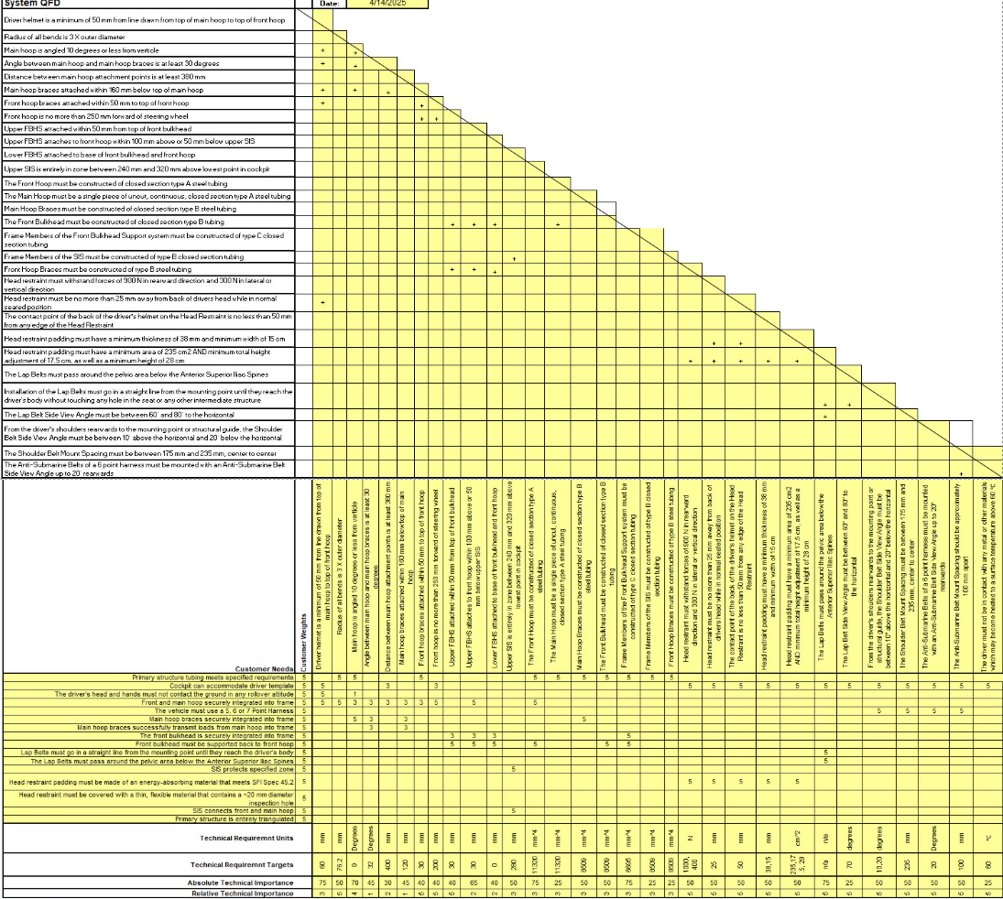

Appendix C: FMEA Chassis
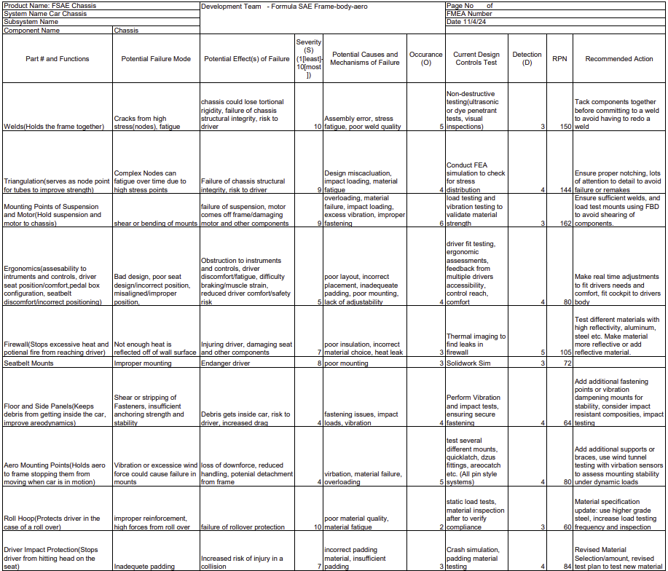

Appendix D: FMEA Aerodynamics

