Automatic Lego Sorting Machine

Preliminary Report

Team 10A
Sultan Alharbi
Husain Alkandari
Abdulaziz Almaimony
Abdullah Almutairi
Fahad Alotaibi

Spring 2019

Project Sponsor: NAU
Instructor: Dr. David Welly

DISCLAIMER
This report was prepared by students as part of a university course requirement. While considerable effort has been put into the project, it is not the work of licensed engineers and has not undergone the extensive verification that is common in the profession. The information, data, conclusions, and content of this report should not be relied on or utilized without thorough, independent testing and verification. University faculty members may have been associated with this project as advisors, sponsors, or course instructors, but as such they are not responsible for the accuracy of results or conclusions.

Table of Contents
DISCLAIMER 1
1. BACKGROUND 5
1.1 Introduction 5
1.2 Project Description 5
2. REQUIREMENTS 6
2.1 Customer Requirements (CRs) 6
2.2 Engineering Requirements (ERs) 6
2.3 Testing procedures (TPs) 7
2.4 House of Quality (HoQ) 8
3. DESIGN SPACE RESEARCH 9
3.1 Literature Review 9
3.1.1 Student 1(Sultan Alharbi) 9
3.1.1.1 Model Design and Simulation of Automatic Sorting Machine 9
3.1.1.2 Introduction to Arduino 10
3.1.1.3 Automation and Robotics 10
3.1.1.4 Machine Control System Operation for Automatic Sorting 10
3.1.1.5 Machine Vision and Object Sorting 11
3.1.2 Student 2 (Fahad Alotaibi). 11
3.1.2.1 Mechanical Engineering Design 11
3.1.2.2 Proximity Sensors 11
3.1.2.3 Lego Bricks Color Sorting Machine 12
3.1.2.4 Automatic Color Sorting machine 12
3.1.2.5 Color image based sorter for separating red and white 12
3.1.3 Student 3 (Abdullah Almutairi) 13
3.1.3.1 BrickLink 13
3.1.3.2 The art of LEGO design 13
3.1.3.3 SolidWorks 2011 Assemblies Bible. 13
3.1.3.4 Programming Arduino. 13
3.1.3.5 Automatic sorting system. 13
3.1.4 Student 4 (Husain Alkandari) 14
3.1.4.1 Actuators. In Hydraulics and Pneumatics - A Technician’s and Engineer’s Guide 14
3.1.4.2 Adaptive Parameter Estimation for an Energy Model of Belt Conveyor with DC Motor 14
3.1.4.3 Welding Fundamentals 14
3.1.4.4 Tomato sorting based on shape, maturity, size, and surface defects using machine vision. 14
3.1.4.5 Motors for Makers 14
3.2 Benchmarking 14
3.2.1 System Level Benchmarking 15
3.2.1.1 Existing Design #1: Lego Sorting Using TensorFlow Arduino [21] 15
3.2.1.2 Existing Design # 2: Elaborate Lego Sorting Machine [22] 16
3.2.1.3 Existing Design # 3: Lego Parts Solver [23] 16
3.2.2 Subsystem Level Benchmarking 17
3.2.2.1 Subsystem #1: Sensors 17
3.2.2.1.1 Existing Design #1: Proximity Sensors 17
3.2.2.1.2 Existing Design # 2: Ultrasonic Sensor 18
3.2.2.1.3 Existing Design # 3: Infrared Sensor 18
3.2.2.2 Subsystem #2: Grabber 19
3.2.2.2.1 Existing Design # 1: Reacher Grabber 19
3.2.2.2.2 Existing Design #2: Claw 19
3.2.2.2.3 Existing Design # 3: Hand Grabber 20
3.2.2.3 Subsystem # 3: Bearing 20
3.2.2.3.1 Existing Design # 1: Roller 20
3.2.2.3.2 Existing Design #2: Shaft 21
3.2.2.3.3 Existing Design # 3: Self Align Ball Bearing 21
3.3 Functional Decomposition 22
3.3.1 Black Box Model 22
3.3.2 Functional Model 22
4. CONCEPT GENERATION 23
4.1 Full System Concepts 23
4.1.1 Full System Design #1: Box on the Wide belt 23
4.1.2 Full System Design #2: Belt with Hurdles 24
4.1.3 Full System Design #3: Weight 24
4.1.4 Full System Design #4: Boxes 25
4.2 Subsystem Concepts 25
4.2.1 Subsystem #1: Align/ Separate Legos 25
4.2.1.1 Design #1: Nozzle down 25
4.2.1.2 Design #2: roulette 26
4.2.1.3 Design #3: Slide box 26
4.2.2 Subsystem #2: Transport Legos 27
4.2.2.1 Design #1: Straight Belt 27
4.2.2.2 Design #2: Round Belt 27
4.2.2.3 Subsystem #3: Hand Grabber 28
4.2.3 Subsystem #3: Classify Legos 28
4.2.3.1 Design #1: Scanner 28
4.2.3.2 Design #2: Camera 29
4.2.4 Design #4: Sorting Legos 29
4.2.4.1 Design #1: Round Box 29
4.2.4.2 Design #2: Multiple Branches Tree 30
5. DESIGN SELECTED 31
5.1 Technical Selection Criteria 31
5.2 Rationale for Design Selection 31
References 34

1. BACKGROUND
Building the Legos sorting machine is a good thing to do but arranging the Legos after destroying the building is a really an annoying thing. And for that purpose, bins use to put them without any sorting so next time it becomes really difficult to build anything.

1.1 Introduction
Sorting of Legos is a tough task, as building the Legos is good time spending but sorting the Lego after build is an annoying thing. For that bins can use, and Legos have to sort by hand with respect to their size and functionality in order to find the parts quickly for next time. Or the other option is just throwing the Legos into bin and take more time to find the perfect parts. So this problem need to sort out because large time consume in either case, whether sort the Legos or whether throw them and find the part in next build. This problem can be solved using an automatic process with the help of some sensors, and logic control. This is a common technique uses in all industries in different ways like arranging the boxes over the conveyor belt, making the assembly line etc.
In sorting the items different kinds of sensors uses along with a logic to check the items and sort them. This project is about sorting the Legos in a specific manner that Legos can find easily for building the blocks. Objective is this project to come up with any unique and good algorithm that will sort the Legos like a robotic structure arrange it and recognize the Legos easily. Design, build and test the system for automatic Lego sorting machine and the Legos can be of any type like brick, plate, rail etc. Find different sorting technique and come up with a sorting technique that make sense in all conditions and can effectively sort the Legos so that sorting by hand will minimize after automatic sorting.
Sponsors have shown interest in this project because it saves the time and it make less attempt to play the Lego games. Furthermore, it provides a competitive idea that can apply to any shape of Lego and make the sorting in short period of time and make it perfect that it doesn’t need to do any final amendments through hand. This project will provide benefits to the stakeholders, client and sponsors as well in a sense that the algorithm utilizes to do the automatic sorting will be advance and it can utilize for commercial purposes as well. So this project is important to do as it provide the ease in arranging any sort of Legos and save the time and also save from facing the annoying situation happens during the sorting of Legos manually.

1.2 Project Description
Following is the original project description provided by the sponsor. “Design an automatic Lego Sorting Machine that sorts by Lego piece type for all classic pieces (brick, plate, rail, etc.) and some specialized pieces that make sense to design for. The system must NOT require human interaction after Legos are loaded into the machine and until they can be stored after sorting.”
Requirements given by the Sponsor:
- Can use standard wall power (120VAC, 60hz)
- Must be safe enough that a child can run the system.
- Must sort automatically by lego type.
- Cannot exceed $500, unless further fundraising can be obtained.
- May be judged by a room full of kids or parents.

2. REQUIREMENTS
This sections contains the requirement for the project provided by the client. These requirements have provided in simple manner so this section will organize the requirements in the form of table and manage them according to their importance. The requirements given by the client are customer requirements and then after the customer requirement engineering requirements will develop, in which all the technical values related to the project which will achieve the completion of this project. Testing procedures will present as well that explain how the engineering requirements will measure and test at the end. The House of Quality will present that will relate the engineering requirements with the customer requirements and identify the priority list of engineering requirements. House of Quality provides the targeted values as well engineering requirements which need to meet at the end of completion of work.

2.1 Customer Requirements (CRs)
Customer requirements have obtained from the description provided for the project. Description has provided in simple way so customer requirements obtain the major works to do for the project. These requirements have simplified in the table to explain that these points need to fulfill by the project. Customer requirements are the most important aspect of project and these requirements need to understand before doing the project. CRs obtained for this project have given below in table 1.
Table 1: Customer Requirements
Customer Requirements
1. Portable Design
2. Long life
3. Easy to assemble
4. Separate legos
5. Cost
6. Safety

There are six customer requirements which have provided by the customer and to do this project.

2.2 Engineering Requirements (ERs)
Engineering requirements are the technical values for doing the project. These technical values are the technical requirements of this project, these have developed in order to measure whether the objective of project has achieved or not. As the customer requirements cannot measure directly therefore ER’s have developed so it can measure. Engineering requirements have given below in table 2.

Table 2: Engineering Requirements
Engineering Requirements | Targeted Values
1. Size (ft) | 2x2x3
2. Safety (OSHA) | Standards
3. Sort by lego type | 85%
4. Fully enclosed system (OSHA) | Standards
5. Lifespan (3 years) | 3 years
6. Normal power source (120V) (15 Amp) | 120V-15 Amp
7. Operating Sound (>55 dB) (OSHA) | < 55 dB
8. Weight (>51 lb) (OSHA) | < 51 lb
9. Cost ($) | < $500
10. Factor of Safety | < 1.2
11. Fused | 15 Amp

The technical values have given in order to test the values and check if these values have met or not.

2.3 Testing procedures (TPs)
- Size:
Height, length and width of the device were measured by using a ruler. The height is 2 feet, the length is 2 feet and the width is 3 feet. The device or prototype will be set to measurements to meet the target.
- Safety:
The safety of the device is measured by using OSHA limitation for safety standards.
- Sort by Lego Type:
The sorting process will be based on the result of the machines sorting output. The number of lego pieces will be counted targeting 85% of the input.
- Fully Enclosed System (OSHA):
A fully enclosed system is explained by OSHA enclosed systems standards. It states the a fully closed systems should be fully out of reach the user hands.
- Lifespan:
The lifespan of the device is set by the client to be three years in use without any defaults. As a testing procedure, the device will be tested by calculating what it can handle as a household machine during three years period of time.
- Normal Power Source:
Power source is the main point in powering the device. The device will be tested as simple as it looks like. It will be powered to 120V power source and it should handle 15 Amps. If the device works the it did pass the test.
- Operating Sound:
The operating sound of the device will be measured by using OSHA limitation for average human residential boundary-noise limit which is less than 55 dB.
- Weight:
The weight of the device was measured by using OSHA limitation for average human weigh that can be lifted without any injuries. which was less than 51 Ib.
- Cost:
The cost of the advice is set after meeting with the client which is $500 USD or less.
- Factor of Safety:
The factor of safety is a hard character to determine so it was suggested by the GTA and the client to by on the safe side which is less than 1.2.
- Fused:
Powering the whole machine as a household device must be safe. So a fuse will be put to mearse the current through the device. if the fuse fails, the device fails. The fuse set up to 15 Amps tobe on the safe side of the house environment.

2.4 House of Quality (HoQ)
House of Quality is known as QFD as well, it is a matrix with different portions, and the purpose of HoQ is basically to make the relationship between the Customer Requirements and Engineering Requirements. In the matrix, a raw weightage assign to the customer requirements and then compare it with each engineering requirement and according to the similarity present in the customer requirement and engineering requirement a number grade assign to the corresponding box. In this way, the matrix generates and then technical absolute values, and relative values calculates. These values show which engineering requirement is most important and which requirement is least important. HoQ for this project has given in table 3.

Table 3: House of Quality (HoQ)
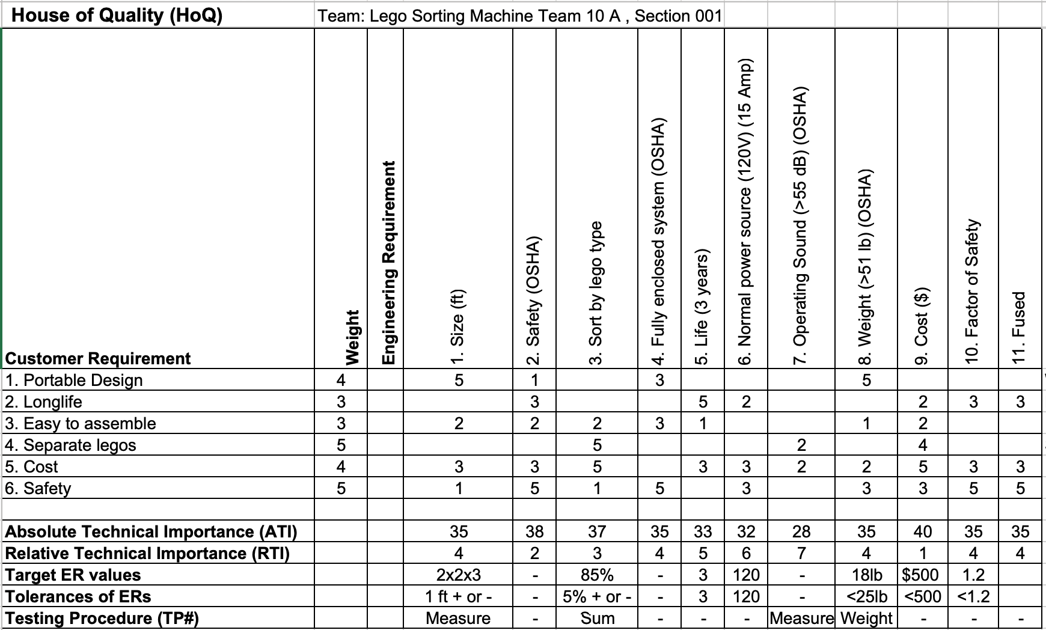

3. DESIGN SPACE RESEARCH
In chapter 3, design projects process has explained in which different have described to do the research for any project. As the design project need lot of research to see others work and take help from the sources to do the design project. For doing any design project, different sources need to search which can help like peer reviewed journal articles, engineering books, patent designs, existing designs, engineering reports, and website sources. These type of sources provide different kind of solutions from which some ideas can take and these ideas can help in implementing the design. Benchmarking is another way of doing the research, in benchmarking interview can conduct with professionals and take some help. The idea is to open different ways and to make creative design idea for the project.

3.1 Literature Review

3.1.1 Student 1(Sultan Alharbi)

3.1.1.1 Model Design and Simulation of Automatic Sorting Machine
This reference has different sensors that can use to sort the Legos, and the main focus of this journal article is on proximity sensor, which use to do the sorting algorithms. Proximity sensor uses the electromagnetic field to detect the nearby objects. With the help of proximity sensor Legos will determine and the size of Legos will also manage through the proximity sensor so it will be a good idea to use the sorting machine using the proximity sensor and this article can help in developing the sorting machine [1].
The created computerized sorting machine can consolidate adaptability and separate types of non-ferrous metal items and in the meantime move protests naturally to the bin as characterized by the direction of the Programmable Logic Controllers (PLC) with a capacitive closeness sensor to identify an esteem scope of articles. The outcome got demonstrates that plastic, wood, and steel were arranged into their individual and right position [1].

3.1.1.2 Introduction to Arduino
This is a textbook reference regarding the Arduino, as we have to build an automatic sorting machine so we have to use a microcontroller that will make the decisions and will pass the instructions to all parts of the device and send the tasks to perform. For the microcontroller, Arduino is one of the best option to use and this reference is explaining the use of Arduino and the working of Arduino and also providing the complete practice on using it and the coding of Arduino. A controller is such a small device which collectively perform many operations using a single chip, and the controller is small integrated circuit with memory, processor core and inputs/outputs [2].
We can use this reference in building the project for microcontroller because we have to understand the microcontroller and its programming as well before using it and this reference can use to learn the programming and working on controller [2].

3.1.1.3 Automation and Robotics
This is mechanical engineering textbook and this is useful for our project because in this textbook automation technologies have defined. In this textbook, different techniques have defined which can use for the automation in the robotics, these techniques include the proximity sensors and other related things. Some conveyor lines have defined in the series which are useful for building the project as the conveyor line process makes it possible to do the automatic of sorting for moving the LEGOS from one side to another side [3]. As the algorithms have
presented in the book as well which can utilize for sorting in automatic condition. In chapter 5, robot grip mechanism has discussed, in which control system and the feedback systems have discussed and these controllers are strongly recommended to use in the automatic system and we can use these controllers in our project to develop an accurate and concise system of sorting the LEGOS [3]. So this reference is quite helpful for us in this regard.

3.1.1.4 Machine Control System Operation for Automatic Sorting
This is an article which is relating to sorting machine and in this article an egg sorting machine has presented and this sorting machine idea can help us in building the LEGO sorting machine.
The article talks about the framework and the machine control program for programmed eggs sorting into classes dependent on size and shape utilizing a specialized vision framework [4]. The foremost distinction between the considered machines for sorting eggs into classes and the current sorting machines, is the detachment of eggs into classifications by size incorporating substandard eggs in the stream. For capturing of eggs in the stream keen camera type NI-1772-EF00303A is chosen, and programmed partition of egg into classifications is conveyed by pneumatic actuators valve, which empowers twofold profitability increment. The program for shrewd cameras is made in the earth. The focal hub task control arrangement of the machine is the controller programming. Controller "OWEN PLC 110-160" supporting perception is executed in CoDeSys 2.3 condition. Trial confirmation demonstrated that the framework permits control of the machine activity units in powerful mode and programmed sorting of eggs in classifications in the stream [4].
So this article has used sorting machine and the phenomena used in this article can help us in using the LEGOS sorting like the conveyor used the egg sorting accordingly and we can implement similar sensors and camera applications in building design project.

3.1.1.5 Machine Vision and Object Sorting
This article is about the machine and the sorting of various items based on their shapes and sizes. A small scale generation line was developed and mechanized utilizing STEP 7 programming, and Simatic-300 based Programmable Logical Controller (PLC); both are fabricated by Siemens [5]. The machine vision part of the theory was done in NI LabVIEW, a graphical program improvement condition from National Instruments [5]. The correspondence between the PLC and LabVIEW was done utilizing OLE for Process Control, an extra for LabVIEW [5].
This reference is also helpful in building the project as it has used the Programmable controller for applying the sorting algorithms and therefore it can help us in building the sorting machine using PLC and using the software LabVIEW.

3.1.2 Student 2 (Fahad Alotaibi).

3.1.2.1 Mechanical Engineering Design
As the project is Automatic Lego sorting machine and for this project a textbook reference is using as a starting point to understand. This textbook is a good reference for helping in building the project because it has lot of details regarding the materials, springs, and gears, which can help in the project. As the project will sort the Legos so materials will help in understanding the best materials for the Legos and identify the stress, materials can bear which are perfect to use for Legos, springs will use to move the Legos from one place to another place, gears will also help in moving the Legos for sorting them.
In materials, material strength and stiffness is useful to select the best material for the Lego because the Legos must be strong enough to bear any external force or if drop down then don’t get broken [6]. The selection of a material for a machine part or a structural member is one of the most important decisions the designer is called on to make. The decision is usually made before the dimensions of the part are established. After choosing the process of creating the desired geometry and the material (the two cannot be divorced), the designer can proportion the member so that loss of function can be avoided or the chance of loss of function can be held to an acceptable risk [6]. Hardness of the material is important factor as well to select the final material and it can learn from the reference that hardness can determine for different materials [6]. The resistance of a material to penetration by a pointed tool is called hardness. Though there are many hardness-measuring systems, we shall consider here only the two in greatest use [6].
Gears can better understand through this reference as all type of gears have explained in the textbook so it will be useful when implementing the project which gear can use to move Legos. This chapter addresses gear geometry, the kinematic relations, and the forces transmitted by the four principal types of gears: spur, helical, bevel, and worm gears. The forces transmitted between meshing gears supply torsional moments to shafts for motion and power transmission and create forces and moments that affect the shaft and its bearings. The next two chapters will address stress, strength, safety, and reliability of the four types of gear [6].

3.1.2.2 Proximity Sensors
This is a textbook related to the proximity sensors as proximity sensors can use in our project to determine the positions of LEGOS and carrying them from one point to another point. Proximity sensors works on the basis of rays which detects the distance from the object and in this way we can apply the sorting algorithm and get the required arrangement of LEGOS. For this purpose, proximity sensors textbook has taken as a reference to understand different kind of proximity sensors and determine which proximity sensor can use in our project and serve the purpose in its best way. In this book, different kind of proximity sensors have discussed which includes optical proximity sensors, ultrasonic proximity sensors, pneumatic proximity sensors, capacitive proximity sensors, inductive proximity sensors, magnetic proximity sensors and mechanical sensors [7]. All these sensors have different criteria and usage and their usage has defined along with their operational working and because of the detailed description of each sensor make it easy to determine which sensor is best to use for the project [7]. This source is quite useful in this project because we are going to use the sensors for building the project and it will be helpful for us to understand which sensor is best to use according to our requirements.

3.1.2.3 Lego Bricks Color Sorting Machine
LEGO Bricks Color Sorting Machine is a framework with capacity to sort LEGO bricks as per their color. This framework configuration utilizes Arduino Mega as a controller. In this task, PIXY sensor is utilized to recognize the color of the article after it was physically sustained by clients at nourishing slide [8]. In view of the sensor readings, the framework will consequently begin to sort them to their correct area or station. The best splitter space will move to one side or directly so as to alter the area for the drop [8]. The upside of this framework is the capacity of the framework to sort LEGO bricks dependent on its color, and contains a station for rejected article on the off chance that it doesn't meet the framework prerequisites, for instance color isn't identified or object isn't perceived. The framework sorts the item in quickest time and with no blunders. The exploratory outcomes bolster the objectives which is to build up the LOGO bricks color sorting machine with decreased sorting time and better quality in the field of robotics [8]. This source has complete LEGOS sorting solution and the machine presented in this article has developed for the LEGOS on the basis of color. So this solution can utilize for building the design of LEGOS sorting machine.

3.1.2.4 Automatic Color Sorting machine
Sorting of items is an extremely troublesome modern process. Nonstop manual sorting makes consistency issues. This paper portrays a working model intended for programmed sorting of articles dependent on the color [9]. TCS230 sensor was utilized to recognize the color of the item and the PIC16F628A microcontroller was utilized to control the general procedure [9]. The distinguishing proof of the color depends on the recurrence examination of the yield of TCS230 sensor. Two transport lines were utilized, each constrained by isolated DC engines. The primary belt is for setting the item to be broke down by the color sensor, and the second belt is for moving the holder, having isolated compartments, so as to isolate the items [9]. The exploratory outcomes guarantee that the model will satisfy the requirements for higher generation and exact quality in the field of robotic [9].
This reference has a complete design about sorting through different colors and this design can utilize for building the design of automatic LEGOS sorting, as this design has color sorting, and it can help us in finalizing our own design.

3.1.2.5 Color image based sorter for separating red and white
A straightforward imaging framework was produced to examine and sort wheat tests and different grains at moderate feed-rates [10]. A solitary camera caught color pictures of three sides of every portion by utilizing mirrors, and the pictures were prepared utilizing a (PC). Continuous picture procurement and preparing was empowered on a common PC under Windows XP working framework utilizing the IEEE 1394 information exchange convention, DirectX application programming, and double center PC processor. Picture obtaining and exchange to the PC required roughly 17ms per piece, and an extra 1.5ms was required for picture handling. After order, the PC could yield a flag from the parallel port to enact an air valve to occupy (sort) bits into an auxiliary compartment [10]. Hard red and hard white wheat parts were utilized in this examination to test and show sorter capacity. Basic picture measurements and histograms were utilized as highlights. Discriminant examination was performed with one, two, or three highlights to exhibit characterization enhancements with expanded quantities of highlights. The sorter could isolate hard red portions from hard white bits with 95 to 99% precision, contingent upon the wheat assortments, feed-rate, and number of grouping highlights [10]. The framework is a prudent and helpful instrument for sorting wheat and different grains with high exactness [10]. This source is also useful in our project because of the design for separating the red and white color and we can continue developing this technique on the basis of LEGOS.

3.1.3 Student 3 (Abdullah Almutairi)

3.1.3.1 BrickLink
It is a website that shows for me all the sizes and the shapes of the lago parts. The most important thing for us is the weight of the lagos. It will help us to find everything about the parts that we need to sort. However, a good source for us that will help [11].

3.1.3.2 The art of LEGO design
This source was the best start for our team. The start that give us a brief description about what we want to sort will help our team alot. All in all, we need to know what we are sorting in order for our team to success[12].

3.1.3.3 SolidWorks 2011 Assemblies Bible.
This book will give as much as we want to see more better by drowning every part. However, when we draw them it will be as clear as we want to see. For example, when we want to see the part better we will draw it and we will see the things that we want to change if it need to be changed[13].

3.1.3.4 Programming Arduino.
This book will make us know how to start with arduinos. It will give a good information about how to start with programming these things in order to make them work for our project. the book will help because we are a mechanical engineers not a programming engineers so, we need to learn how to do it. all in all, learning is what we do[14].

3.1.3.5 Automatic sorting system.
In extensive scale production of numerous gadgets and components, it is unreasonable to make every individual gadget Within amazingly close resiliencia. It is, in this manner, normal to fabricate a gathering of gadgets using generously a similar procedure and from there on test the individual gadgets for motivations behind ordering them into gatherings I whose qualities fall inside worthy breaking points or above or beneath such cutoff points. Such a training is particularly normal in the assembling of electronic segments, for example, curls, condensers, resistors, diodes, transistors, and so on.
For instance, at least four diverse sort of transistors may result from a solitary creation run. The main distinction in the different sorts of transistors coming about because of the creation run might be, for instance, an alternate scope of current intensification factors or a distinction in authority breakdown voltage or contrasts in one of the other transistor parameters which are viewed as basic. Albeit every one of the transistors is made utilizing indistinguishable procedures to the best degree conceivable, even little contrasts in the measure of pollution material diffused into the semiconductor body or a little warmth differential in the diffusing heaters can deliver distinctive gadget qualities. In this manner, it is known measurably that shifting rates of every one of a few diverse sort gadgets will be gotten from every creation run.

3.1.4 Student 4 (Husain Alkandari)

3.1.4.1 Actuators. In Hydraulics and Pneumatics - A Technician’s and Engineer’s Guide
Hydraulics and Pneumatics: A Technician's and Engineer's Guide serves as a guide to the hydraulic and pneumatic systems operations. It features mathematical content that has been presented in a style understandable even to beginners and non-experts. It has nine chapters that cover both hydraulic and pneumatic machinery, their fundamental principles including safety standards and regulations. The book also features abundant referencing, updated web links, and masterful tables for easier understanding of the concepts covered. The text is written to serve as an introductory reference for novices and students in pneumatics and hydraulics. It is also invaluable and can be used as primary reference for control, manufacturing, mechanical, and electrical engineers, operations managers, and technicians working with hydraulic and pneumatic equipment. [16]

3.1.4.2 Adaptive Parameter Estimation for an Energy Model of Belt Conveyor with DC Motor
In this paper, a new energy model of belt conveyor with a DC motor is introduced. Then, an adaptive observer is designed for the model. In order to identify the four coefficients of the energy model , the feed rate T of the belt conveyor and the angular velocity wm of the rotor of the DC motor should be measured on‐line. Then, based on the adaptive observer, a parameter estimation algorithm is derived. In addition, under a persistent excitation condition, the convergence of the parameters to the desired values can also be concluded. Simulation results show the validity of our methods. [17]

3.1.4.3 Welding Fundamentals
Welding Fundamentals is designed to provide students with a strong understanding of the underlying theory and skills required for successful welding, with a strong emphasis on safety. It provides all of the information needed to help students develop proficiency with the most common welding processes (including GTAW, GMAW, FCAW, SMAW, and oxy fuel welding), thermal cutting, basic print reading and weld symbology, and joint design and fit up. The text also introduces students to weld inspection and testing. [18]

3.1.4.4 Tomato sorting based on shape, maturity, size, and surface defects using machine vision.
In this study, an image processing technique was developed to sort tomatoes according to 4 quality criteria: maturity, defects, shape, and size. The software developed in this study evaluated tomato shape by its eccentricity, tomato size by its 2-D image area, tomato maturity by its mean color, and tomato defect by its fullness parameter. [19]

3.1.4.5 Motors for Makers
This book explains how DC motors work. It also shows to connect servos to mega arduino specifically.

3.2 Benchmarking
For doing the benchmarking, different searches have done and different projects have seen which have done before related to this project. Some existing designs have found as well which are similar to this project. The basic purpose of doing this benchmarking is to find similar designs, which have found over the google. These designs have analyzed and some of the design ideas have found useful for this project.

3.2.1 System Level Benchmarking
In system level benchmarking such similar designs have searched which fully applied to the project. As the name stated system level benchmarking, so the full complete device comes under the system level. Some existing designs have presented in this section.

3.2.1.1 Existing Design #1: Lego Sorting Using TensorFlow Arduino [21]
The LEGO bricks begin a chute as a gathering, and after that slide down onto a moderate moving transport to disperse the gathering. Next, a second, quicker moving, transport further isolates the bricks. With a good space between one brick and the following, they're channeled into a region where they can be captured. The Arduino with TensorFlow at that point chooses what sort of brick it is and pivots another chute to the relating container, where the brick is saved. Garcia's initially kept running of the machine precisely arranged 89% of the bricks, and that can probably be improved with better TensorFlow preparing. It has shown below in figure 1.
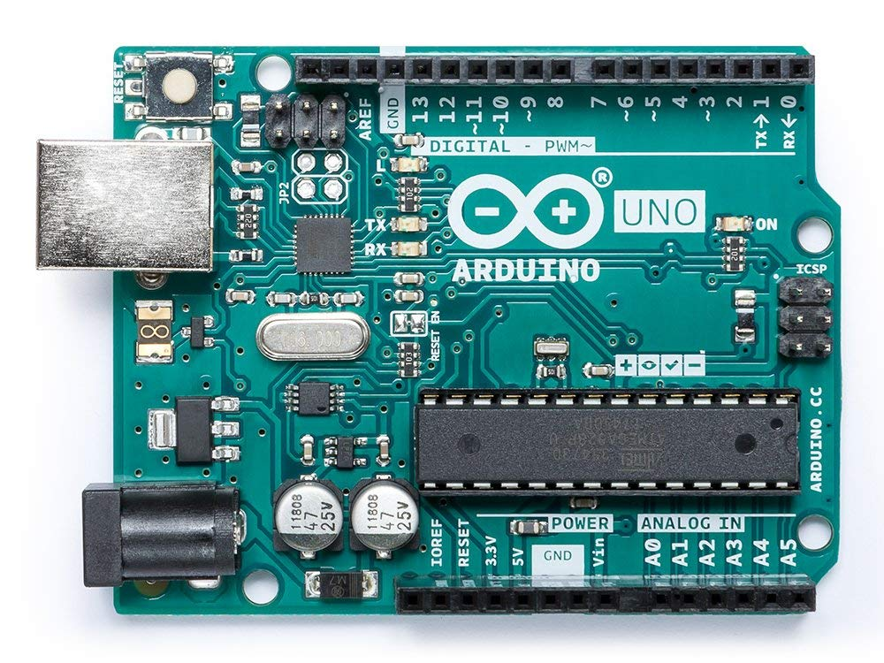
Figure 1: Arduino Design [21]

3.2.1.2 Existing Design # 2: Elaborate Lego Sorting Machine [22]
Utilizing Python code, repurposed mechanical weight sensor machine sorts in excess of 38,000 shapes in 100 conceivable hues and shades. The pieces are pulled up the belt on a stepping stool, slide down a chute, are captured and afterward taken to their fitting canisters on another transport line. It has shown below in figure 2.
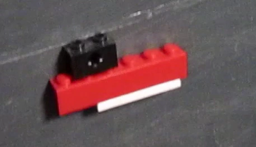
Figure 2: Elaborate Sorting [22]

3.2.1.3 Existing Design # 3: Lego Parts Solver [23]
The 5-foot by 10-foot sorter runs bricks down a transport line, shunting them into containers dependent on size and shape, and even tile and pivot styles. The mechanical subtleties of the construct can be difficult to parse, however essentially, Chow step by step expands the span of the openings a brick may fail to work out, dumping littler ones first, and after that bit by bit abatements the tallness of the boundaries to permit level pieces through while uneven ones get expelled.
It depends mostly on Akiyuky's Automatic Liftarm Sorter, which sorts just liftarm-type pieces. Chow additionally has a video of early models, yet it doesn't give away a great part of the assemble strategy either.
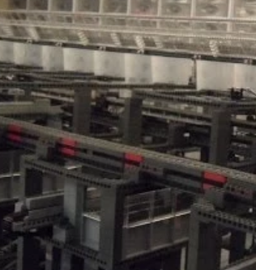
Figure 3: Lego Solver [23]

3.2.2 Subsystem Level Benchmarking
In this section, sub-system level parts are defining like some important basic parts that will play important role in the project will use. Like sensors, catcher etc. that will play important role in the project.

3.2.2.1 Subsystem #1: Sensors
There are different kind of sensors that can use in this project. Sensors detect different conditions and respond if something has happened or not. Proximity sensor is one of its kind which detect the nearest hurdles.

3.2.2.1.1 Existing Design #1: Proximity Sensors
It is a kind of sensor that can detect the nearest hurdle, so it detects any object is present in nearby or not. This sensor can use in our project to detect the Lego bricks, and identify the location because of its sonar beams. This existing design can help in the project for finding the Legos.
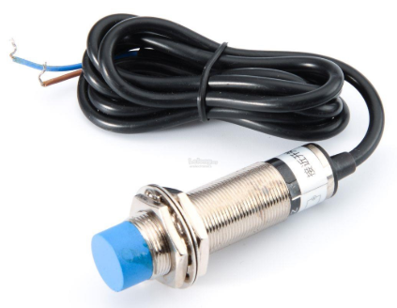
Figure 4: Proximity sensor [24]

3.2.2.1.2 Existing Design # 2: Ultrasonic Sensor
This is another sensor which detect the object far from its location and this sensor can use in the project. It uses the ultrasonic rays which goes and then come back to the source and detect the object present in the way. In this way ultrasonic sensor can use for sorting the Legos by finding the Legos and then sort them on the basis of their shape.
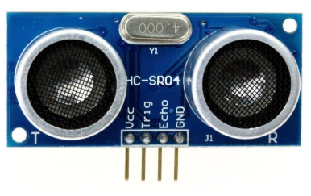
Figure 5: Ultrasonic Sensor [25]

3.2.2.1.3 Existing Design # 3: Infrared Sensor
This sensor can also use to find the location of object without touching it, in this way this existing design can help in making the project so that Legos shape can recognize easily. This sensor can use in multiple ways, like detecting the object, placement of object, recognizing the shape as well.
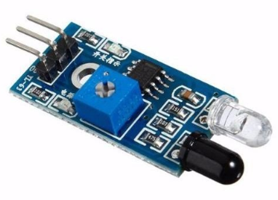
Figure 6: IR Sensor [26]

3.2.2.2 Subsystem #2: Grabber
Grabber is another in the project that can catch the Lego and place it from one location to another location. So the grabber has to handle all type of Lego shapes.

3.2.2.2.1 Existing Design # 1: Reacher Grabber
This is a grabber design which has a button at the start that need to push to open the mouth and then catch the item. Mouth of grabber is like in U shape and it can possible carry all type of Lego shapes. This existing design can use in our project in a way that we have to carry the Legos so it can place as a catcher of Lego bricks.
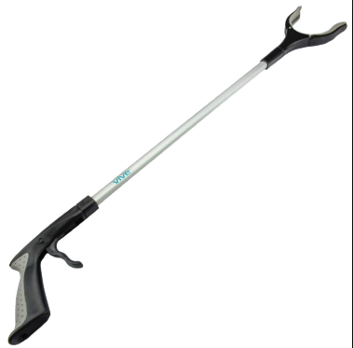
Figure 7: Reacher [27]

3.2.2.2.2 Existing Design #2: Claw
This is another existing design which can use in our project, the design of grabber is like a finger shape with 4 to 5 tips that can grab the product easily so it can use for carrying the Legos and as the fingertips can open to multiple directions so it can easily use and carry the Lego bricks
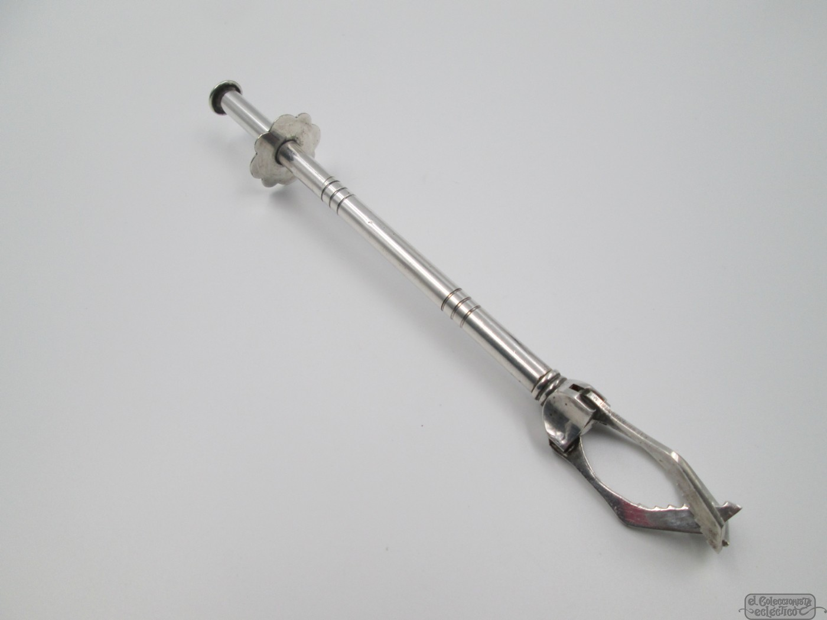.*
Figure 8: Claw [28]

3.2.2.2.3 Existing Design # 3: Hand Grabber
This is another type of grabber, which has hand shape and it can hold the product like a human hand so it can also use in our project to carry the product.
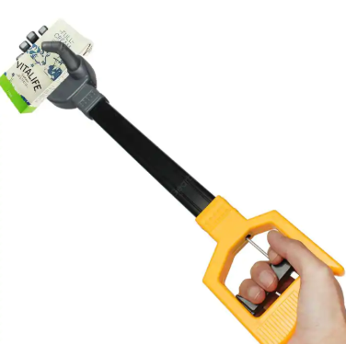
Figure 9: Hand Grabber [29]

3.2.2.3 Subsystem # 3: Bearing
It is another subsystem that will use in the project for the movement of grabber from one direction to another direction without changing the base position. So in that situation bearing will use to rotate the grabber in 360 degree directions.

3.2.2.3.1 Existing Design # 1: Roller
It is a type of bearing which has the roller with the ball to move easily in 360 degrees. This can use for supporting the grabber to rotate the grabber from one position to another position.
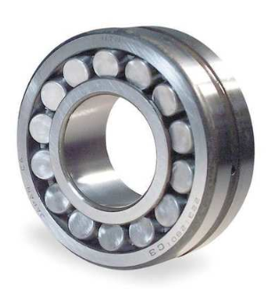
Figure 10: Roller [30]

3.2.2.3.2 Existing Design #2: Shaft
Another existing design is shaft, that provide the rotation at the fixed position, so this existing design can help in the project for moving the grabber around 360 degrees.
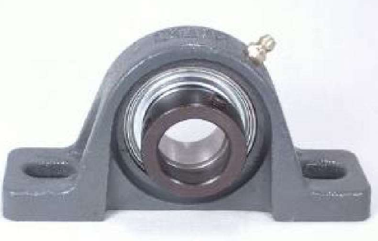
Figure 11: Shaft [31]

3.2.2.3.3 Existing Design # 3: Self Align Ball Bearing
This is another existing design which can use in the project as it provides the movement in all the directions. And we can use this design in the project for moving the grabber.
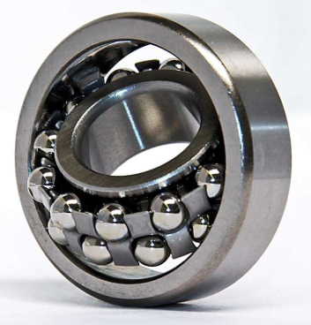
Figure 12: Self Align Bearing [32]

3.3 Functional Decomposition
As the project divided into multiple functions so that’s why it has named functional decomposition. In this part of the project, different sub parts of the project will describe that will possible present in the design and will perform the operation. In this section the Black Box model and functional model is presenting. The Black Box model describes the input and outputs of the system and functional model defines what is happening inside the product.

3.3.1 Black Box Model
This is a model in which inputs and outputs of the device shows like what is going as an input to the device and what is getting from the device, without any consent of what is happening inside the device and that is why it has named the Black Box model. The black box model has three inputs, first is hand and random Legos/non Legos, second is electrical energy and human energy and third input is on/off and empty reservoir. And the output of this device is hand and sorted Legos/non legos, second output is sound and heat, and third output is on/off and full reservoir. Black box has shown below in the figure
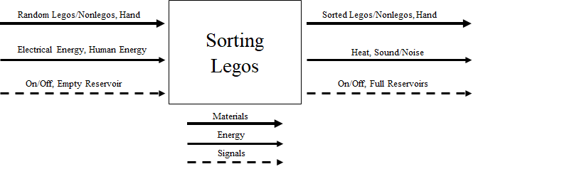
Figure 13: Black Box Model

3.3.2 Functional Model
Functional model shows the complete system from the inside of product in steps like what is happening with the input at first and then what is going to happen next and so on. In this way all the steps and sub parts shows in the functional model and that’s why it has named functional model. In the functional model complete process has shown that hand will use to import the Legos and then aligne the legos and transport them to the sensors to analyze and then classify and sort the legos.
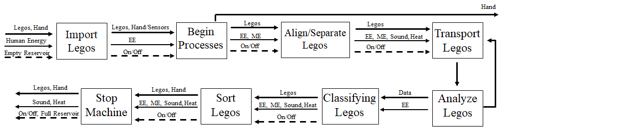
Figure 14: Functional Model

4. CONCEPT GENERATION
In this section different ideas are presenting that have generated by the team members. These design ideas have created by the team and sketch them as well for better understanding. In this way final design will select from these developed design ideas.

4.1 Full System Concepts

4.1.1 Full System Design #1: Box on the Wide belt
This is a wide belt in which the Legos will place randomly and it will move forward to the next belt for sorting as it has shown below.
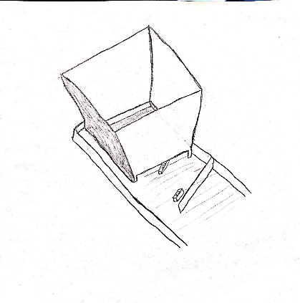
Figure 24: Wide Belt
Advantages:
- Randomly movement
- Easy movement
Disadvantages:
- Slow process

4.1.2 Full System Design #2: Belt with Hurdles
In this design idea, there are breaks present in the belt that make the que of the Legos and arrange them in one-line shape to make it easy to move.
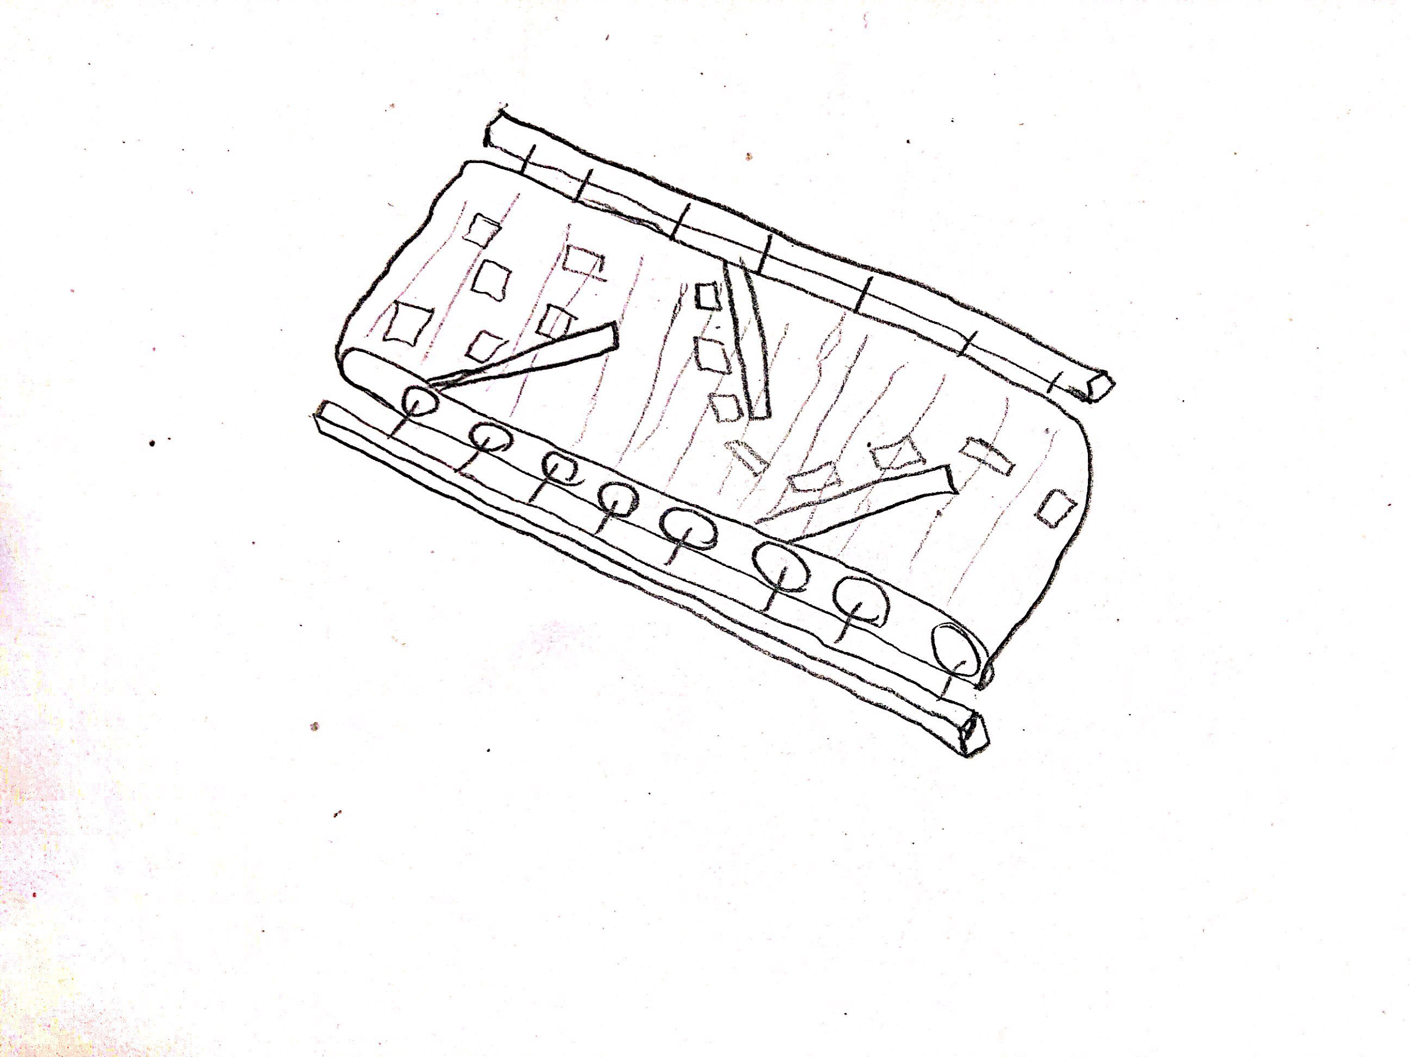
Figure 21: Belt with Hurdles
Advantages:
- Large Lego to put
Disadvantages:
- Slow process

4.1.3 Full System Design #3: Weight
This is the idea that check the weight of each Lego and differentiate it from others and move to the space associated to that weight and it has shown below:
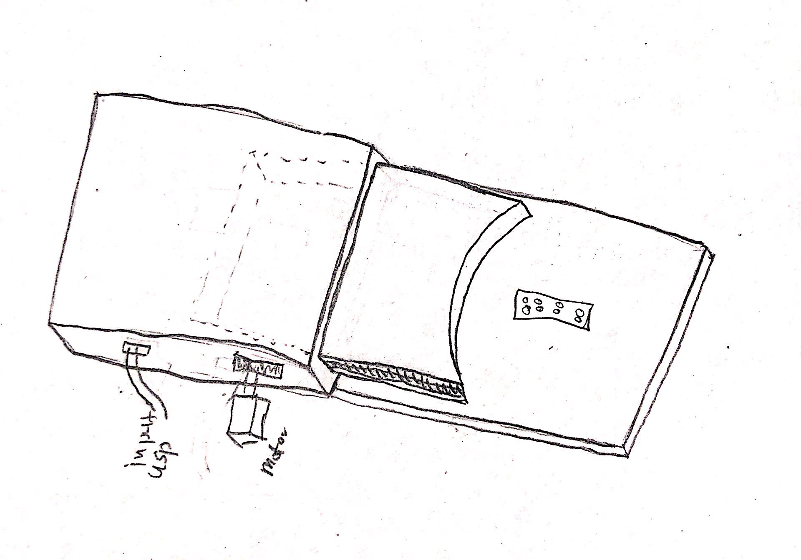
Figure 18: Weight Sensor Idea
Advantages:
- Fast process
- Economical to use
Disadvantages:
- Not efficient

4.1.4 Full System Design #4: Boxes
In this design there are boxes formed with the link from center box and all the Legos have their own box so each design will get its own box so lot space and it is easy as well to store the Legos and within small space. As the design has shown below
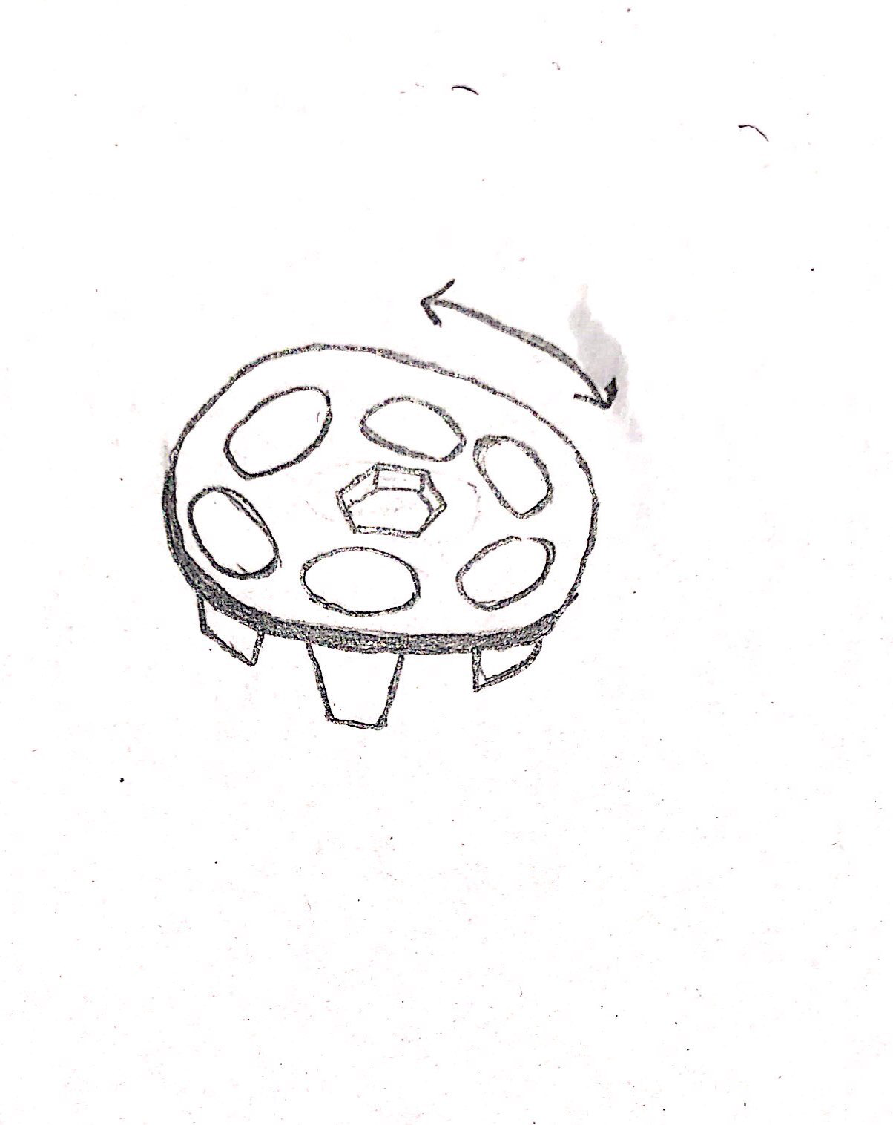
Figure 17: Boxes
Advantages:
- Large Space
- Easy to use
- Sorting is easy

Disadvantages:
- Slow Process

4.2 Subsystem Concepts
In this portion different design ideas will generate related to the project and these ideas will be for the sub system of the project. Lego Sort Level. In this subsystem, Lego will differentiate on the basis of its size and shape.

4.2.1 Subsystem #1: Align/ Separate Legos

4.2.1.1 Design #1: Nozzle down
In this design idea, a nozzle shape has made with the wide open to make easy for the Legos to go inside and then narrow down for reducing the number Legos to move forward, in this way Legos get in a line easily as the idea has shown below.
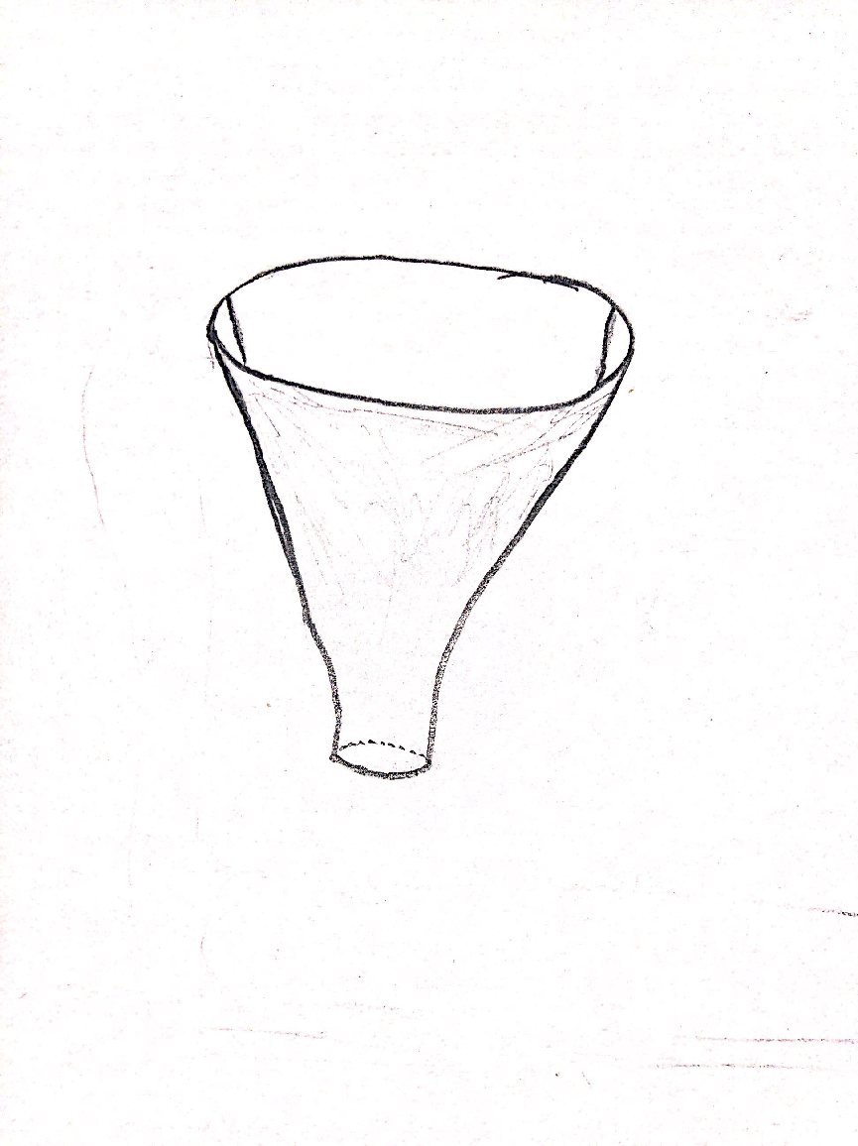
Figure 25: Nozzle Down
Advantages:
- Fast
- Easy to narrow down

Disadvantages:
- Chance of obstacle

4.2.1.2 Design #2: roulette
There is a Roulette in which the Legos goes, spin through the walls of the Roulette and then move to the next stage one by one, when the wall push it to move forward. The idea has shown below as well.
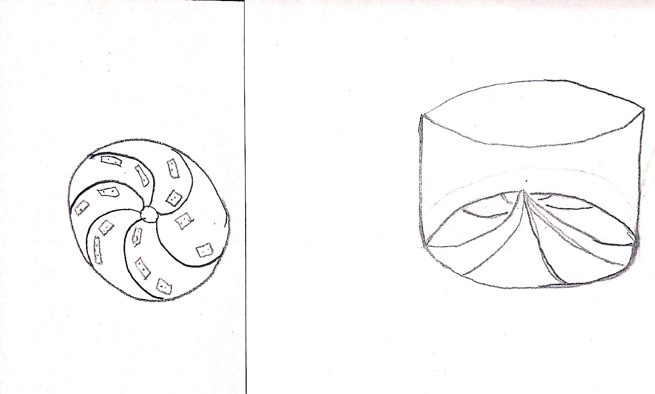
Figure 26: Roulette
Advantages:
- Fast

Disadvantages:
- Costly
- Chance of breaking

4.2.1.3 Design #3: Slide box
In his idea, we have a slide box that makes the Legos go to the next step by just throw it into the slide without any electrical or kinetic energy to move the Legos. The idea has shown below as well.
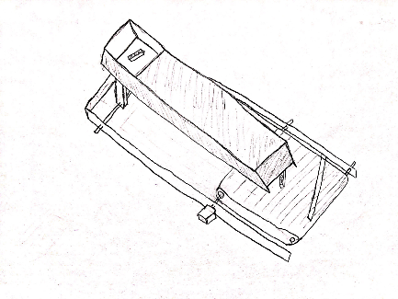
Figure 27: Slide Box
Advantages:
- Fast
Disadvantages:
- Chance of breaking

4.2.2 Subsystem #2: Transport Legos

4.2.2.1 Design #1: Straight Belt
The design idea states that it is good to use the straight belt which make a long que of Lego and move straightly without any interaction.
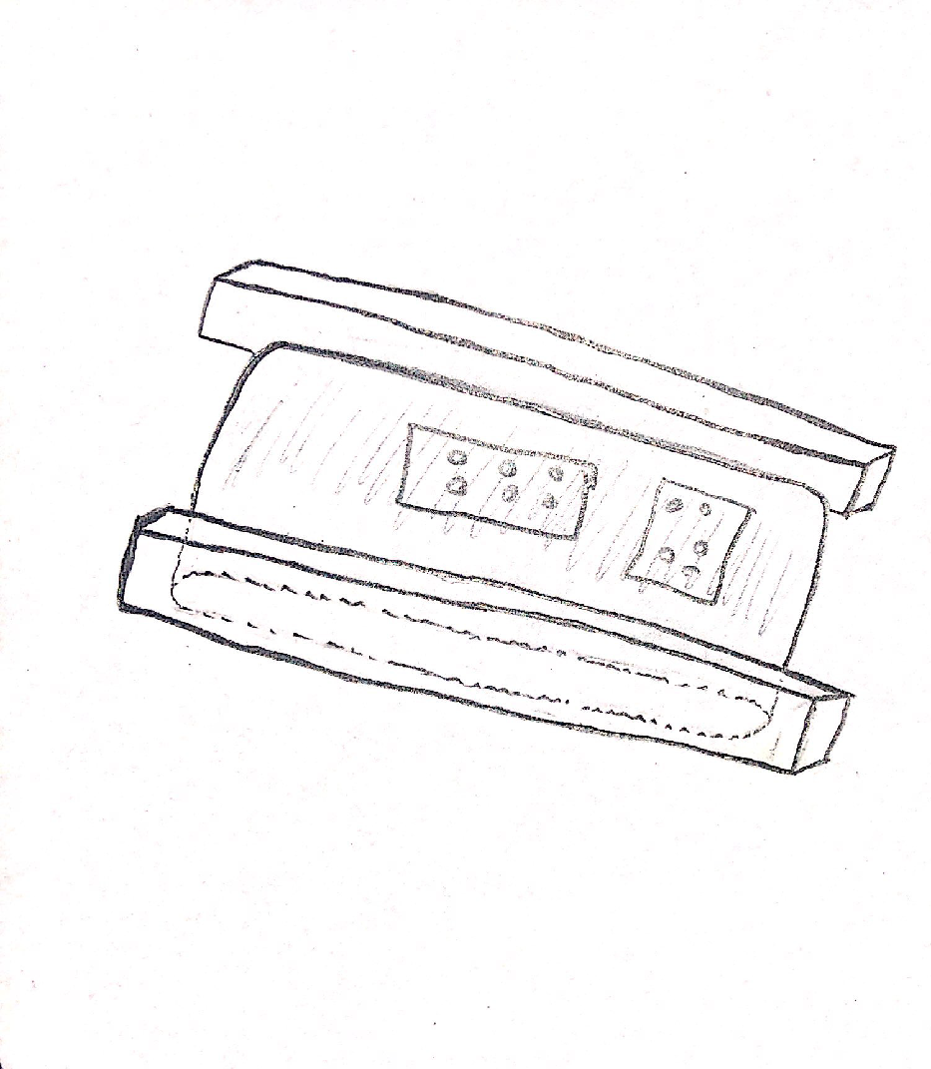
Figure 22: Straight Belt
Advantages:
- Fast
- Straight
Disadvantages:
- Less Legos to put in it.

4.2.2.2 Design #2: Round Belt
In this design idea, there is nozzle shape belt which make a long que and provide large space to the Legos as the idea has shown below.
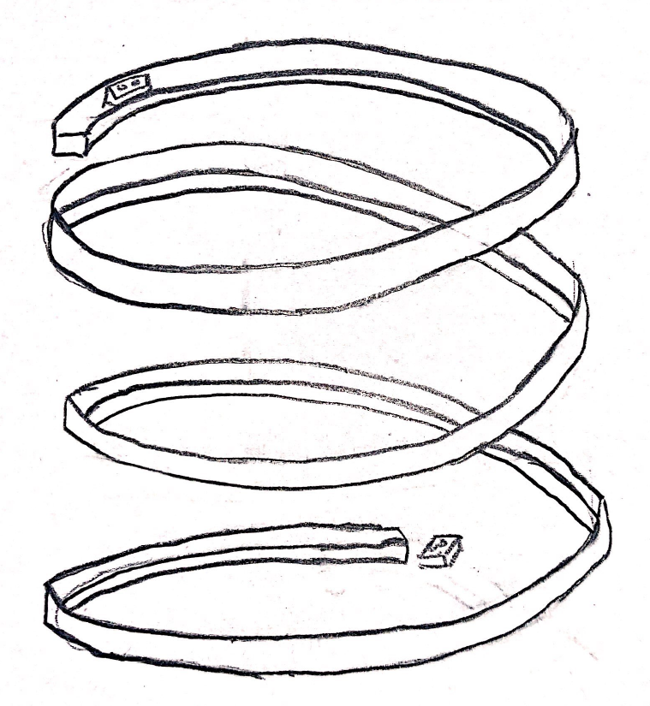
Figure 23: Round Belt
Advantages:
- Large number of Legos
Disadvantages:
- Time taking

4.2.2.3 Subsystem #3: Hand Grabber
Hand grabber might be a useful idea, because we are going to create a robot to transport the Legos to the next step. As shown in the figure below.

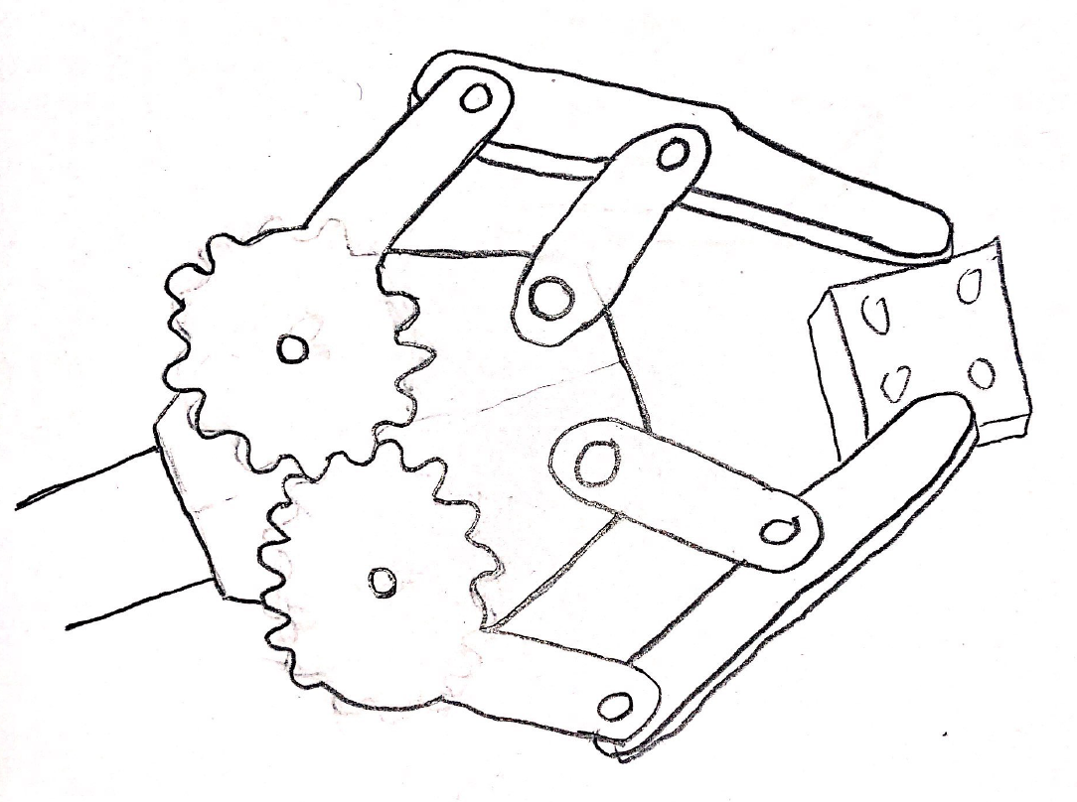
Figure: Hand Grabber
Advantages:
- Easy to use
- Safe time
Disadvantages:
- Costly
- Needed more maintenance

4.2.3 Subsystem #3: Classify Legos

4.2.3.1 Design #1: Scanner
This is the idea that scan the Lego and differentiate it from others to find its location where it need to go according to the associated space and the idea has shown below.
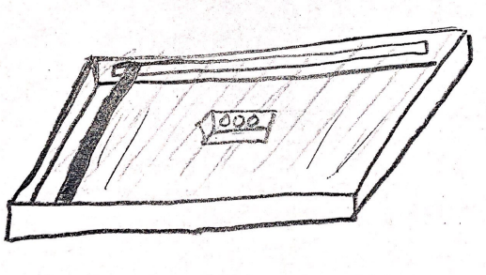
Figure 19: Scanner
Advantages:
- Easy to operate
- Economical
Disadvantages:
- Less efficient

4.2.3.2 Design #2: Camera
Another option we have decided is the use of camera to do the differentiation between the Legos and recognize the Lego so it can move to its associated space.
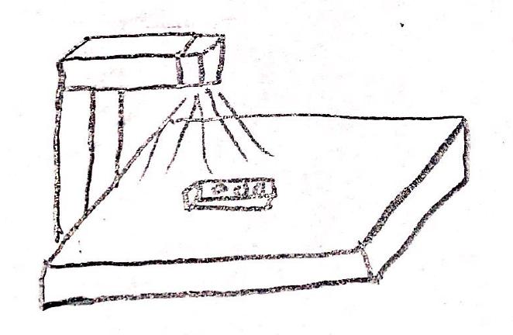
Figure 20: Camera
Advantages:
- Accurate
- Speedy
Disadvantages:
- Costly

4.2.4 Design #4: Sorting Legos

4.2.4.1 Design #1: Round Box
In this design, all the Legos will sort out in one round shape area with the hands outside it and these hands store the Legos. One hand will store one kind of Lego and other hand will store second kind of Lego and in this way all the Legos will sort in this round shape. The design has shown below.
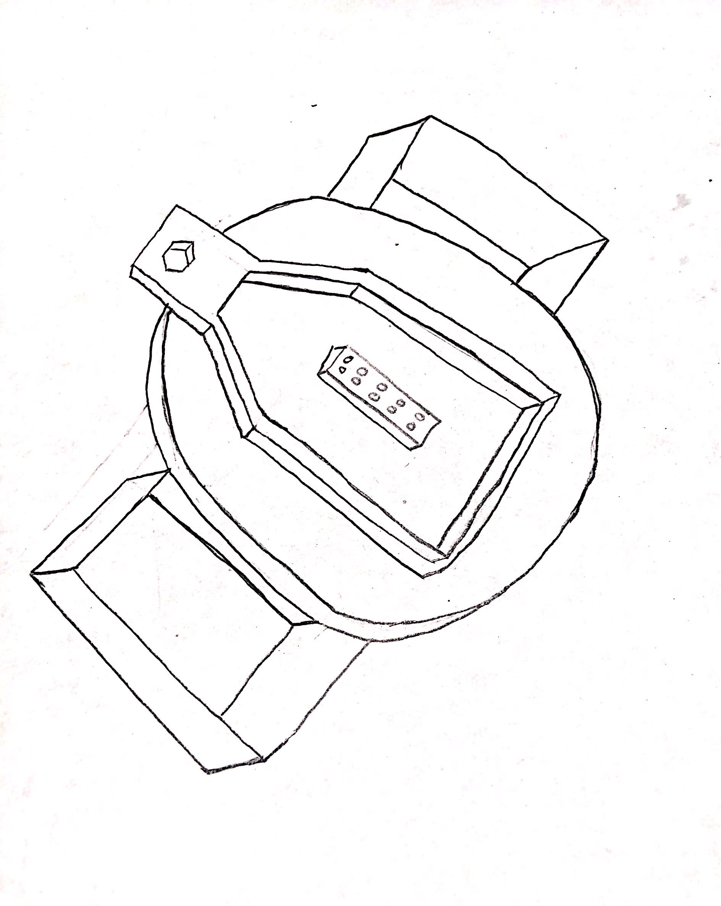
Figure 15: Round Box
Advantages:
- Easy to use.
Disadvantages:
- Less space
- Slow Process
- Sorting is difficult

4.2.4.2 Design #2: Multiple Branches Tree
In this design, Legos have lot of space to store so different Legos store in different portions of the branches, so this design can manage multiple shapes, multiple colors and multiple sizes as well as the design has shown below.
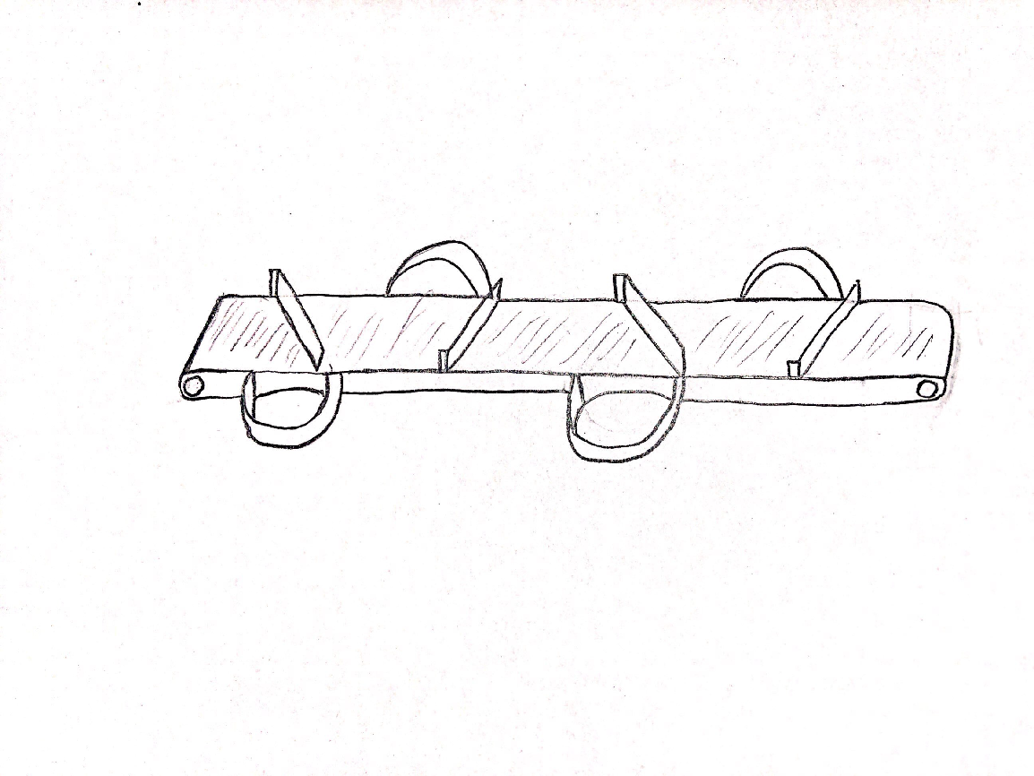
Figure 16: Tree Design
Advantages:
- Large Space
Disadvantages:
- Slow Process.
- Sorting is difficult

5. DESIGN SELECTED
In this section final design will going to select from the concepts which have generated in the previous section. There are different ways to select the design from multiple designs but it is difficult to select the best design by simply checking the design so there are some methods available which can help in choosing the design like decision matrix, and Pugh chart. These design ideas use the customer requirements and then test each design with each requirement to and then the best design select.

5.1 Technical Selection Criteria
Criteria for selecting the design depends on the efficiency and the requirements they are fulfilling. The basic criteria for selecting the design is that test it with the requirements and see if all the requirements are following by the design or not. If all the design is following by the requirement the design is acceptable otherwise the design is not acceptable. In this way selection of design happens. The technical criteria of design engineering requirements and engineering requirements can measure as well so technical criteria for the design is engineering requirement that need to meet by the design to count as a final design.

5.2 Rationale for Design Selection
There are different design ideas which have generated, and to select these design ideas, Pugh chart and Decision matrix have used.
Pugh Chart
Pugh chart has used to check for each requirement against each design and then assign a plus sign if the requirement is present in it. And if the requirement is not present then it assign a negative sign. And at the end sum up the plus sign and minus sign. So the design with higher plus sign will count as the final design.

Table 3: Pugh Chart
LEGO SORTING | Weight | Design # 1 | Design # 2 | Design # 3 | Design # 4
1. Carriable | 8 | + | + | + | D
2. Reliability | 7 | + | - |  | D
3. Warranty | 6 | + | + | - | D
4. Functionality | 5 | + | + | + | D
5. Separate non-Legos | 4 | + | S | + | D
6. Durability | 3 | + | - | + | D
7. Cost | 2 | + | + | - | D
8. Safety | 1 | + | + | - | D
Pluses |  | 8 | 5 | 4 | Na
Minus |  | 0 | 2 | 3 | Na

From the Pugh chart, we have the best design as design #1 which has 8 plus and 0 minus sign that’s why it has count as final design. Now check it with decision matrix.
Decision Matrix
Decision matrix is a matrix in which each requirement test against each design and then assign a score, and there is a raw score for each requirement so multiply the assign score with the raw score for each requirement and then add up to make the total. The highest total score is count as the best design.

Table 4: Decision Matrix
Decision Matrix | Carriable | Reliability | Warranty | Functionality | Separate non-Legos | Durability | Cost | Safety | Total
Weight | 8 | 7 | 6 | 5 | 4 | 3 | 2 | 1
Design # 1 | 6x8=40 | 6x7=42 | 2x6=12 | 7x5=35 | 7x4=28 | 5x3=15 | 5x2=10 | 5x1=5 | 157
Design # 2 | 6x8=40 | 6x7=42 | 2x6=12 | 7x5=35 | 7x4=28 | 5x3=15 | 5x2=10 | 1x1=1 | 153
Design # 3 | 4x8=32 | 4x7=28 | 3x6=18 | 4x5=20 | 4x4=16 | 3x3=9 | 3x2=6 | 1x1=1 | 130

So from the decision matrix the best design is Design 1.

References
[1] B. Oladapo, all, “Model Design and Simulation of Automatic Sorting Machine Using Proximity Sensor”, Vol 19, Issue 3, September 2016, Page 1452 – 1456
[2] A. G. Smith, “Introduction to Arduino”, September 30, 2011, available [online], https://www.introtoarduino.com/downloads/IntroArduinoBook.pdf
[3] M. Boboulos, “Automation and Robotics”, published by Vents Publishing 2010, ISBN 978-87-7681-696-4.
[4] J. Alikhanov, n all, “Machine Control System Operation for Automatic Sorting of Eggs into Categories”
[5] P. Bikarna, “Machine Vision and Object Sorting”, published by HAMK, May 2013, University of Applied Sciences
[6] R. G. Budynas, J. K. Nisbett, “Mechanical Engineering Design”, 9Th Edition, by Shigley
[7] E. Frank, N. Siegfried, “Proximity Sensor”, published by FESTO, 2003, Germany
[8] S. Anuar, A. Mohammad, “Lego Bricks Color Sorting Machine”, August 2016, 2nd International Symposium on Agent DOI: 10.1109/ISAMSR.2016.7810018
[9] S. Abdulla, S. Sahan, “Automatic Color Sorting Machine Using TCS230 Color Sensor and PIC Microcontroller”, January 2016, published by Research Gate
[10] T. Pearson, S. Haley, “Color image based sorter for separating red and white wheat”, December 2008, published in Sensing and Instrumentation for Food Quality and Safety
[11] BrickLink, BrickLink - Minifig poc007 : Lego Blackbeard [Pirates of the Caribbean] - BrickLink Reference Catalog. [Online]. Available: https://www.bricklink.com/catalogTree.asp?itemType=P. [Accessed: 03-Mar-2019].
[12] Martin, Fred G. "The art of LEGO design." The Robotics Practitioner: The Journal for Robot Build rs 1.2 (1995): 1-19.
[13] Lombard, Matt R. SolidWorks 2011 Assemblies Bible. 1st ed. Indianapolis, Ind.: Wiley, 2011. Bible. Web.
[14] MONK, SIMON. Programming Arduino: Getting Started with Sketches. Mcgraw-Hill Education, 2016.
[15] Bickel, Richard L. "Automatic sorting system." U.S. Patent No. 3,176,840. 6 Apr. 1965.
[16] A. Parr, “Actuators,” Hydraulics and Pneumatics, pp. 117–147, 2011.

[17] Y. Shen and X. Xia, “Adaptive Parameter Estimation for an Energy Model of Belt Conveyor with DC Motor,” Asian Journal of Control, vol. 16, no. 4, pp. 1122–1132, 2013.
[18] William A. Bowditch, Kevin E. Bowditch, and Mark A. Bowditch, “Welding Fundamentals, 5th Edition, 2017
[19] Arjenaki, O. O., Moghaddam, P. A., & Motlagh, A. M. Online tomato sorting based on shape, maturity, size, and surface defects using machine vision. Turkish Journal of Agriculture and Forestry, 37(1), 62-68. 2013
[20] M. Scarpino, Motors for makers: a guide to steppers, servos, and other electrical machines. INpolis, IN: Que, 2016.
[21] “ARDUINO UNO R3 [A000066],” Amazon. [Online]. Available: https://www.amazon.com/Arduino-A000066-ARDUINO-UNO-R3/dp/B008GRTSV6. [Accessed: 04-Mar-2019].
[22] S. Cole, “This Guy Built an Elaborate Lego Sorting Machine,” Motherboard, 01-May-2017. [Online]. Available: https://motherboard.vice.com/en_us/article/9axem3/this-guy-built-an-elaborate-lego-sorting-machine. [Accessed: 04-Mar-2019].
[23] Brickformula. [Online]. Available: http://brickformula.com/. [Accessed: 04-Mar-2019].
[24] “Proximity Sensor, Inductive, NPN-NO Output LJ12A3-4-Z/BX: Best Price in Malaysia,” Lelong.my. [Online]. Available: https://www.lelong.com.my/proximity-sensor-inductive-npn-output-lj12a3-4-z-bx-arelectronics-F528295-2007-01-Sale-I.htm. [Accessed: 04-Mar-2019].
[25] “HC-SR04 Ultrasonic Sensor,” Bot Shop. [Online]. Available: https://www.botshop.co.za/product/hc-sr04-ultrasonic-sensor/. [Accessed: 04-Mar-2019].
[26] S. Jain, “10 IR Sensor projects that you can do,” Engineering, 24-Jul-2018. [Online]. Available: https://engineering.eckovation.com/10-ir-sensor-projects-that-you-can-do/. [Accessed: 04-Mar-2019].
[27] “Vive Reacher Grabber - 32’ Extra Long Mobility Aid - Rotating Hand, Heavy Duty Grip Arm - Reaching Assist Tool for Trash Pickup, Litter Picker, Garden Nabber, Disabled, Handicap Arm,” Amazon. [Online]. Available: https://www.amazon.com/Vive-Reacher-Grabber-Mobility-Rotating/dp/B00O47NWE6?th=1. [Accessed: 04-Mar-2019].
[28] “Mechanical claw ice tongs. Silver plated. 1880's. Adolphe Boulenger,” El Coleccionista Ecléctico. [Online]. Available: https://www.elcoleccionistaeclectico.com/mechanical-claw-ice-tongs-adolphe-boulenger. [Accessed: 04-Mar-2019].
[29] “Giocattolo per Bambini di Plastica Robot Braccio Grabber - 5.10€ Spedizione gratuita | Gearbest.com Mobile,” Gearbest. [Online]. Available: https://m-it.gearbest.com/novelty-toys/pp_009264152547.html?wid=1433363. [Accessed: 04-Mar-2019].
[30] “Home,” Zoro the fox. [Online]. Available: https://www.zoro.com/ntn-spherical-roller-bearing-bore-90-mm-22318eaw33c3/i/G0706027/. [Accessed: 04-Mar-2019].
[31] “FHLP201-12mmG Pillow Block Low Shaft Height 12mm Ball,” Bearings Canada .com. [Online]. Available: https://www.bearingscanada.com/FHLP201-12mmG-Pillow-Block-Low-Shaft-Height-12mm-p/fhlp201-12g-low-height-12.htm. [Accessed: 04-Mar-2019].
[32] “1317 Self Aligning Bearing 85x180x41 Ball Bearing,” Bearings Canada .com. [Online]. Available: https://www.bearingscanada.com/1317-Self-Aligning-Bearing-85x180x41-Ball-Bearing-p/1317-85x180x41.htm. [Accessed: 04-Mar-2019].

ers 1.2 (1995): 1-19

